Supplemental Figures

E.T

Table of contents

## 1. Instantaneous model

### 1.1. AF All param & Single replicate

#### 1.1.1. Monogenic

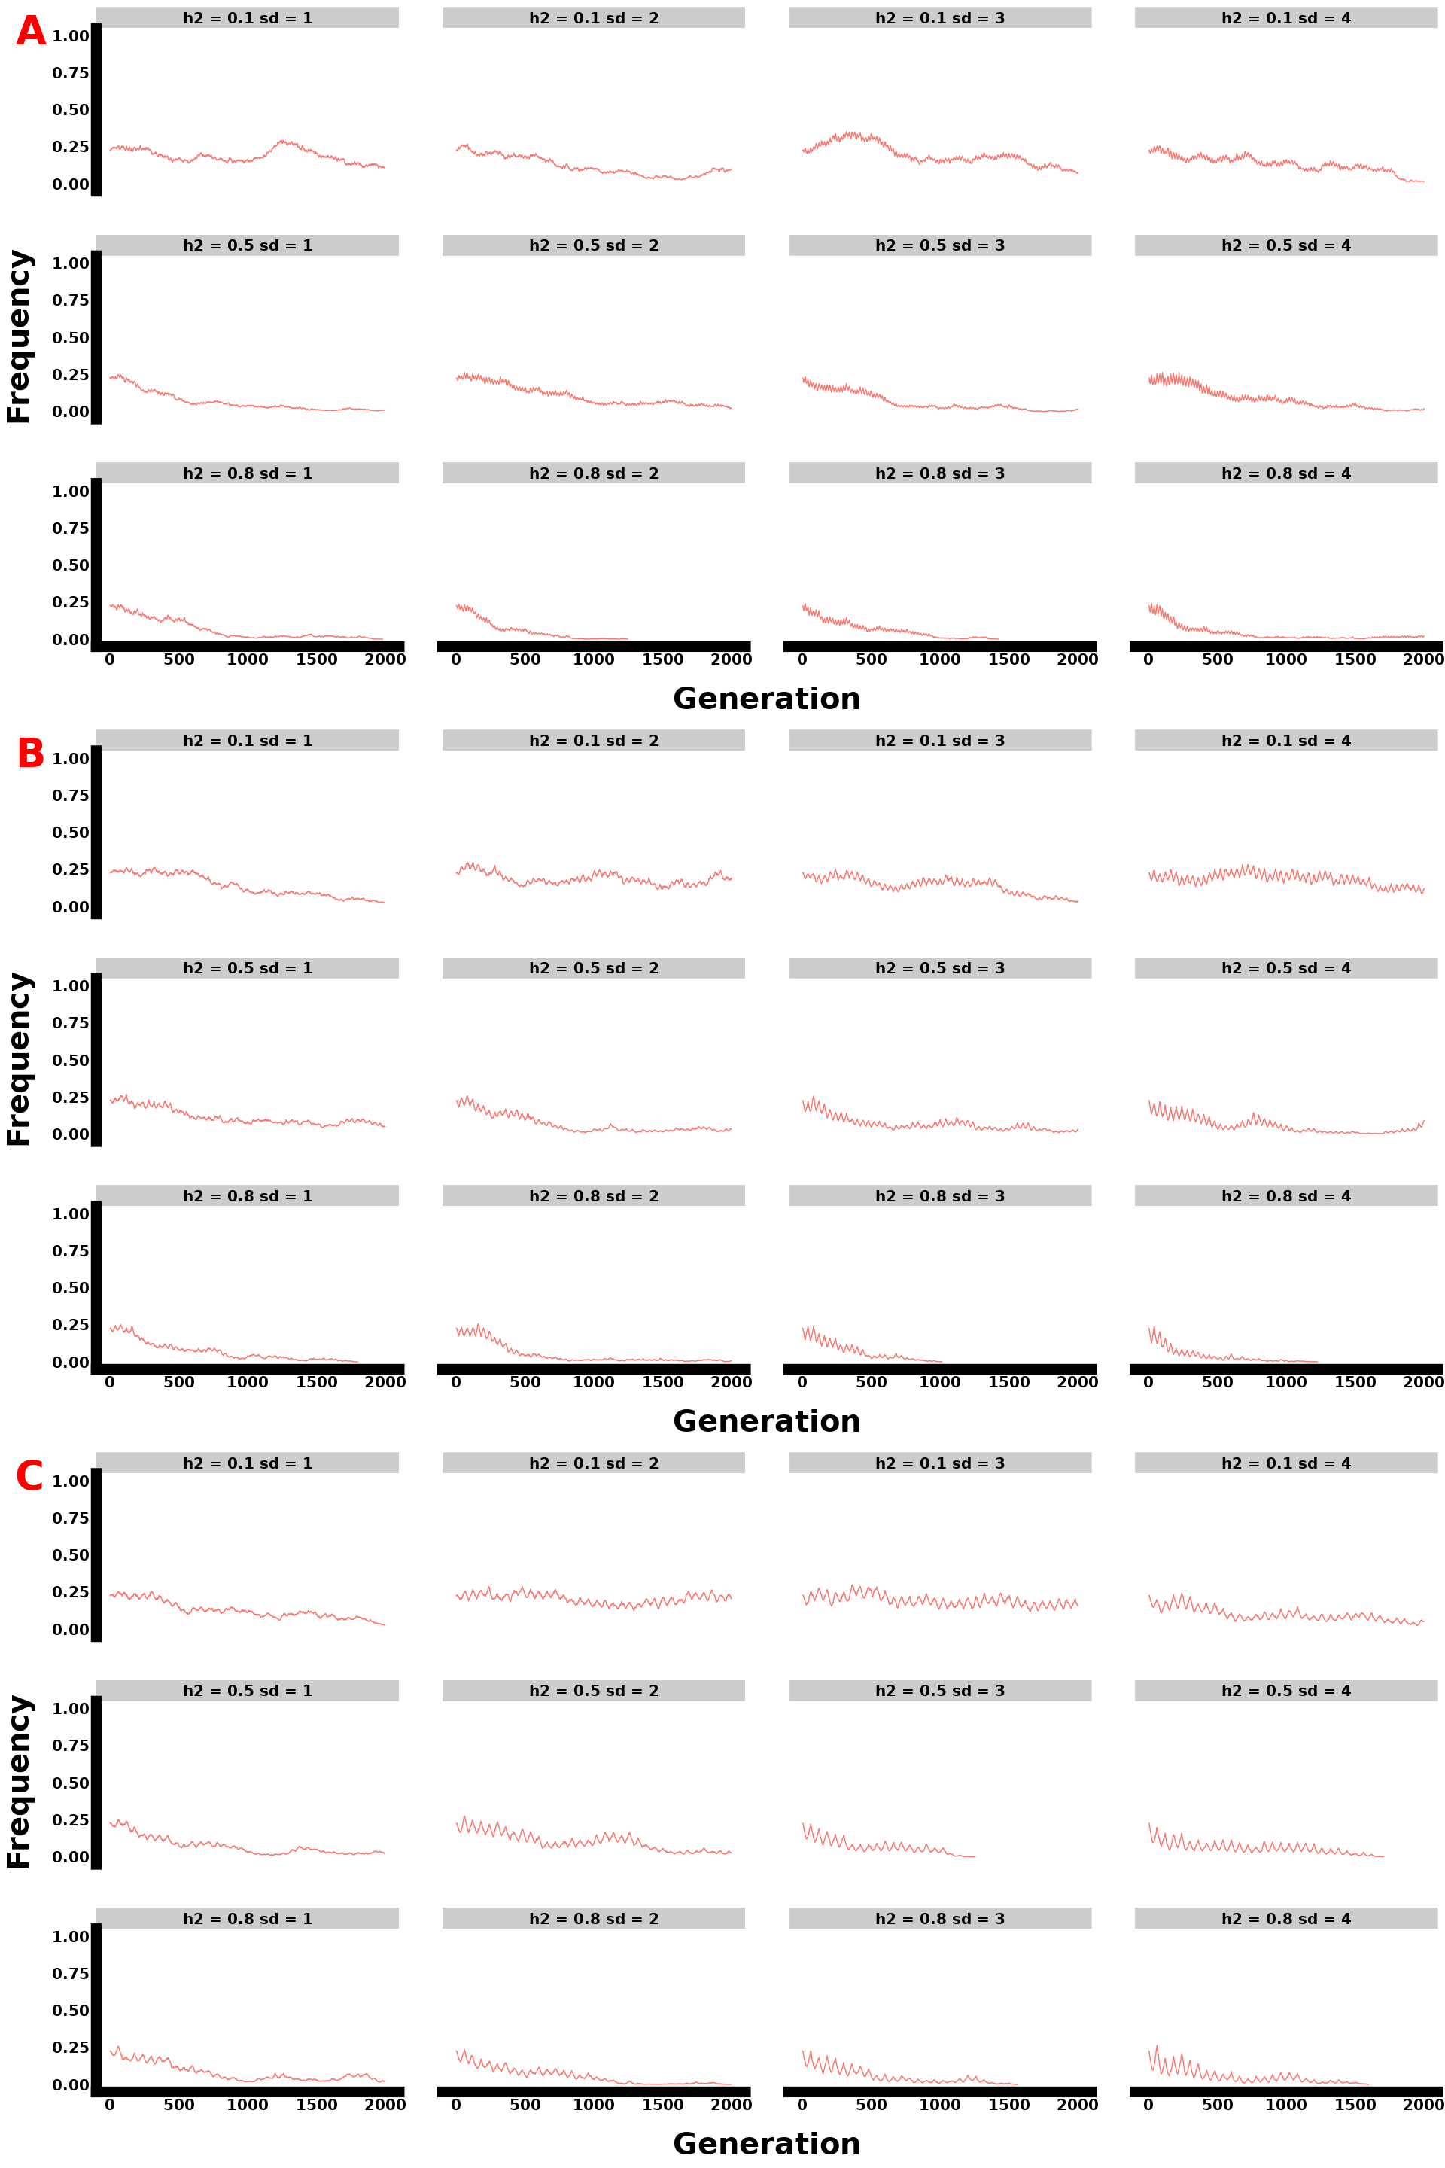

Figure: Monogenic single replicate allele frequency plot for instantaneous selection, showing parameter interactions with A representing a selection lasting 10 generations, B 20 generations, and C 30 generations.

#### 1.1.2. Oligogenic

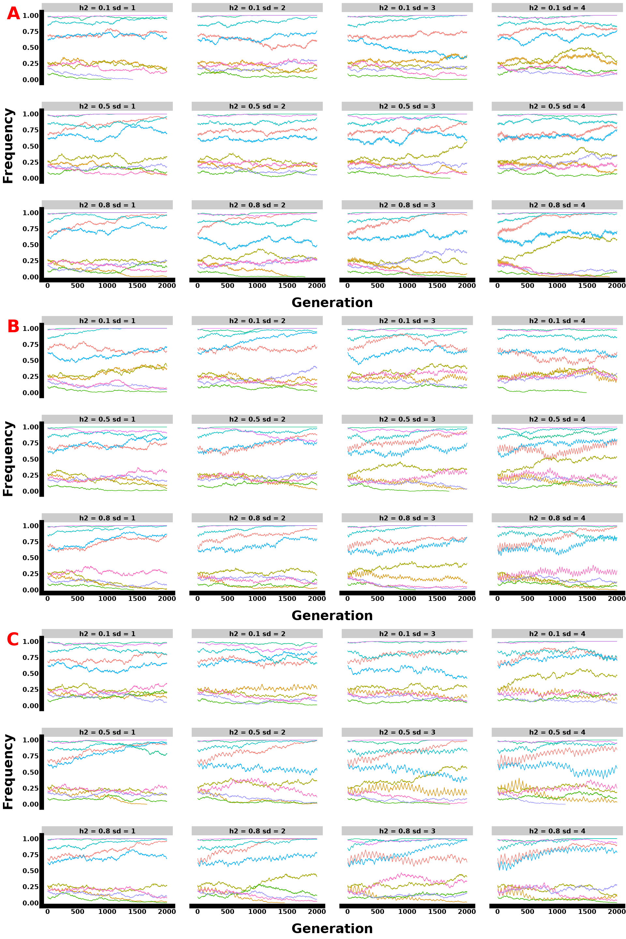

Figure: Oligogenic single replicate allele frequency plot for instantaneous selection, showing parameter interactions with A representing a selection lasting 10 generations, B 20 generations, and C 30 generations.

#### 1.1.3. Ploygenic 70 loci

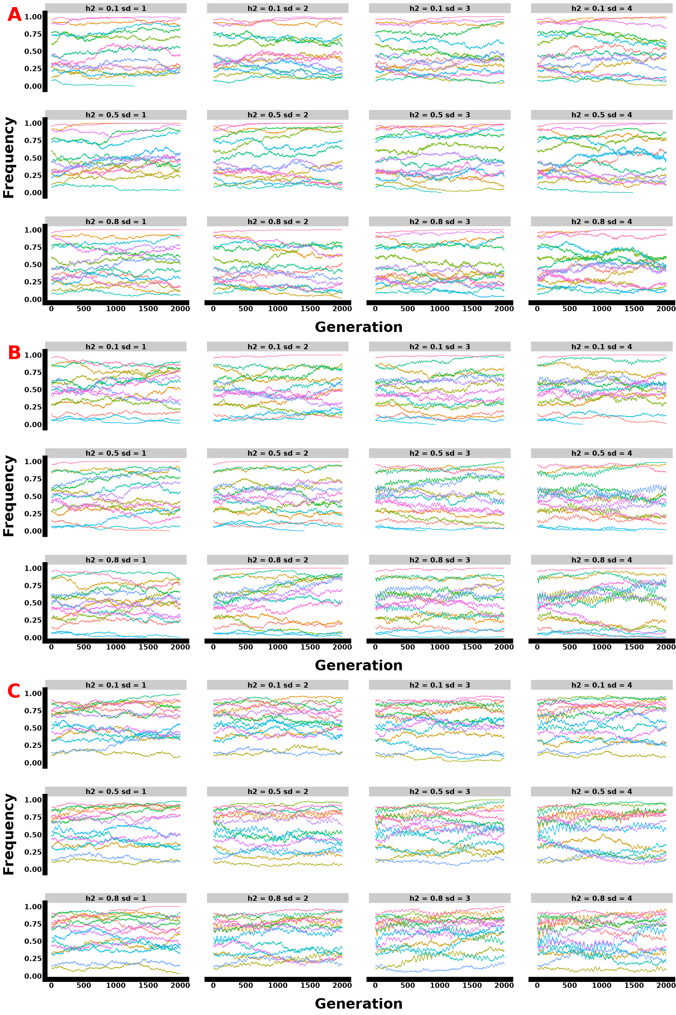

Figure: Polygenic single replicate allele frequency plot with 15 loci sampled from 70 genomic architecture for instantaneous selection, showing parameter interactions with A representing a selection lasting 10 generations, B 20 generations, and C 30 generations.

#### 1.1.4. Polygenic 100 loci

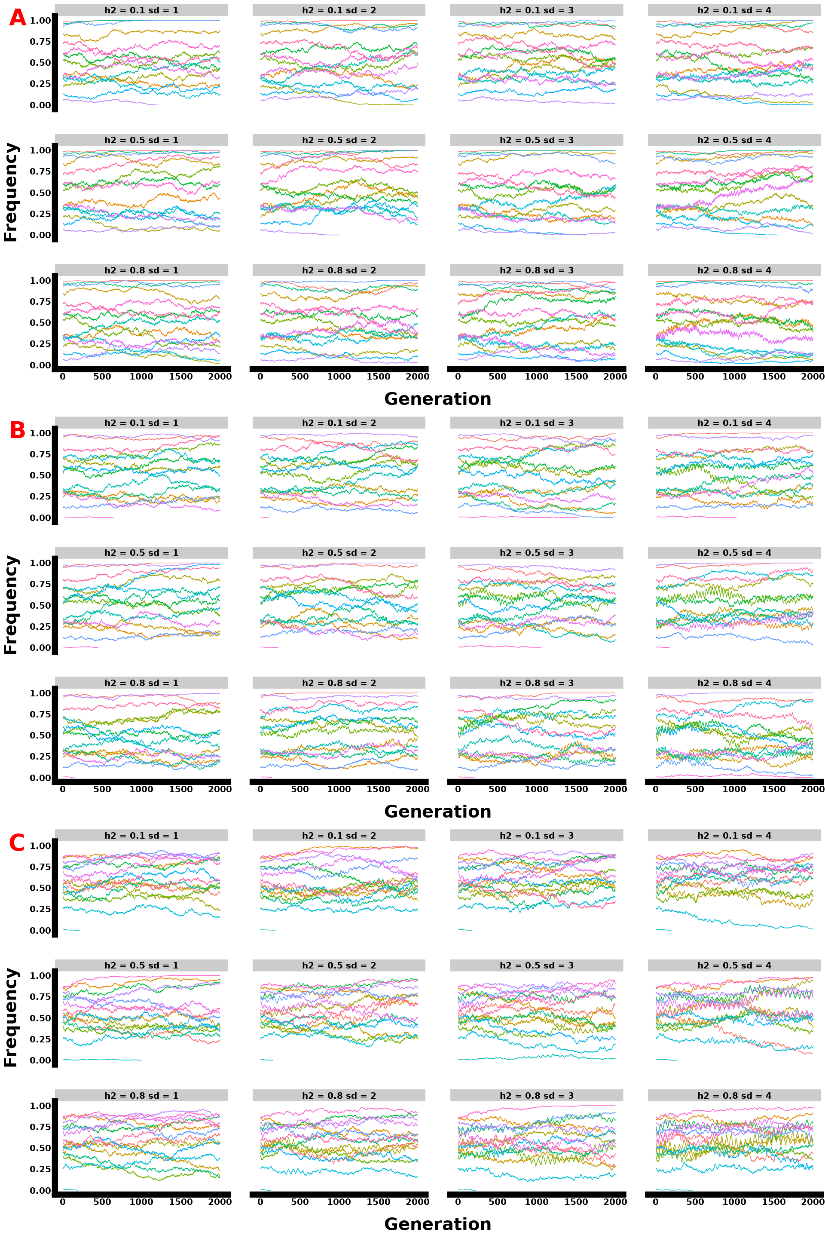

Figure: Polygenic single replicate allele frequency plot with 15 loci sampled from 100 genomic architecture for instantaneous selection, showing parameter interactions with A representing a selection lasting 10 generations, B 20 generations, and C 30 generations.

#### 1.1.5. Polygenic 300 loci

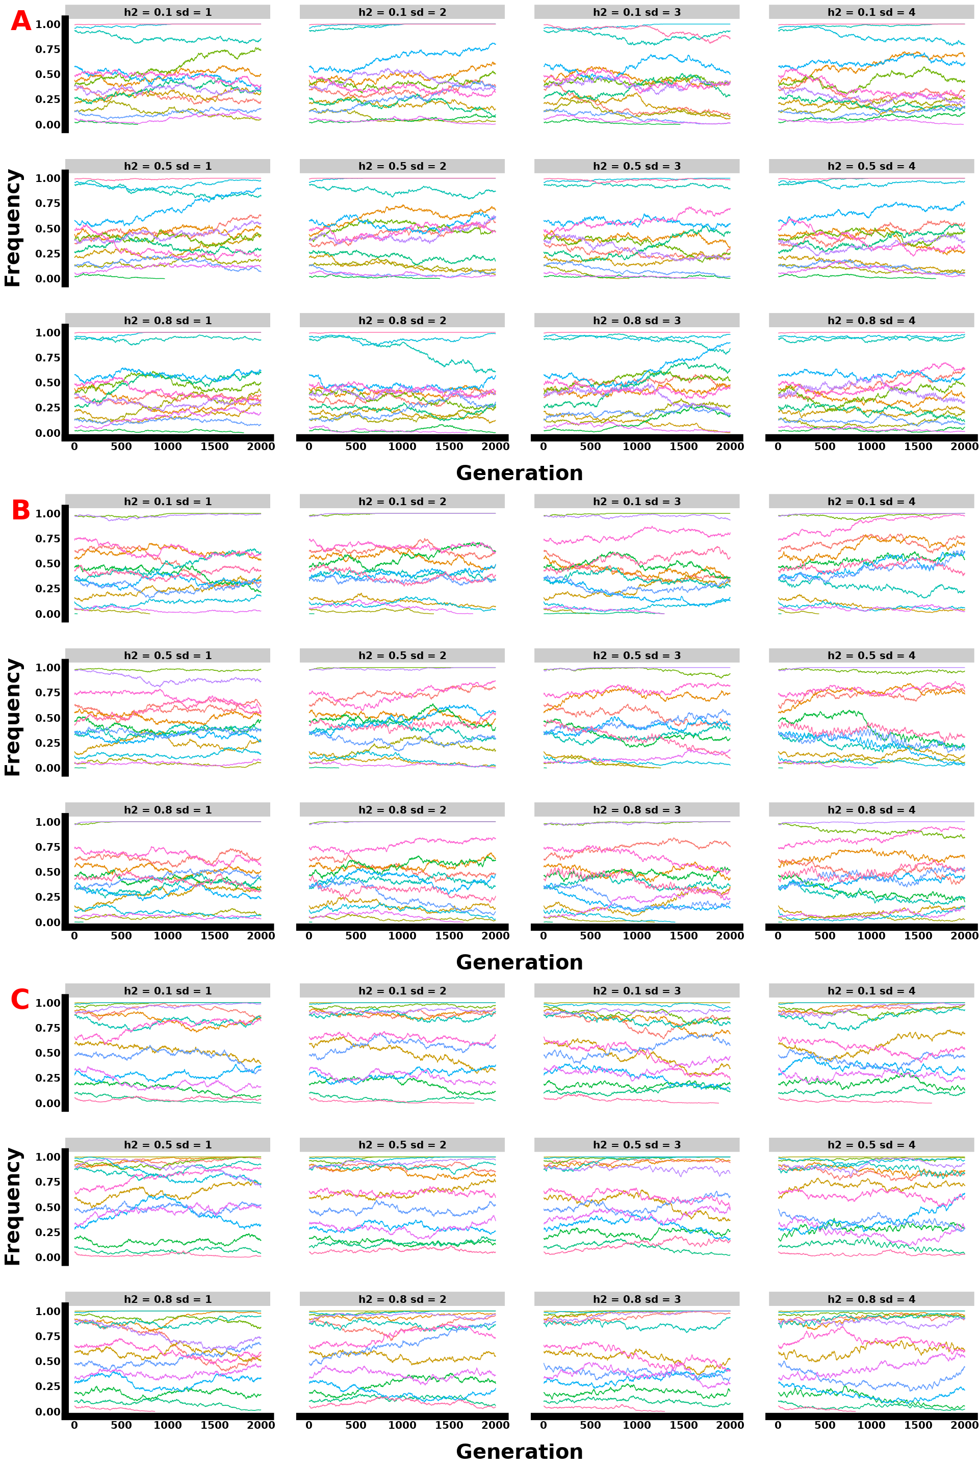

Figure: Polygenic single replicate allele frequency plot with 15 loci sampled from 300 genomic architecture for instantaneous selection, showing parameter interactions with A representing a selection lasting 10 generations, B 20 generations, and C 30 generations.

### 1.2. Phenotypes all params

#### 1.2.1. Monogenic

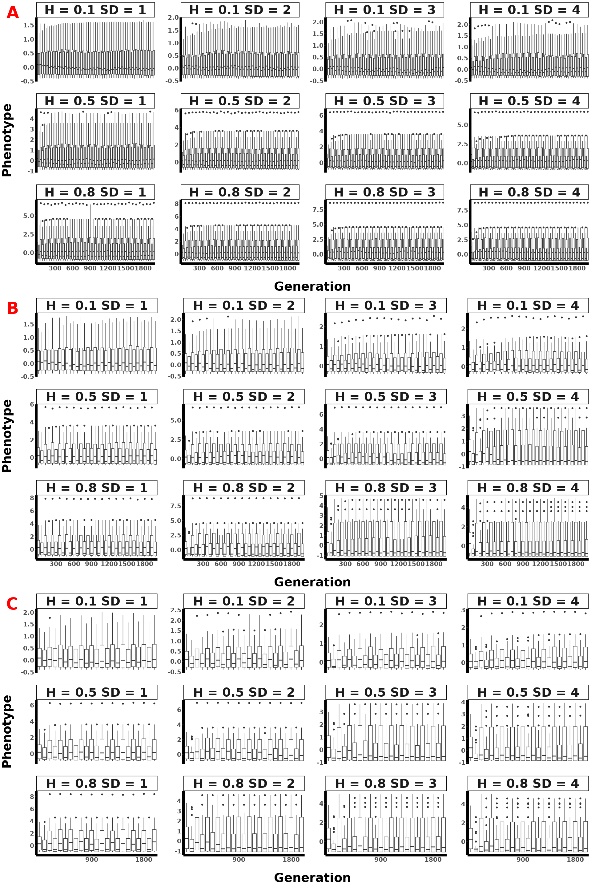

Figure: Monogenic mean population phenotypic plot across 30 replicates for instantaneous selection, showing parameter interactions with A representing a selection lasting 10 generations, B 20 generations, and C 30 generations.

#### 1.2.2. Oligogenic

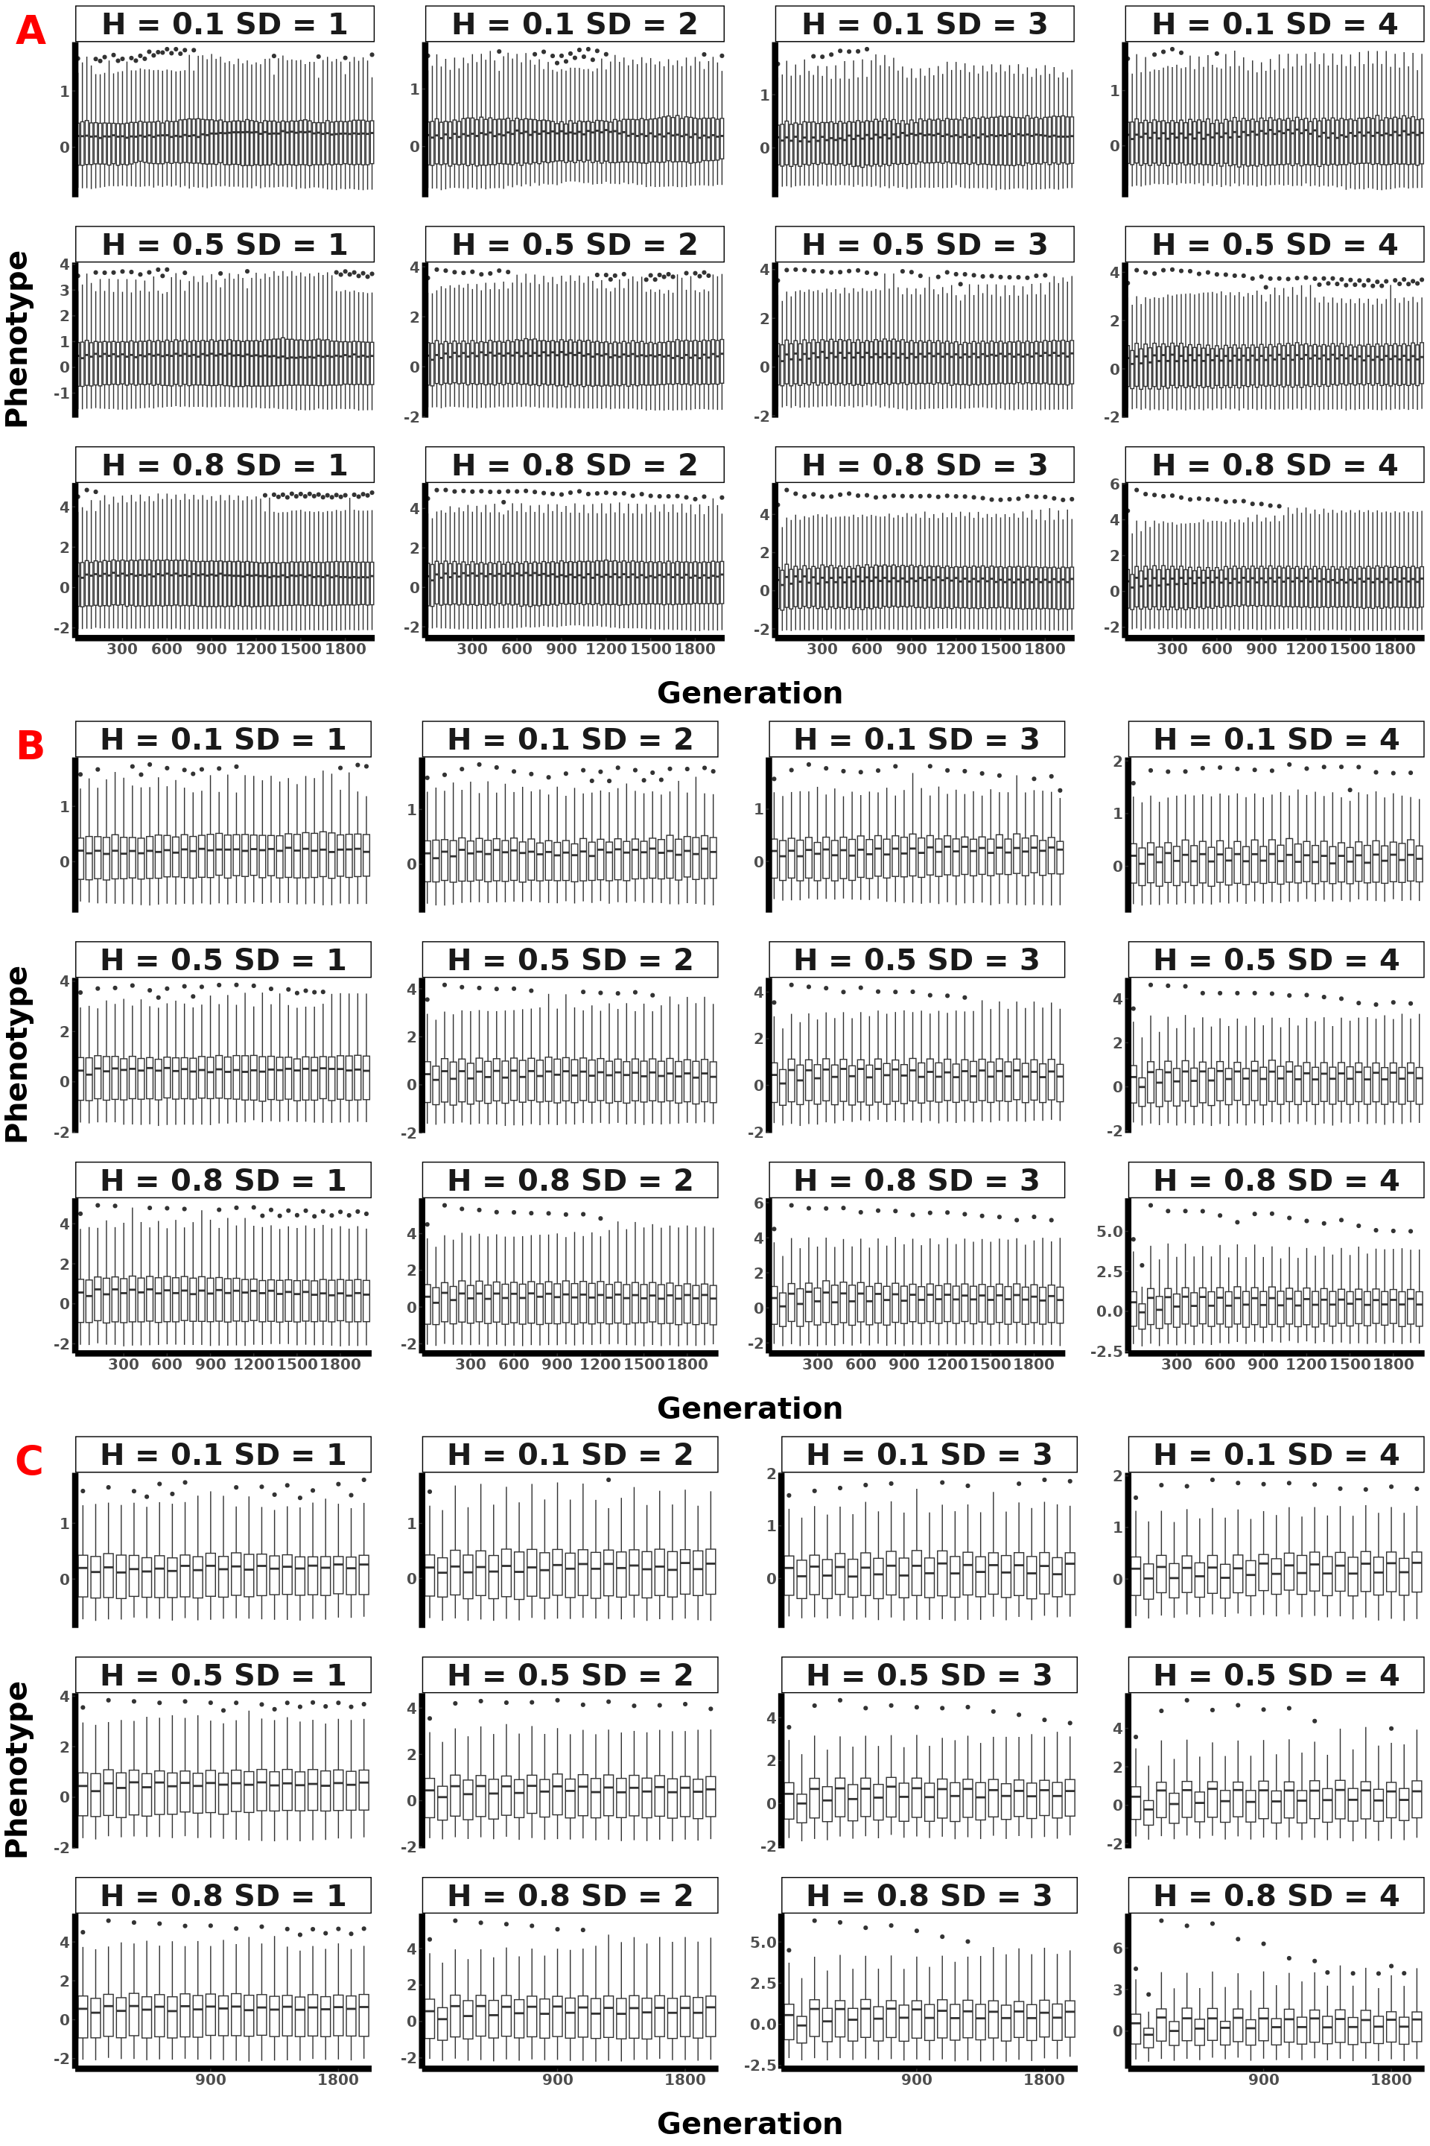

Figure: Oligogenic mean population phenotypic plot across 30 replicates for instantaneous selection, showing parameter interactions with A representing a selection lasting 10 generations, B 20 generations, and C 30 generations.

#### 1.2.3. Polygenic 70

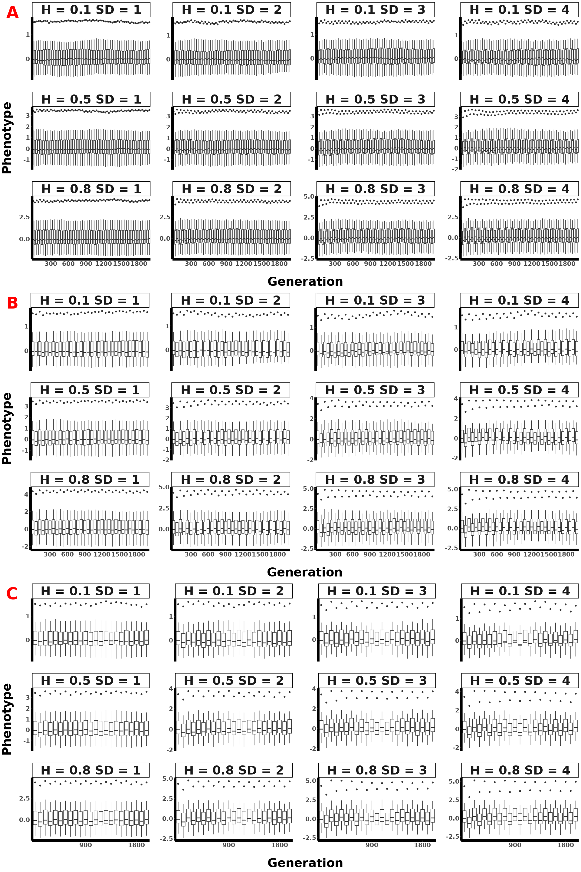

Figure: Polygenic (70 loci) mean population phenotypic plot across 30 replicates for instantaneous selection, showing parameter interactions with A representing a selection lasting 10 generations, B 20 generations, and C 30 generations.

#### 1.2.4. Polygenic 100

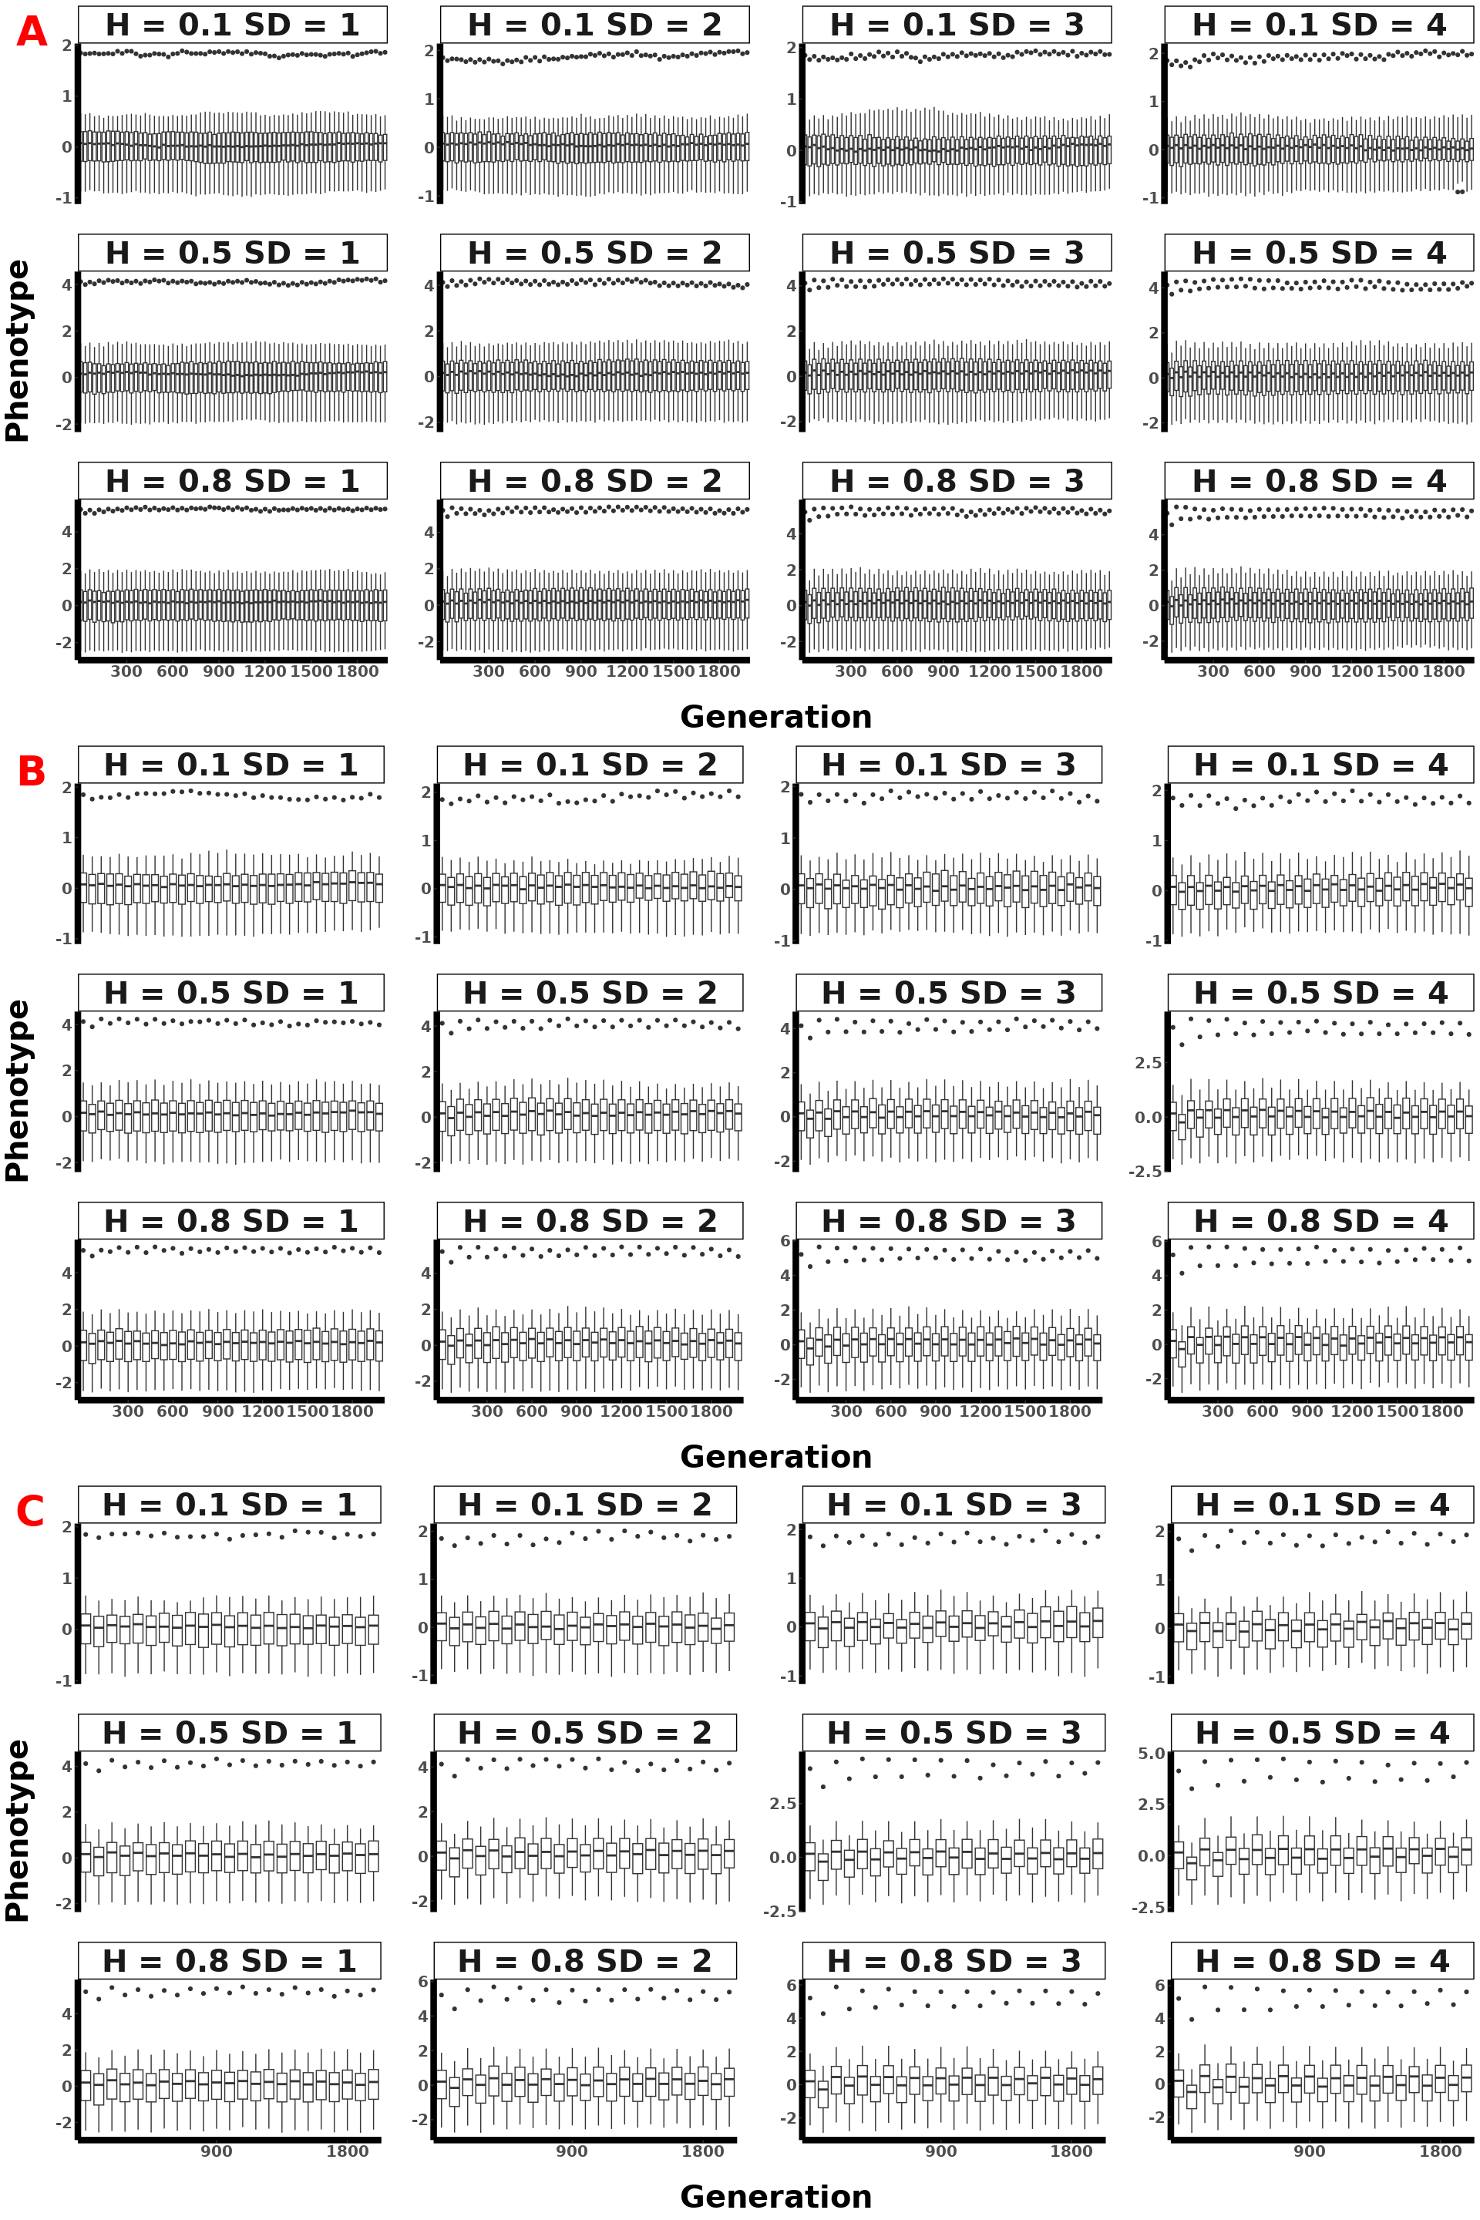

Figure: Polygenic (100 loci) mean population phenotypic plot across 30 replicates for instantaneous selection, showing parameter interactions with A representing a selection lasting 10 generations, B 20 generations, and C 30 generations.

#### 1.2.5. Polygenic 300

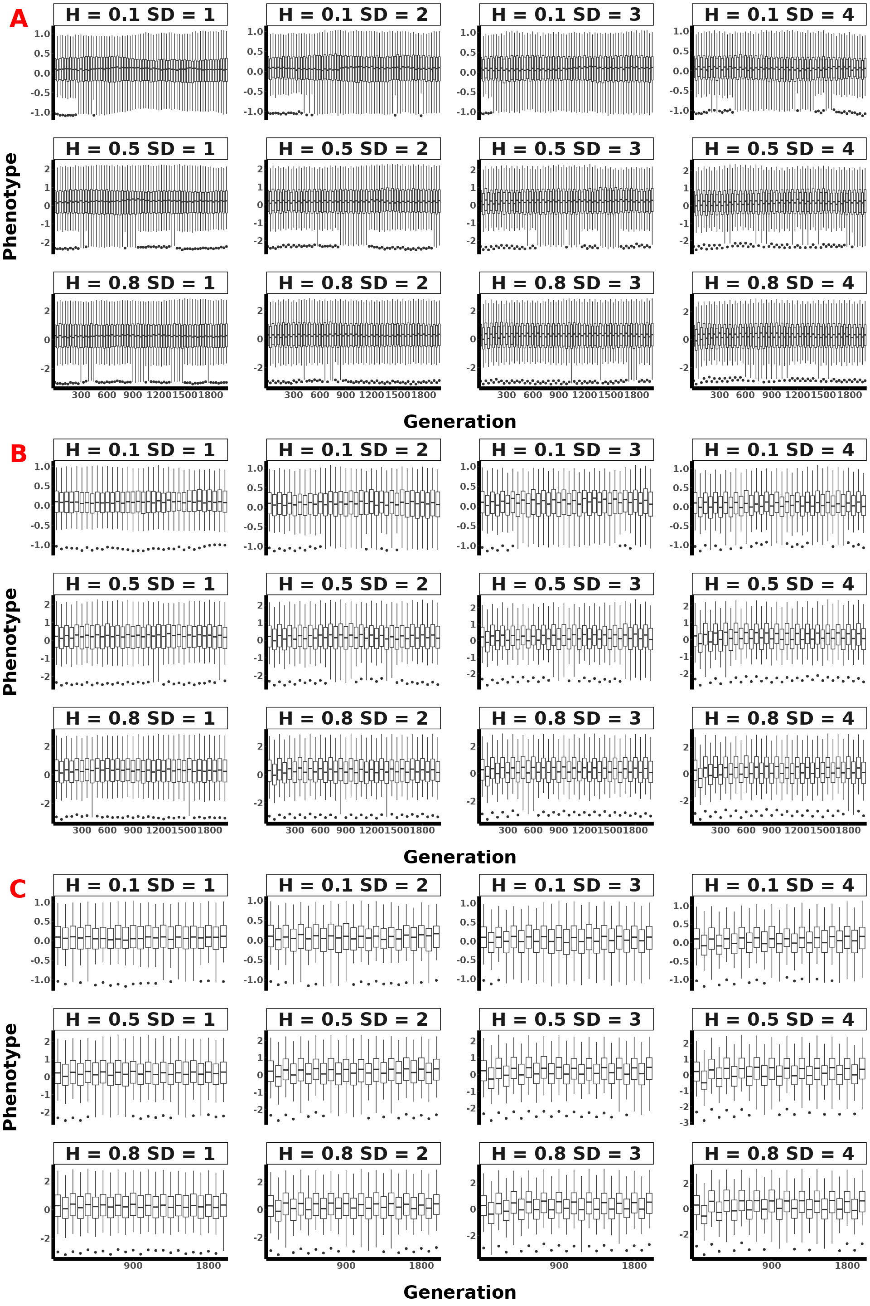

Figure: Polygenic (300 loci) mean population phenotypic plot across 30 replicates for instantaneous selection, showing parameter interactions with A representing a selection lasting 10 generations, B 20 generations, and C 30 generations.

### 1.3. Spec All params

#### 1.3.1. Monogenic

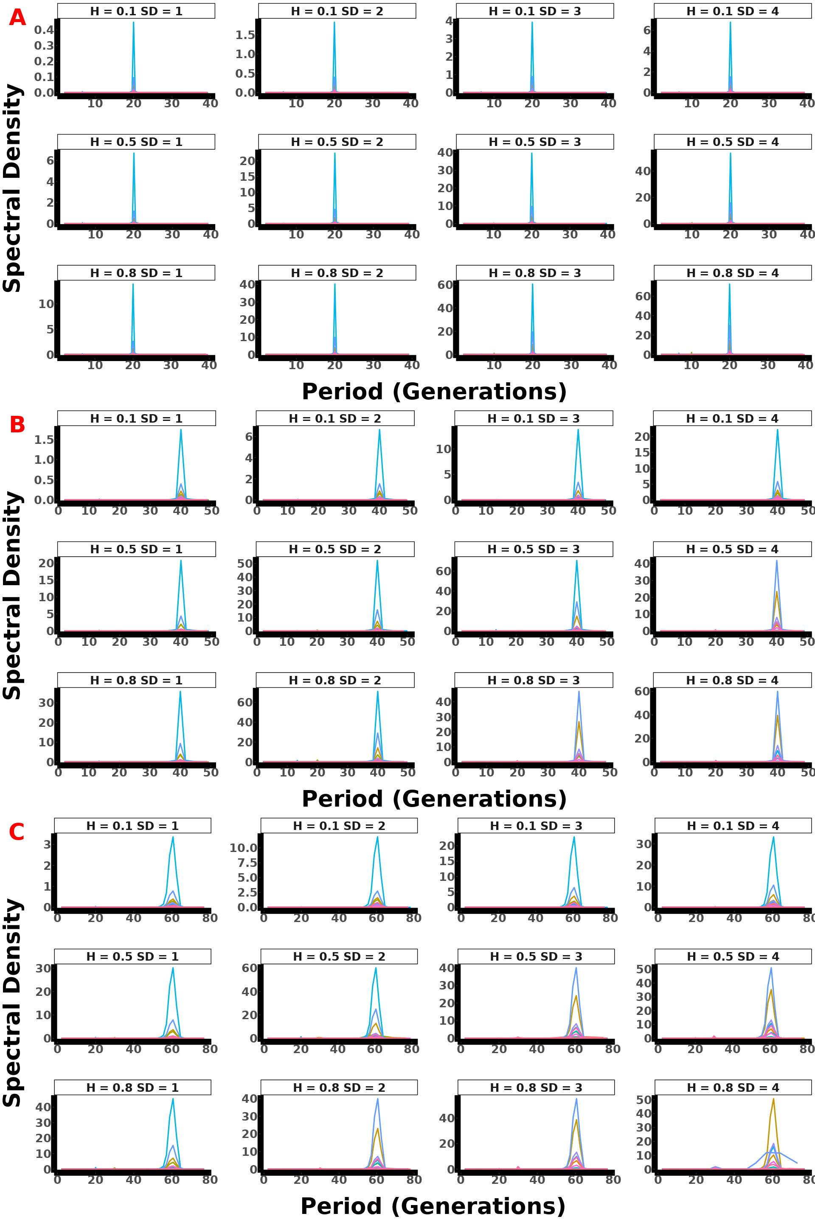

Figure: Monogenic spectral density plot across 30 replicates for instantaneous selection, showing parameter interactions with A representing a selection lasting 10 generations, B 20 generations, and C 30 generations.

#### 1.3.2. Oligogenic

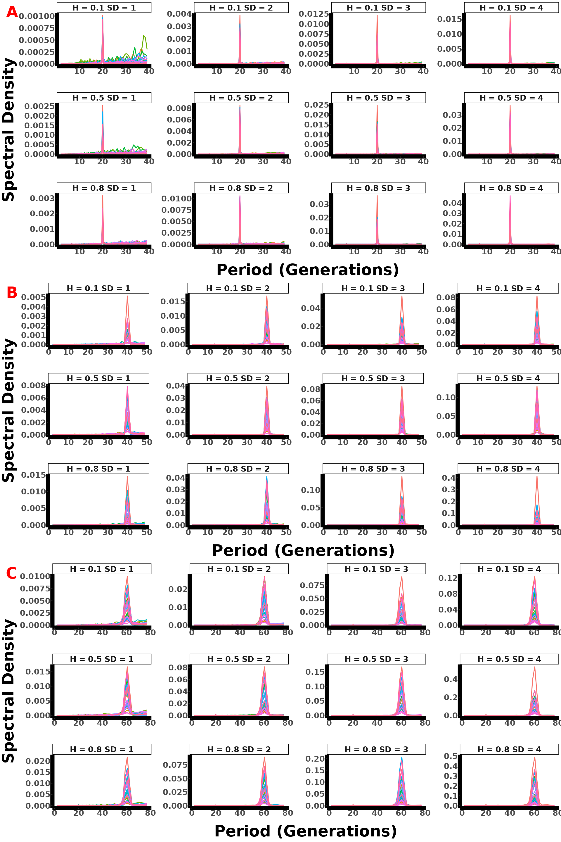

Figure: Oligogenic spectral density plot across 30 replicates for instantaneous selection, showing parameter interactions with A representing a selection lasting 10 generations, B 20 generations, and C 30 generations.

#### 1.3.3. Polygenic 70

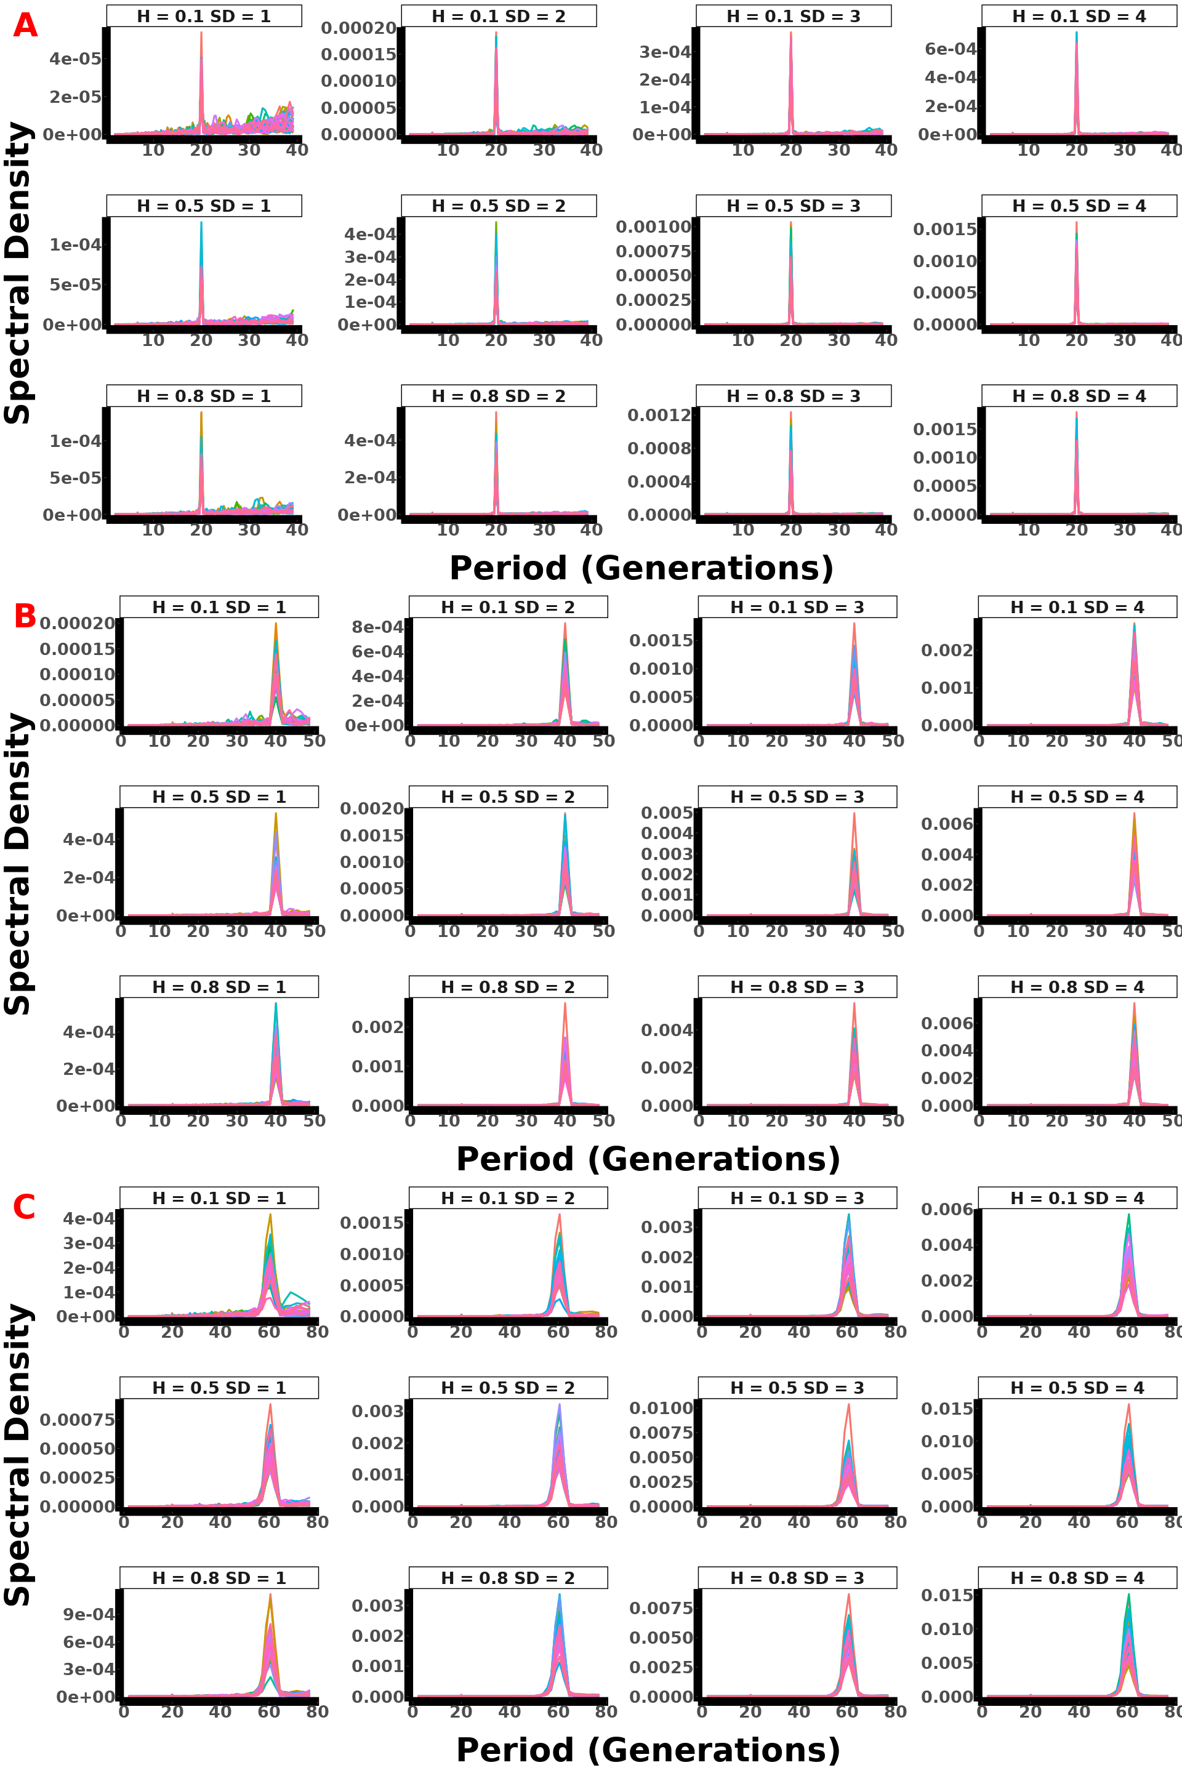

Figure: Polygenic (70 loci) spectral density plot across 30 replicates for instantaneous selection, showing parameter interactions with A representing a selection lasting 10 generations, B 20 generations, and C 30 generations.

#### 1.3.4. Polygenic 100

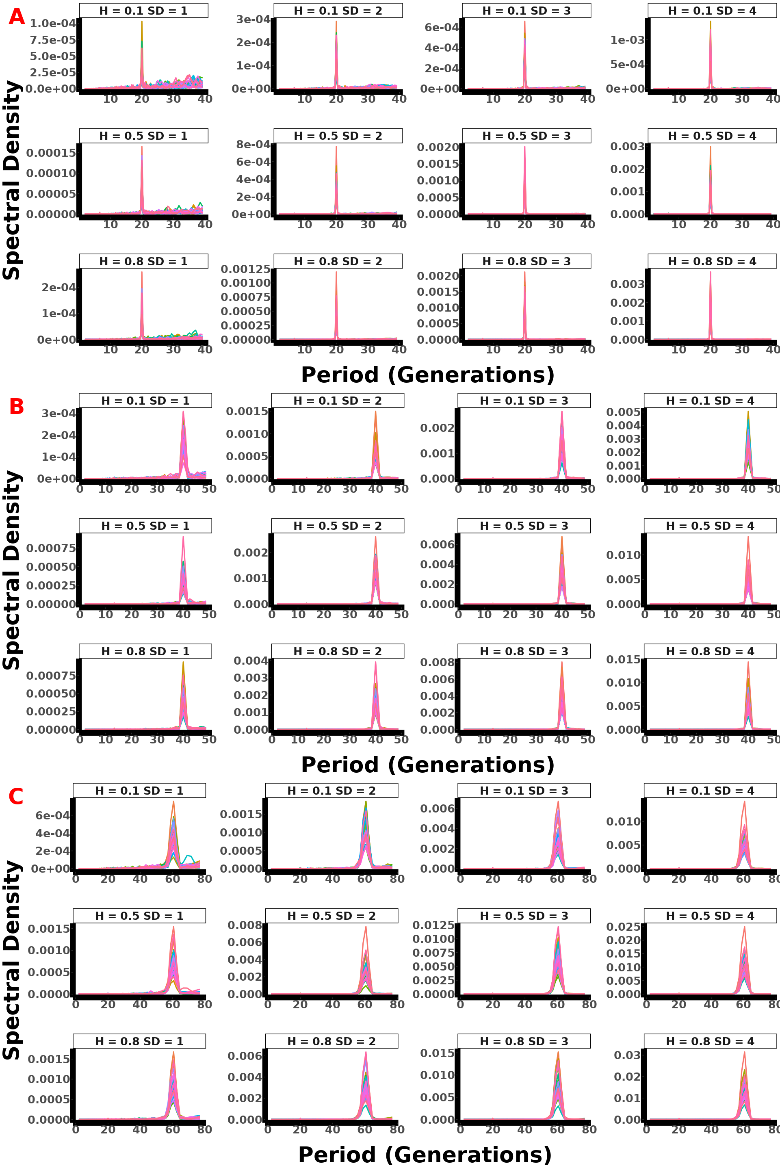

Figure: Polygenic (100 loci) spectral density plot across 30 replicates for instantaneous selection, showing parameter interactions with A representing a selection lasting 10 generations, B 20 generations, and C 30 generations.

#### 1.3.5. Polygenic 300

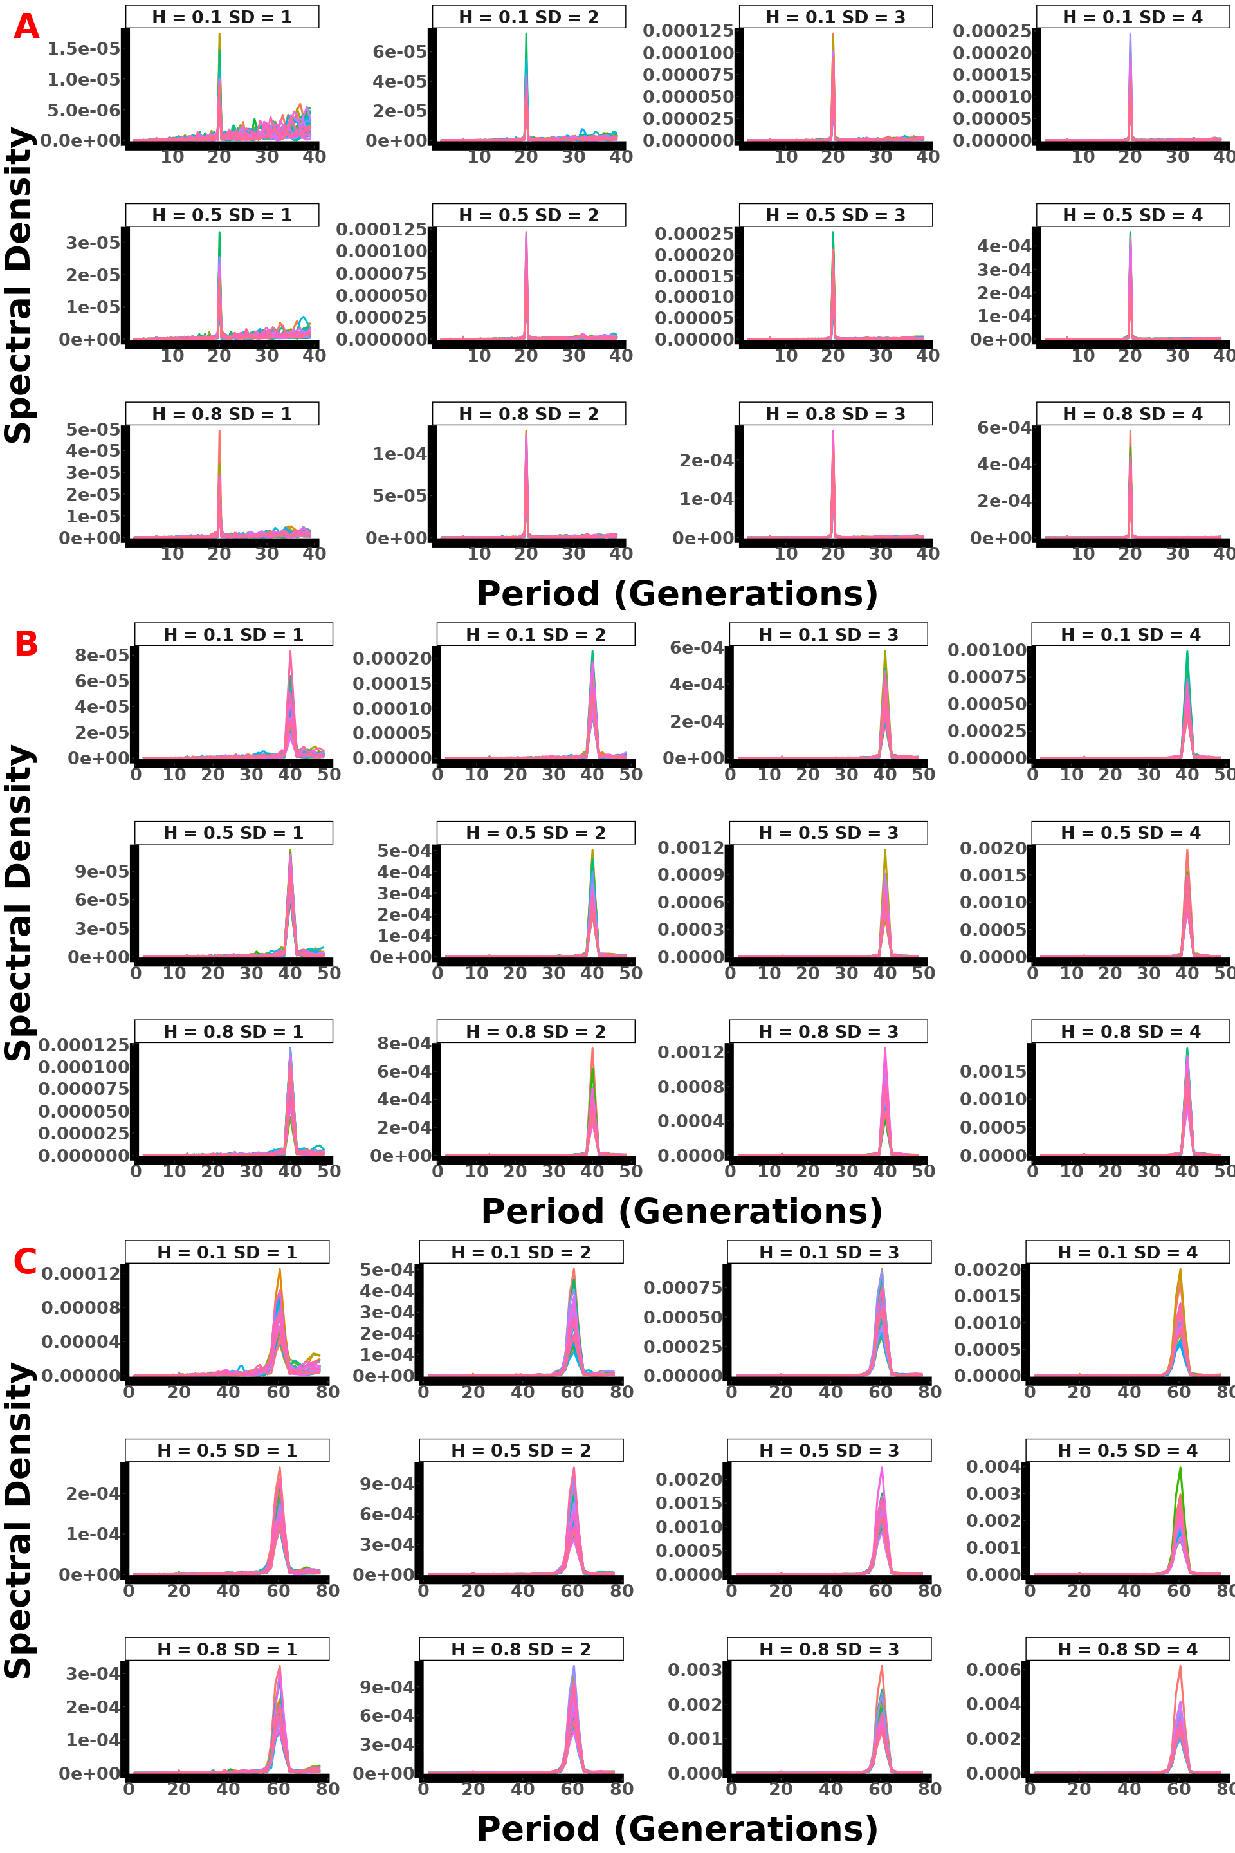

Figure: Polygenic (300 loci) spectral density plot across 30 replicates for instantaneous selection, showing parameter interactions with A representing a selection lasting 10 generations, B 20 generations, and C 30 generations.

## 2. Gradual I model

### 2.1. AF All param & Single replicate

#### 2.1.1. Monogenic

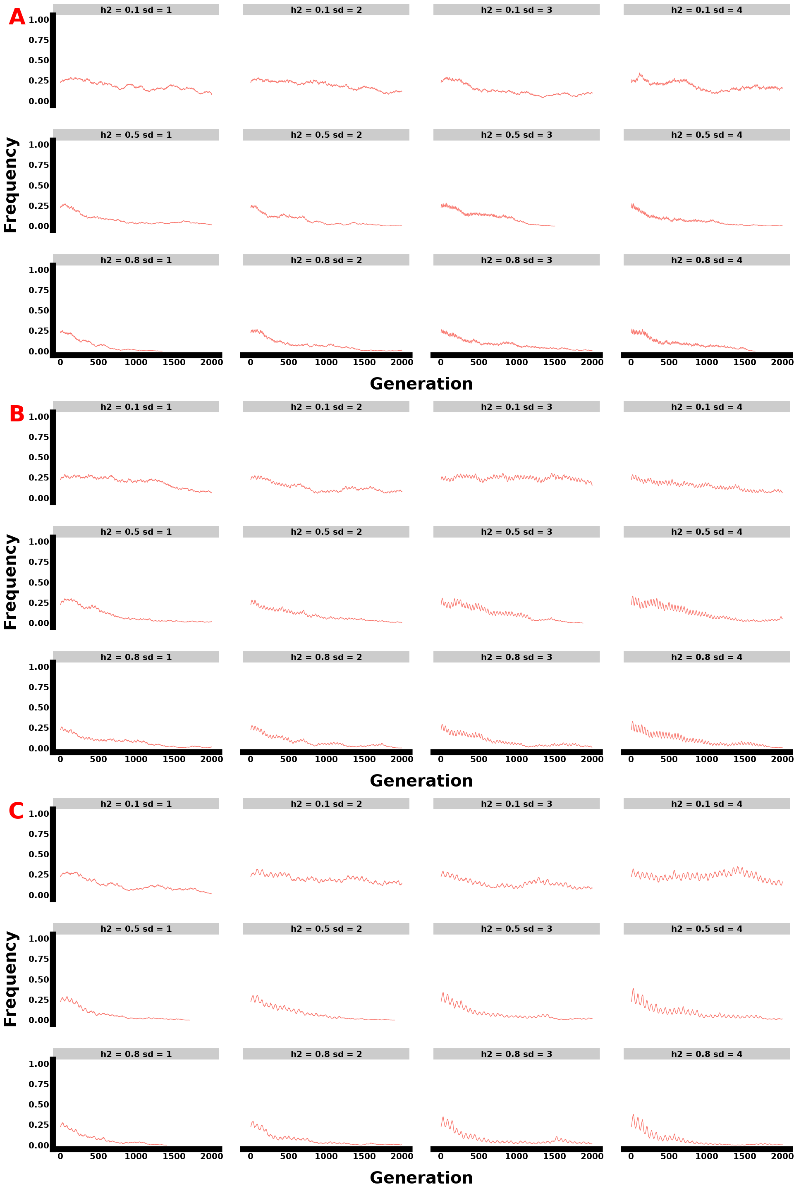

Figure: Monogenic single replicate allele frequency plot for gradual two equal seasons selection, showing parameter interactions with A representing a selection lasting 10 generations, B 20 generations, and C 30 generations.

#### 2.1.2. Oligogenic

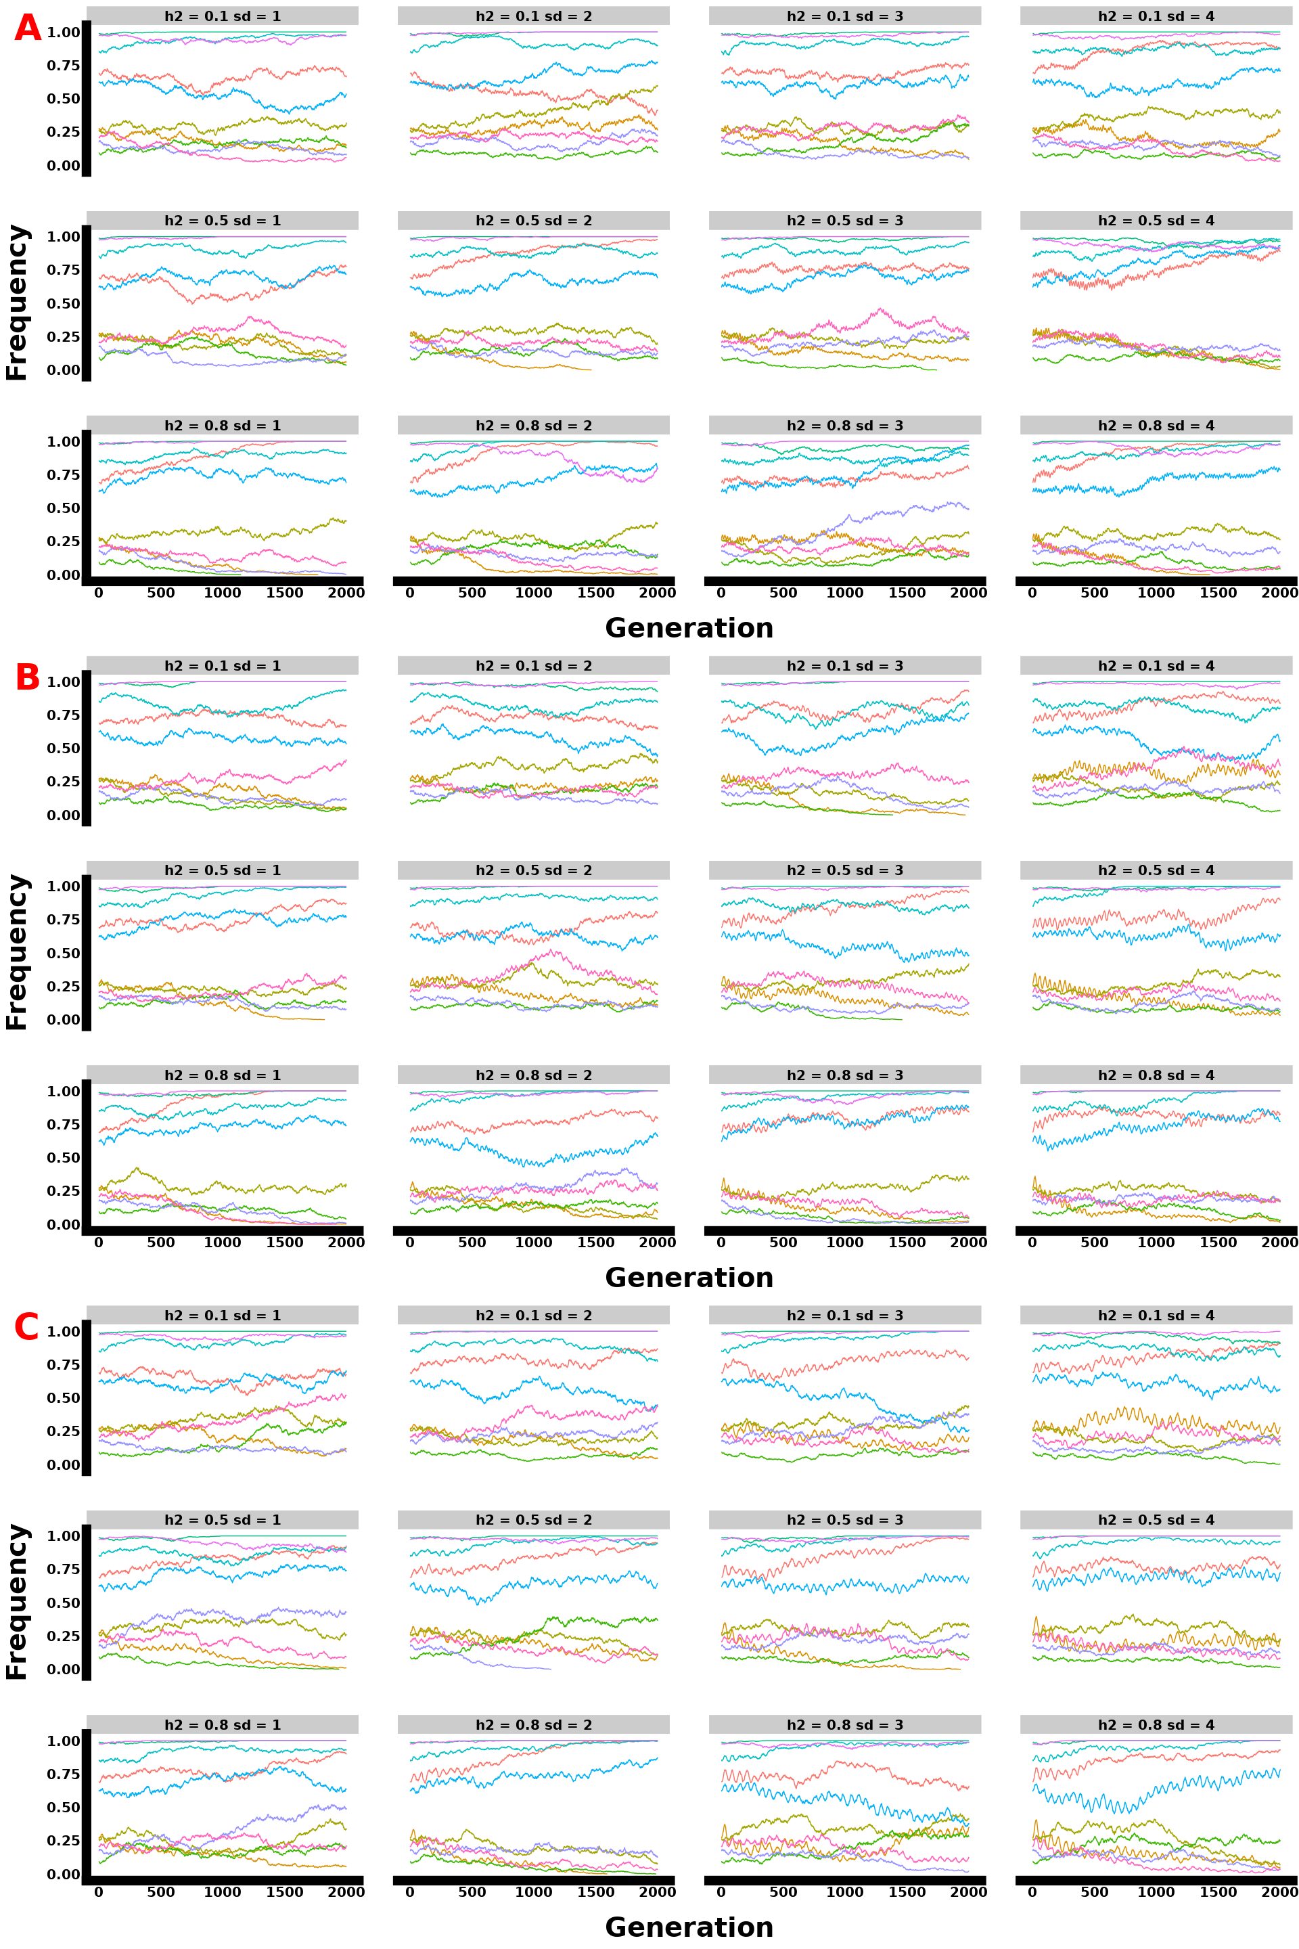

Figure: Oligogenic single replicate allele frequency plot for gradual two equal seasons selection, showing parameter interactions with A representing a selection lasting 10 generations, B 20 generations, and C 30 generations.

#### 2.1.3. Polygenic 70 loci

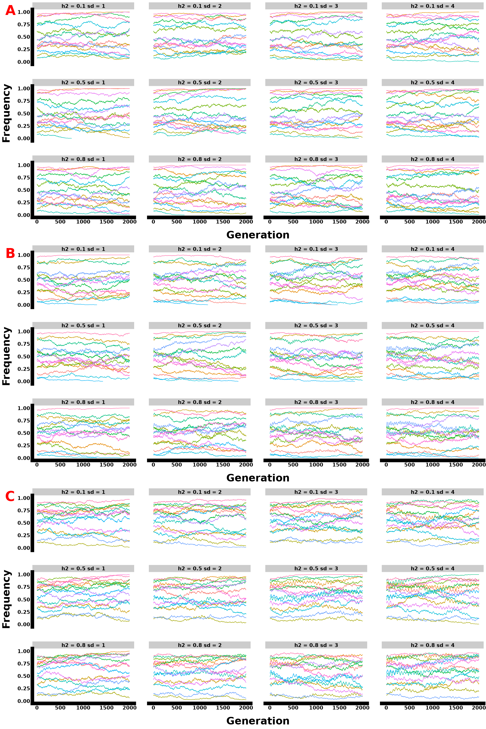

Figure: Polygenic single replicate allele frequency plot with 15 loci sampled from 70 genomic architecture for gradual two equal seasons selection, showing parameter interactions with A representing a selection lasting 10 generations, B 20 generations, and C 30 generations.

#### 2.1.4. Polygenic 100 loci

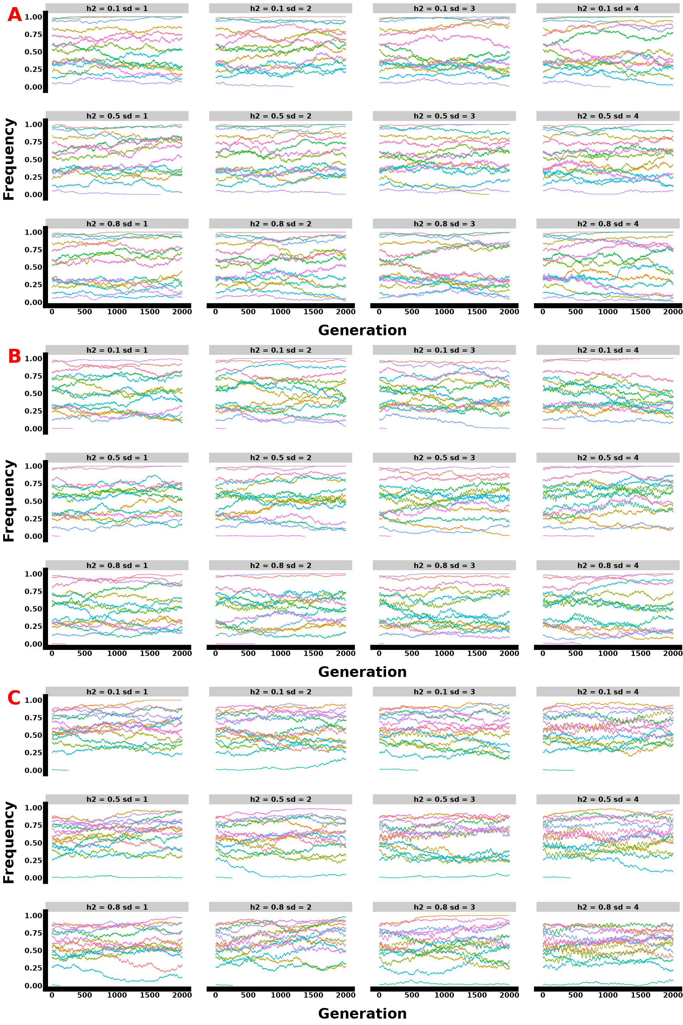

Figure: Polygenic single replicate allele frequency plot with 15 loci sampled from 100 genomic architecture for gradual two equal seasons selection, showing parameter interactions with A representing a selection lasting 10 generations, B 20 generations, and C 30 generations.

#### 2.1.5. Polygenic 300 loci

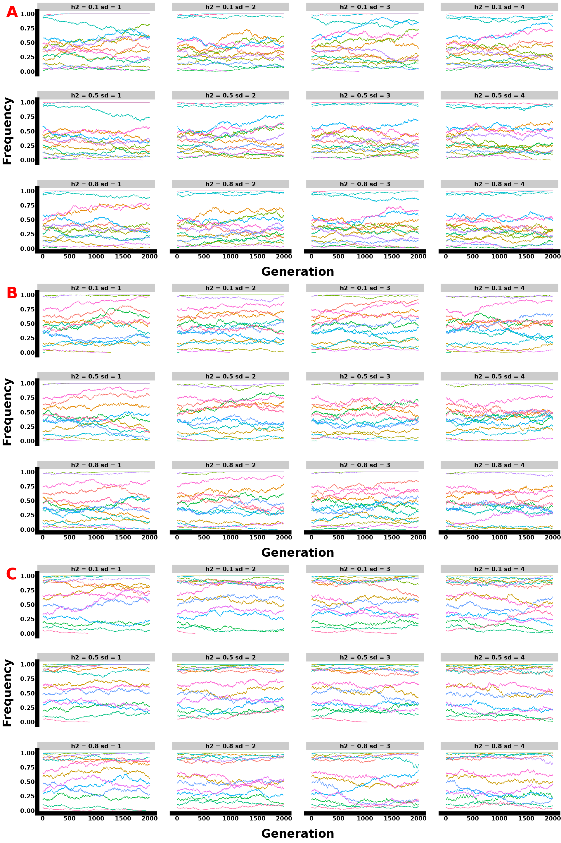

Figure: Polygenic single replicate allele frequency plot with 15 loci sampled from 300 genomic architecture for gradual two equal seasons selection, showing parameter interactions with A representing a selection lasting 10 generations, B 20 generations, and C 30 generations.

### 2.2. Phenotypes all params

#### 2.2.1. Monogenic

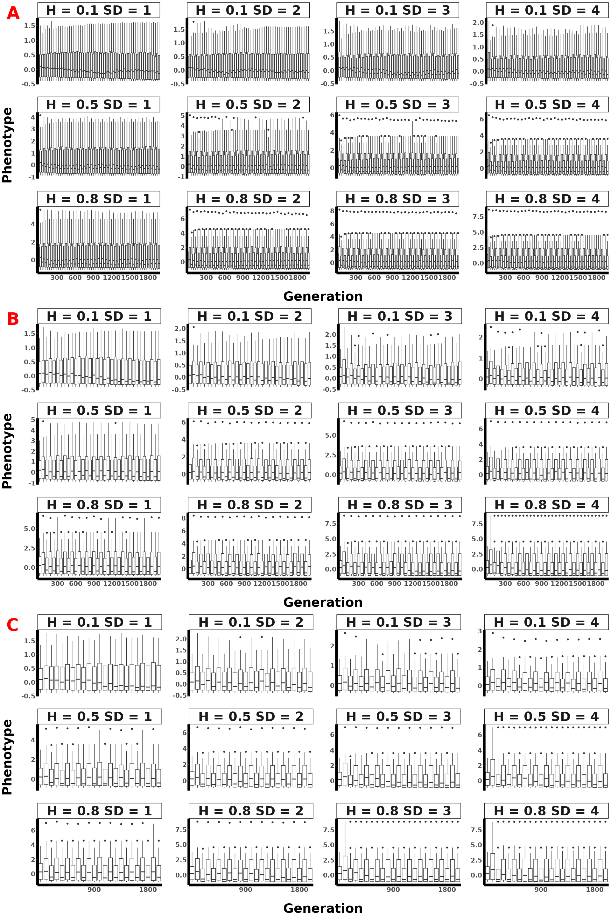

Figure: Monogenic mean population phenotypic plot across 30 replicates for gradual two equal seasons selection, showing parameter interactions with A representing a selection lasting 10 generations, B 20 generations, and C 30 generations.

#### 2.2.2. Oligogenic

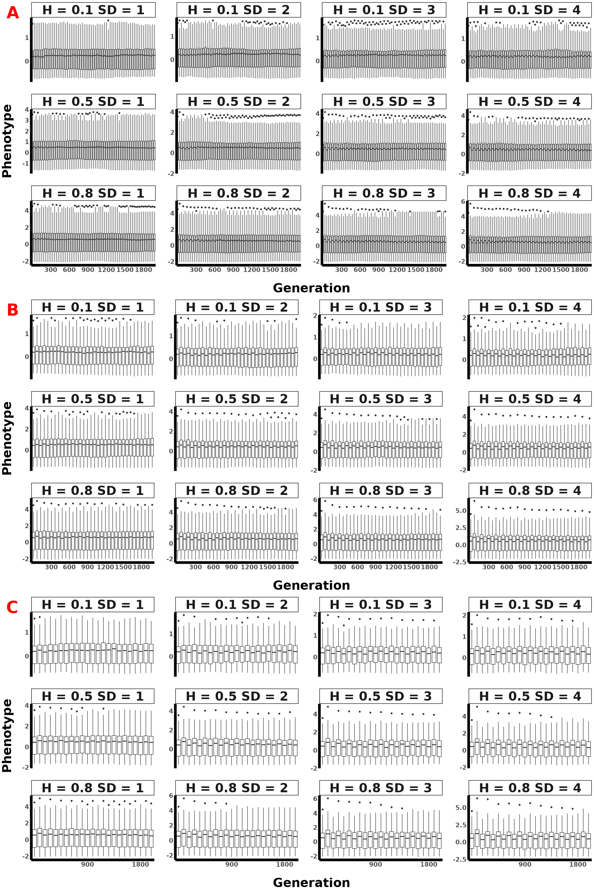

Figure: Oligogenic mean population phenotypic plot across 30 replicates for gradual two equal seasons selection, showing parameter interactions with A representing a selection lasting 10 generations, B 20 generations, and C 30 generations.

#### 2.2.3. Polygenic 70

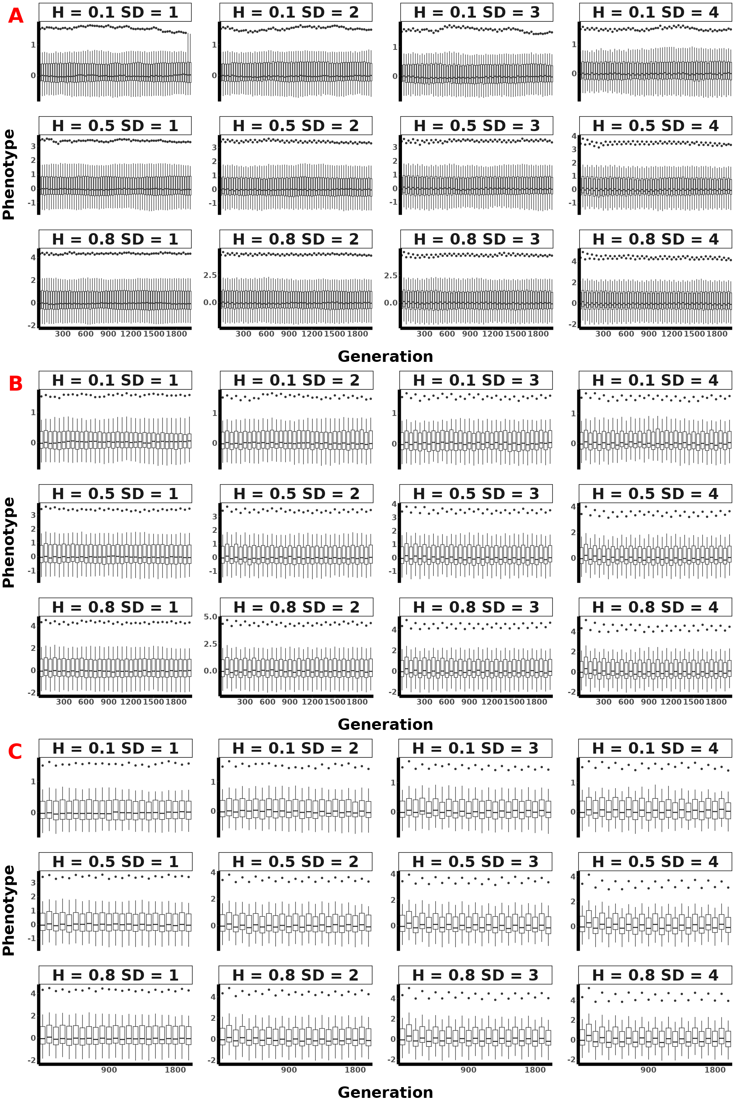

Figure: Polygenic (70 loci) mean population phenotypic plot across 30 replicates for gradual two equal seasons selection, showing parameter interactions with A representing a selection lasting 10 generations, B 20 generations, and C 30 generations.

#### 2.2.4. Polygenic 100

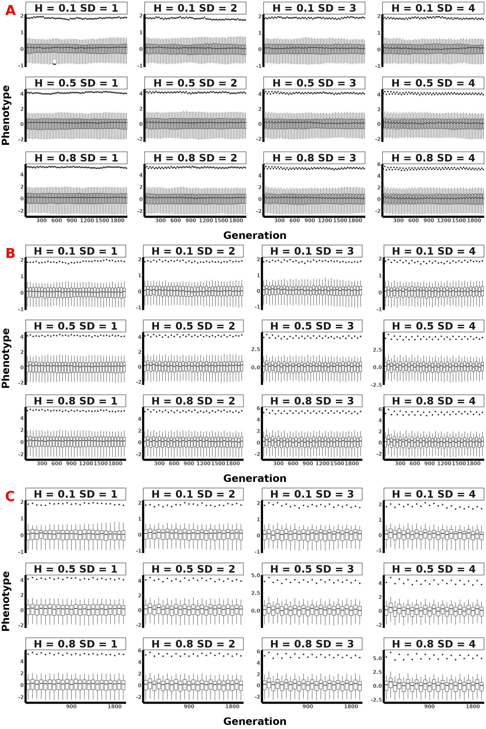

Figure: Polygenic (100 loci) mean population phenotypic plot across 30 replicates for gradual two equal seasons selection, showing parameter interactions with A representing a selection lasting 10 generations, B 20 generations, and C 30 generations.

#### 2.2.5. Polygenic 300

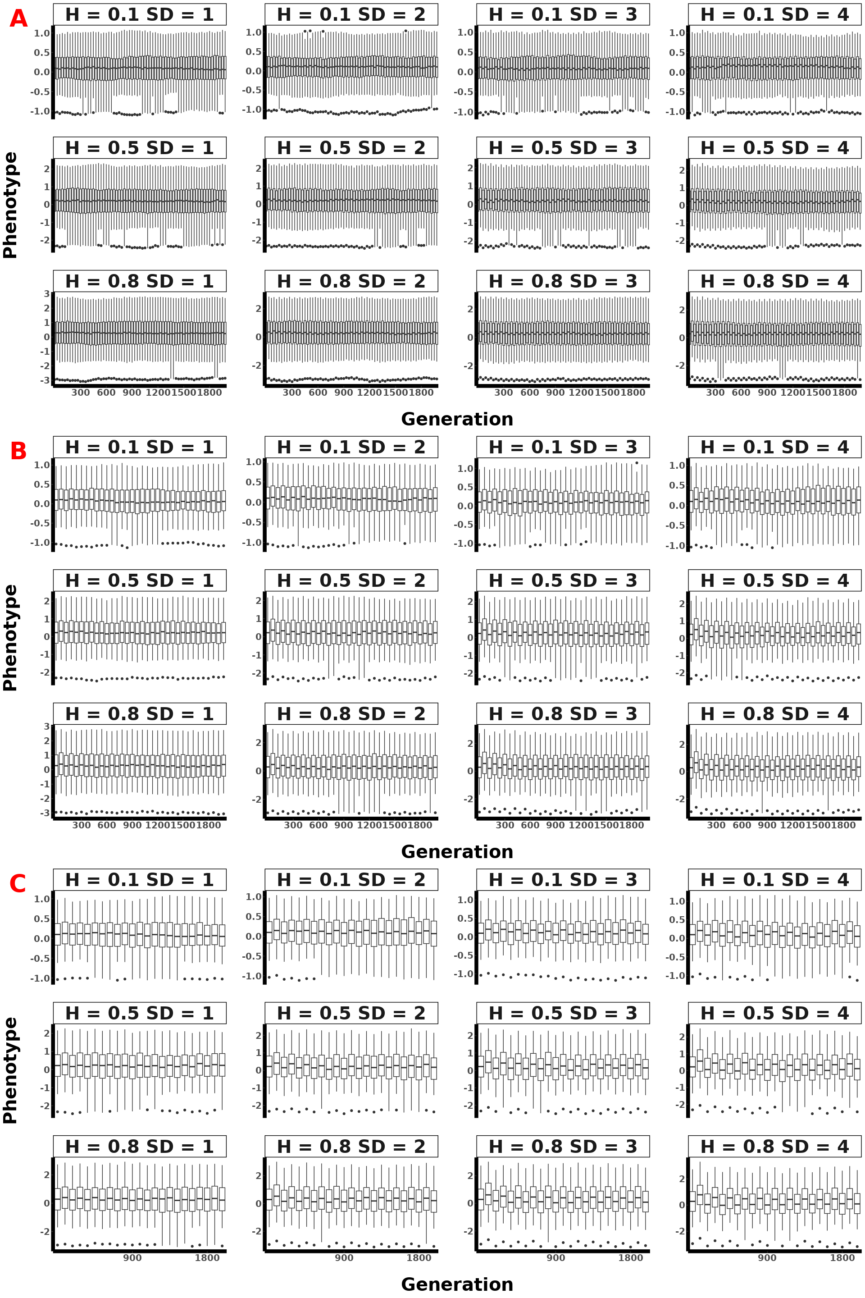

Figure: Polygenic (300 loci) mean population phenotypic plot across 30 replicates for gradual two equal seasons selection, showing parameter interactions with A representing a selection lasting 10 generations, B 20 generations, and C 30 generations.

### 2.3. Spec All params

#### 2.3.1. Monogenic

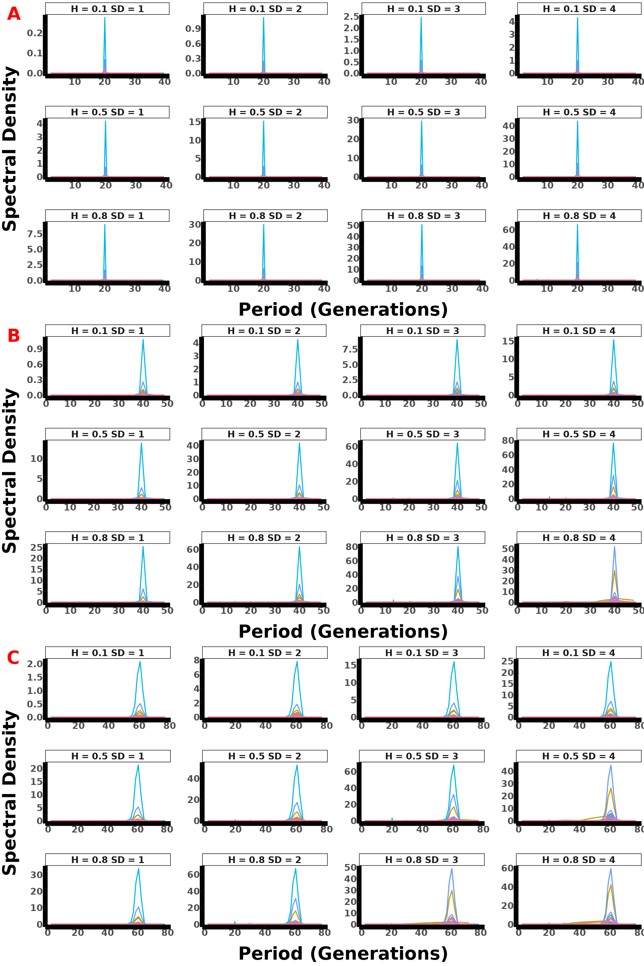

Figure: Monogenic spectral density plot across 30 replicates for gradual two equal seasons selection, showing parameter interactions with A representing a selection lasting 10 generations, B 20 generations, and C 30 generations.

#### 2.3.2. Oligogenic

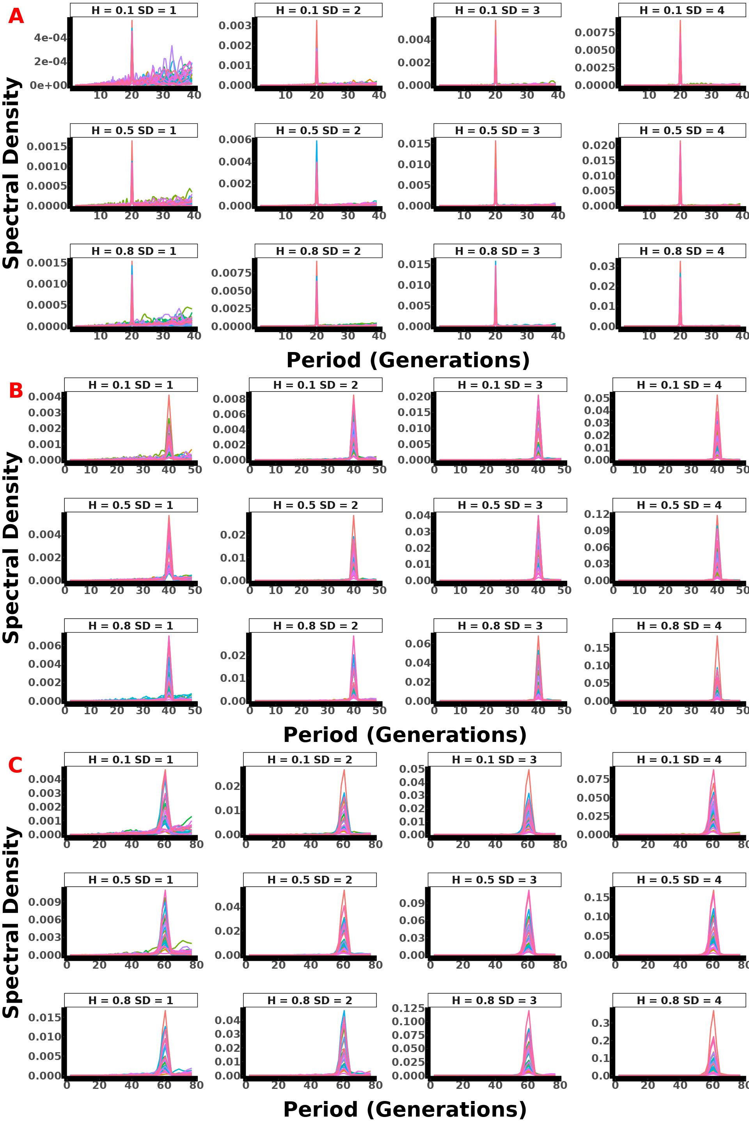

Figure: Oligogenic spectral density plot across 30 replicates for gradual two equal seasons selection, showing parameter interactions with A representing a selection lasting 10 generations, B 20 generations, and C 30 generations.

#### 2.3.3. Polygenic 70

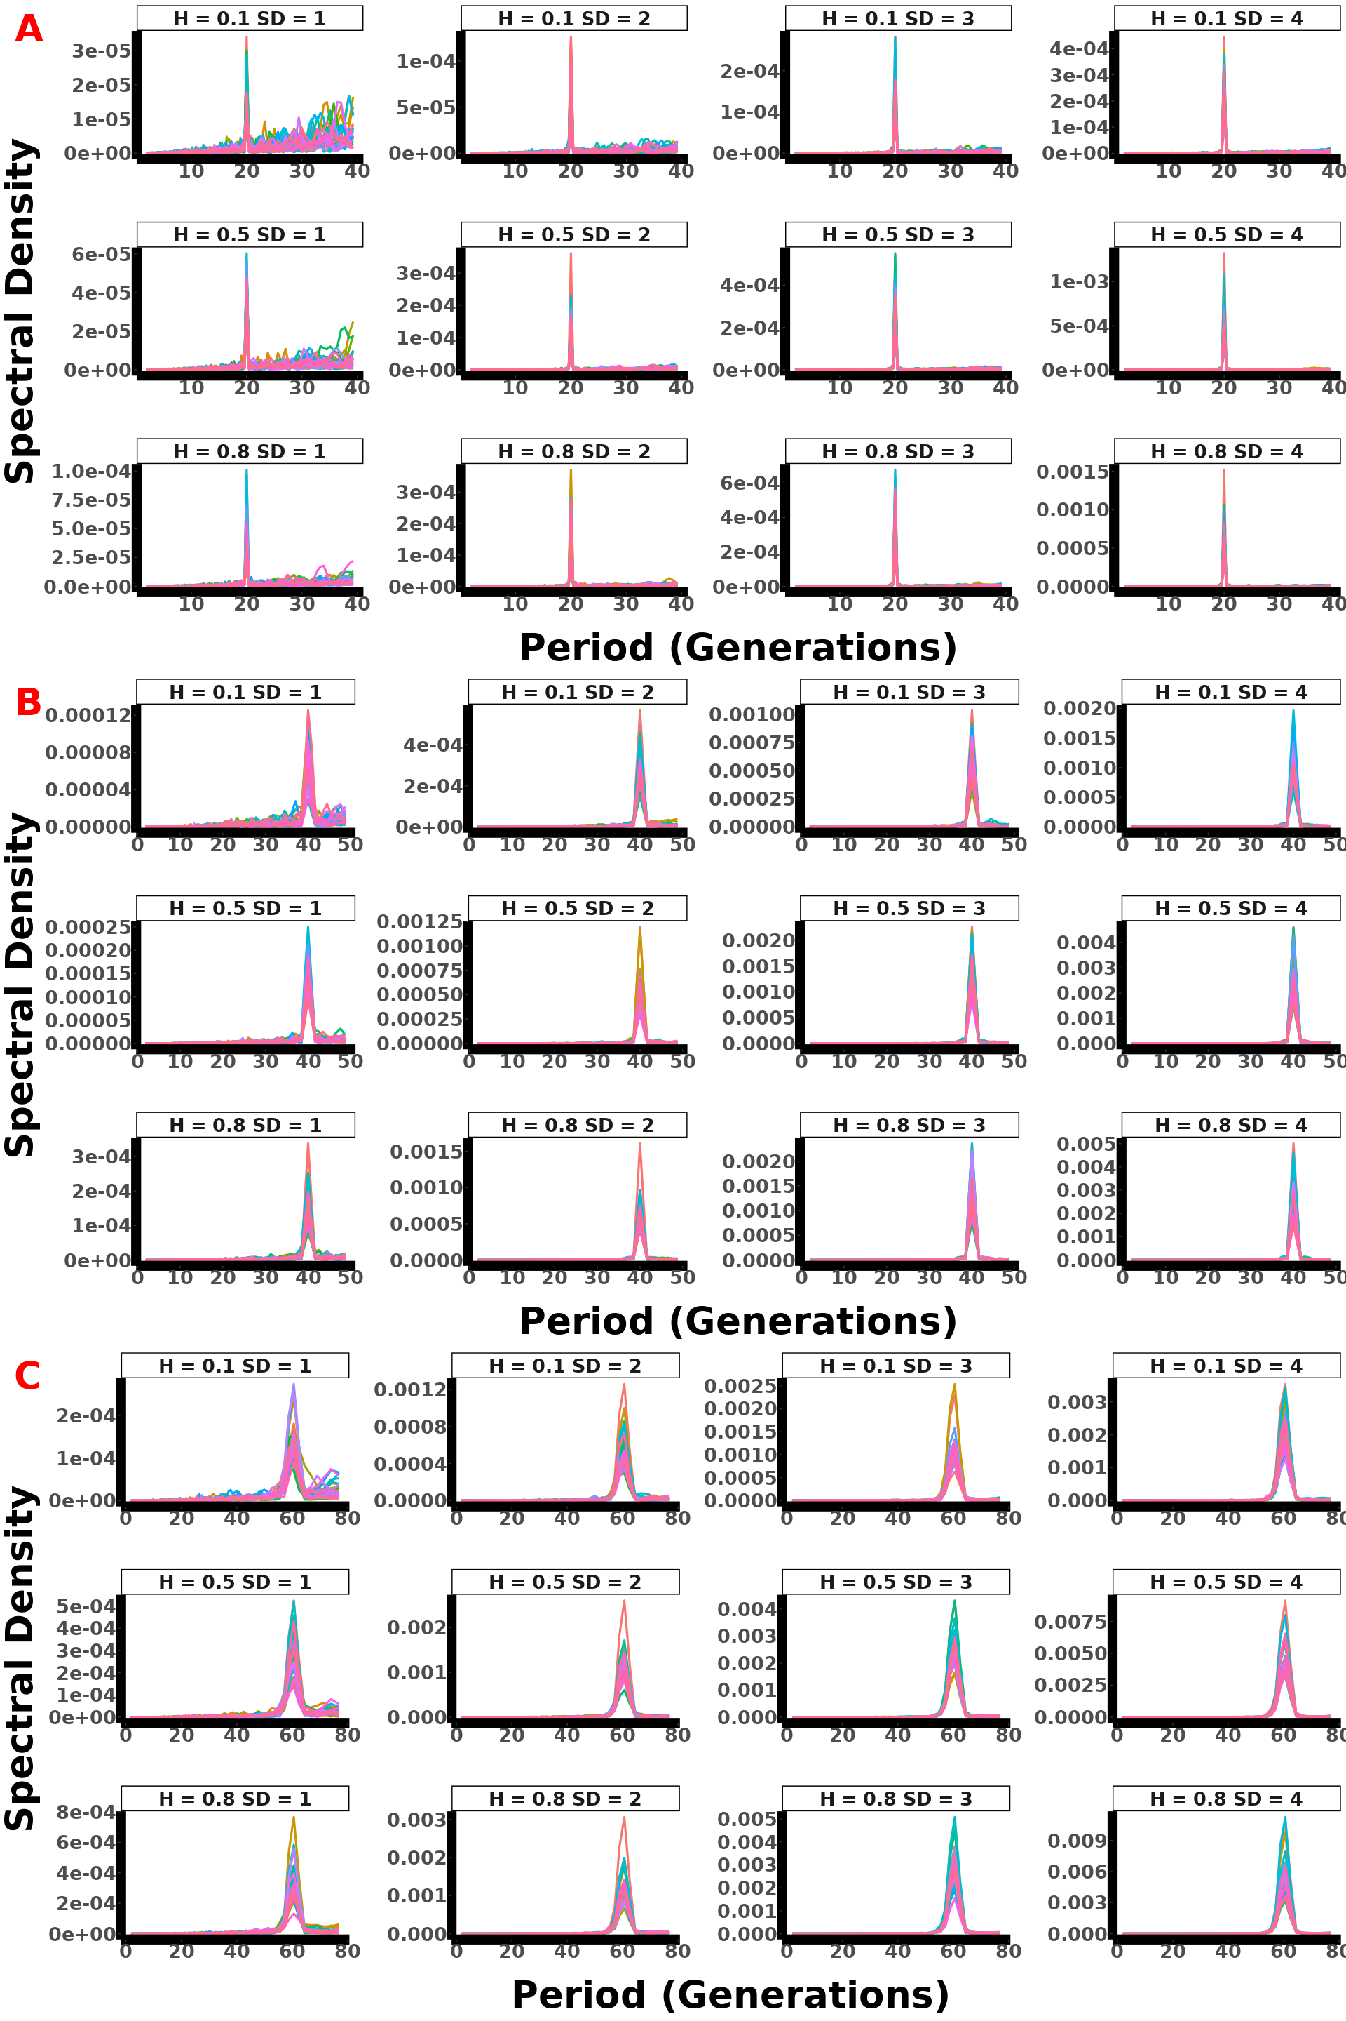

Figure: Polygenic (70 loci) spectral density plot across 30 replicates for gradual two equal seasons selection, showing parameter interactions with A representing a selection lasting 10 generations, B 20 generations, and C 30 generations.

#### 2.3.4. Polygenic 100

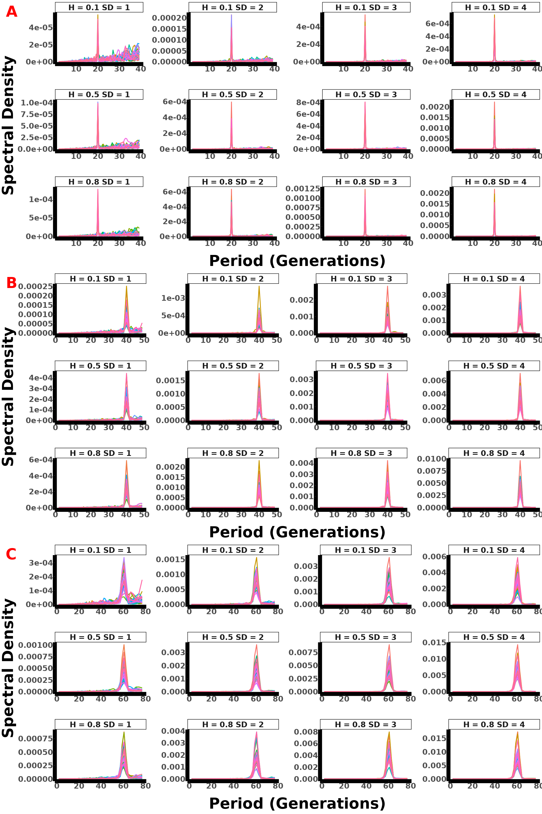

Figure: Polygenic (100 loci) spectral density plot across 30 replicates for gradual two equal seasons selection, showing parameter interactions with A representing a selection lasting 10 generations, B 20 generations, and C 30 generations.

#### 2.3.5. Polygenic 300

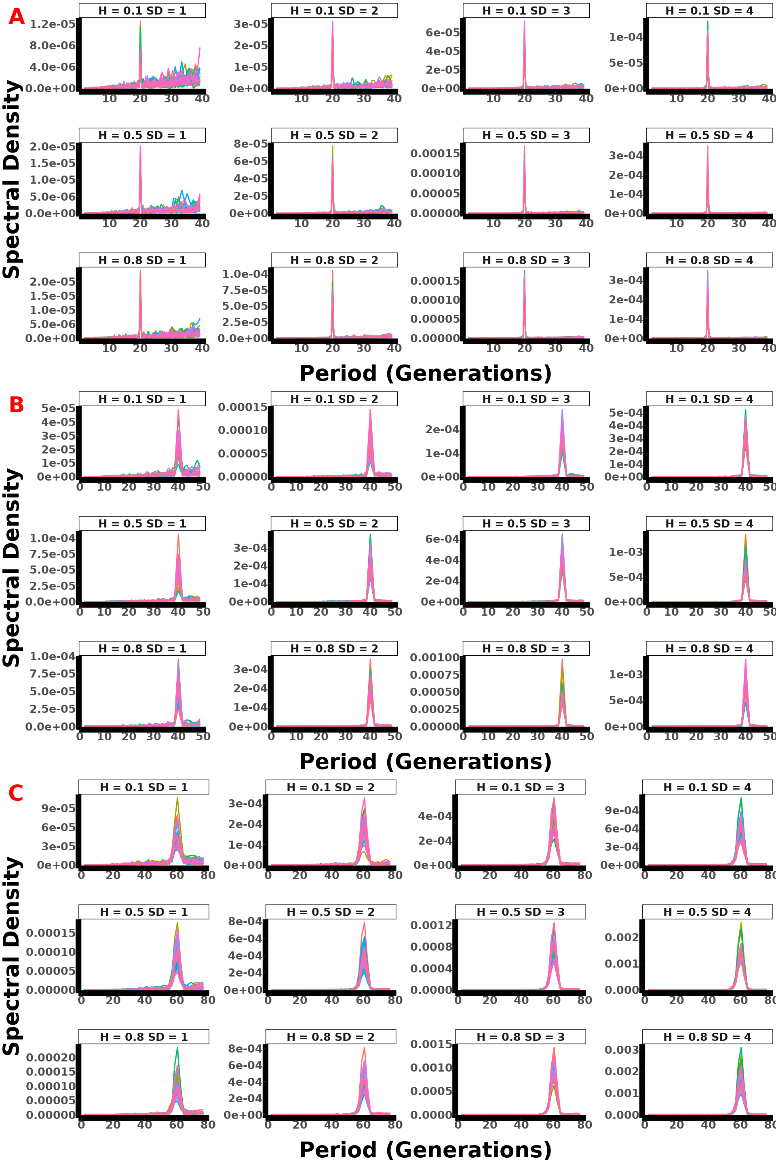

Figure: Polygenic (300 loci) spectral density plot across 30 replicates for gradual two equal seasons selection, showing parameter interactions with A representing a selection lasting 10 generations, B 20 generations, and C 30 generations.

## 3. Gradual II model

### 3.1. AF All param & Single replicate

#### 3.1.1. Monogenic

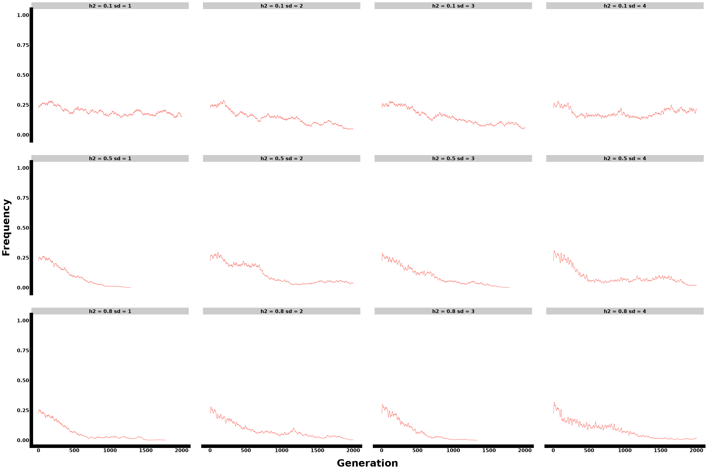

Figure: Monogenic single replicate allele frequency plot for gradual four unequal seasons selection, showing parameter interactions.

#### 3.1.2. Oligogenic

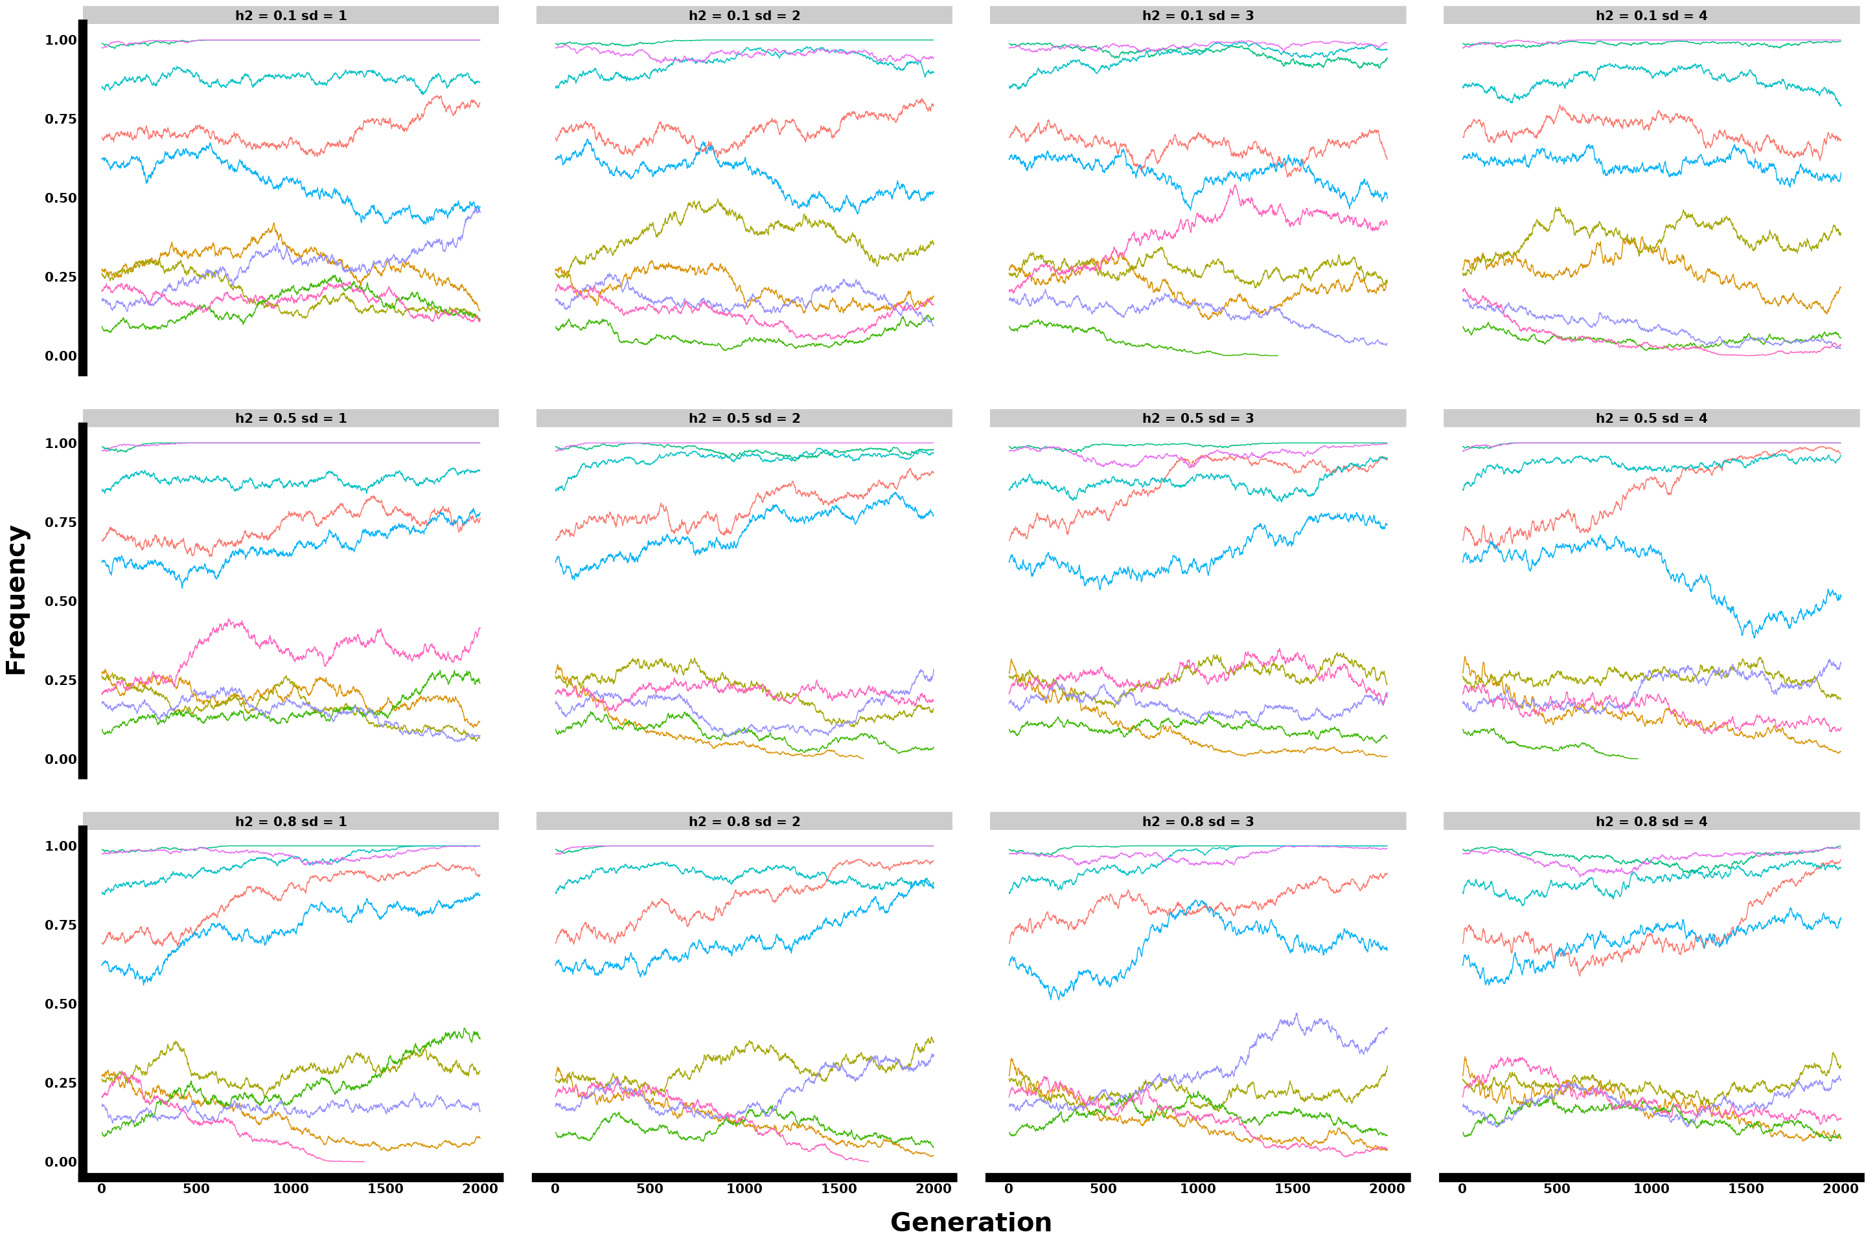

Figure: Oligogenic single replicate allele frequency plot for gradual four unequal seasons selection, showing parameter interactions.

#### 3.1.3. Polygenic 70 loci

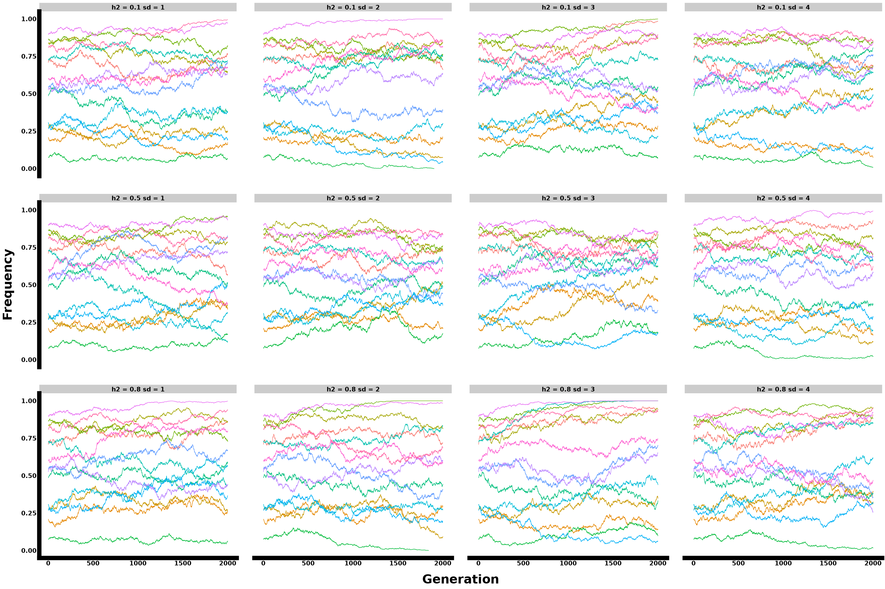

Figure: Polygenic single replicate allele frequency plot with 15 loci sampled from 70 genomic architecture for gradual four unequal seasons selection, showing parameter interactions.

#### 3.1.4. Polygenic 100 loci

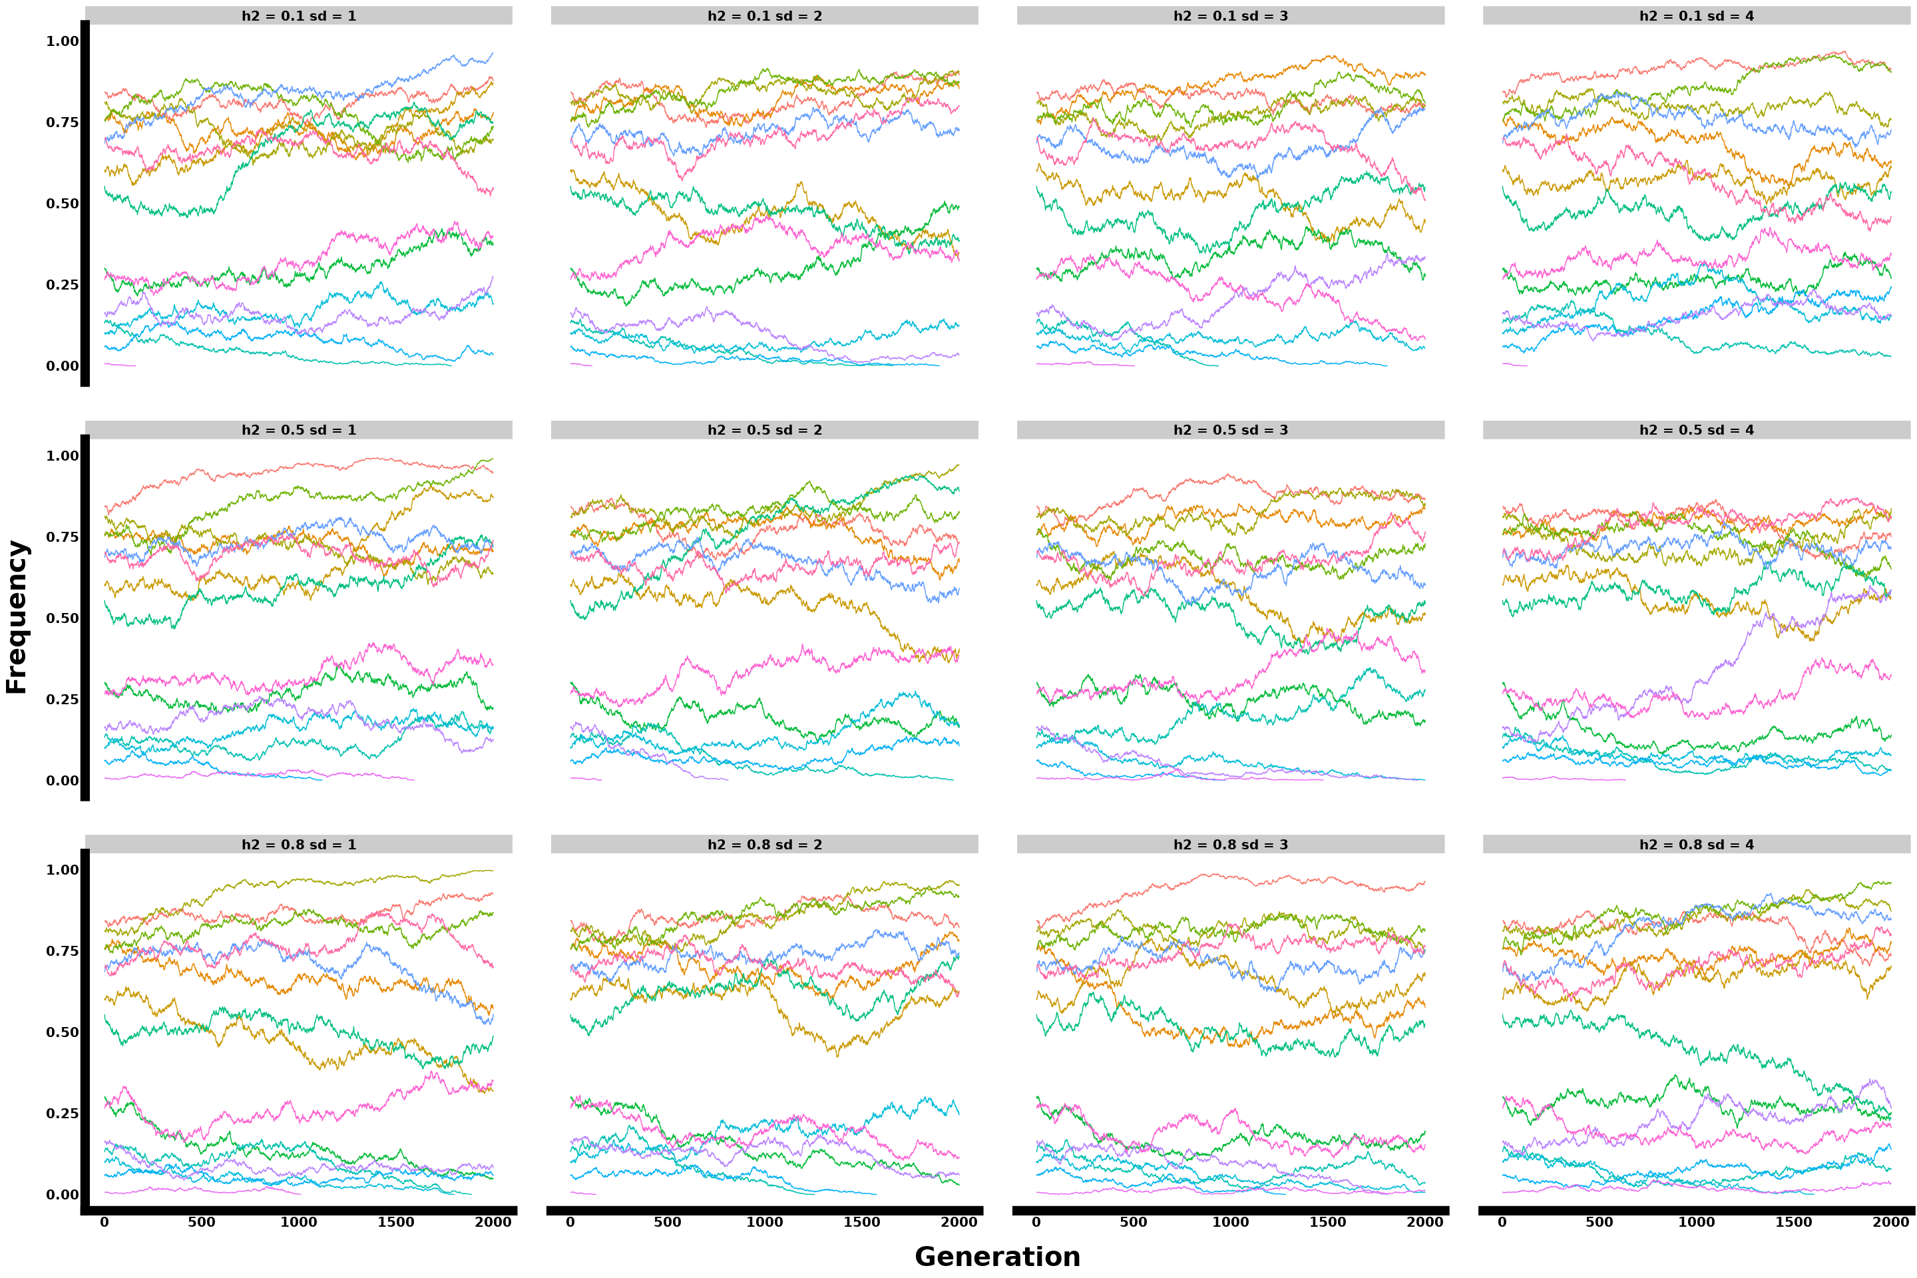

Figure: Polygenic single replicate allele frequency plot with 15 loci sampled from 100 genomic architecture for gradual four unequal seasons selection, showing parameter interactions.

#### 3.1.5. Polygenic 300 loci

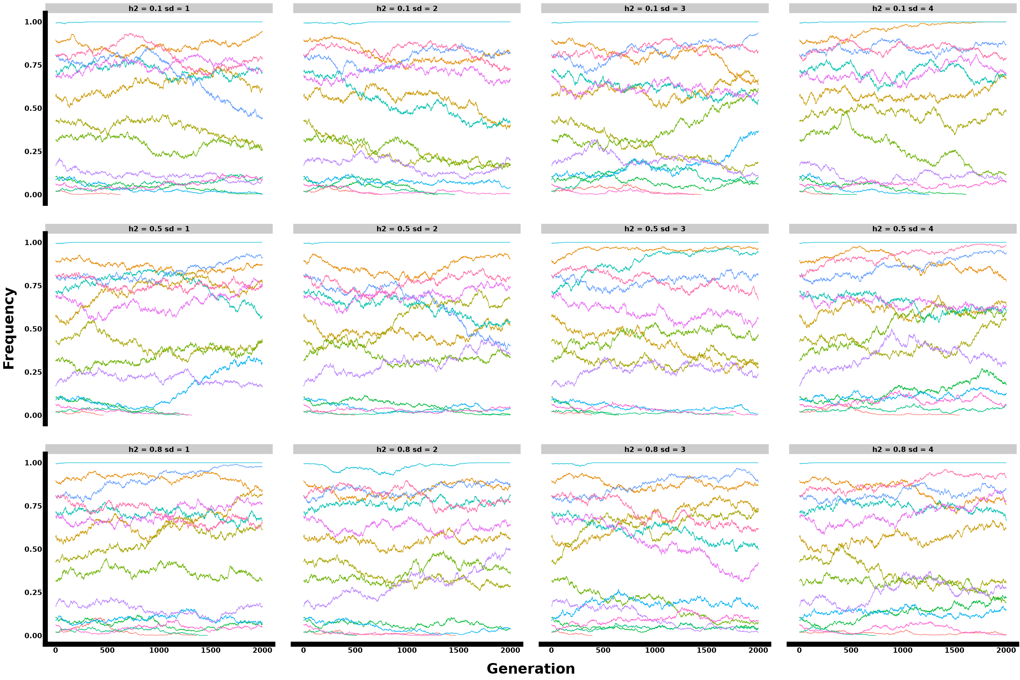

Figure: Polygenic single replicate allele frequency plot with 15 loci sampled from 300 genomic architecture for gradual four unequal seasons selection, showing parameter interactions.

### 3.2. Phenotypes all params

#### 3.2.1. Monogenic

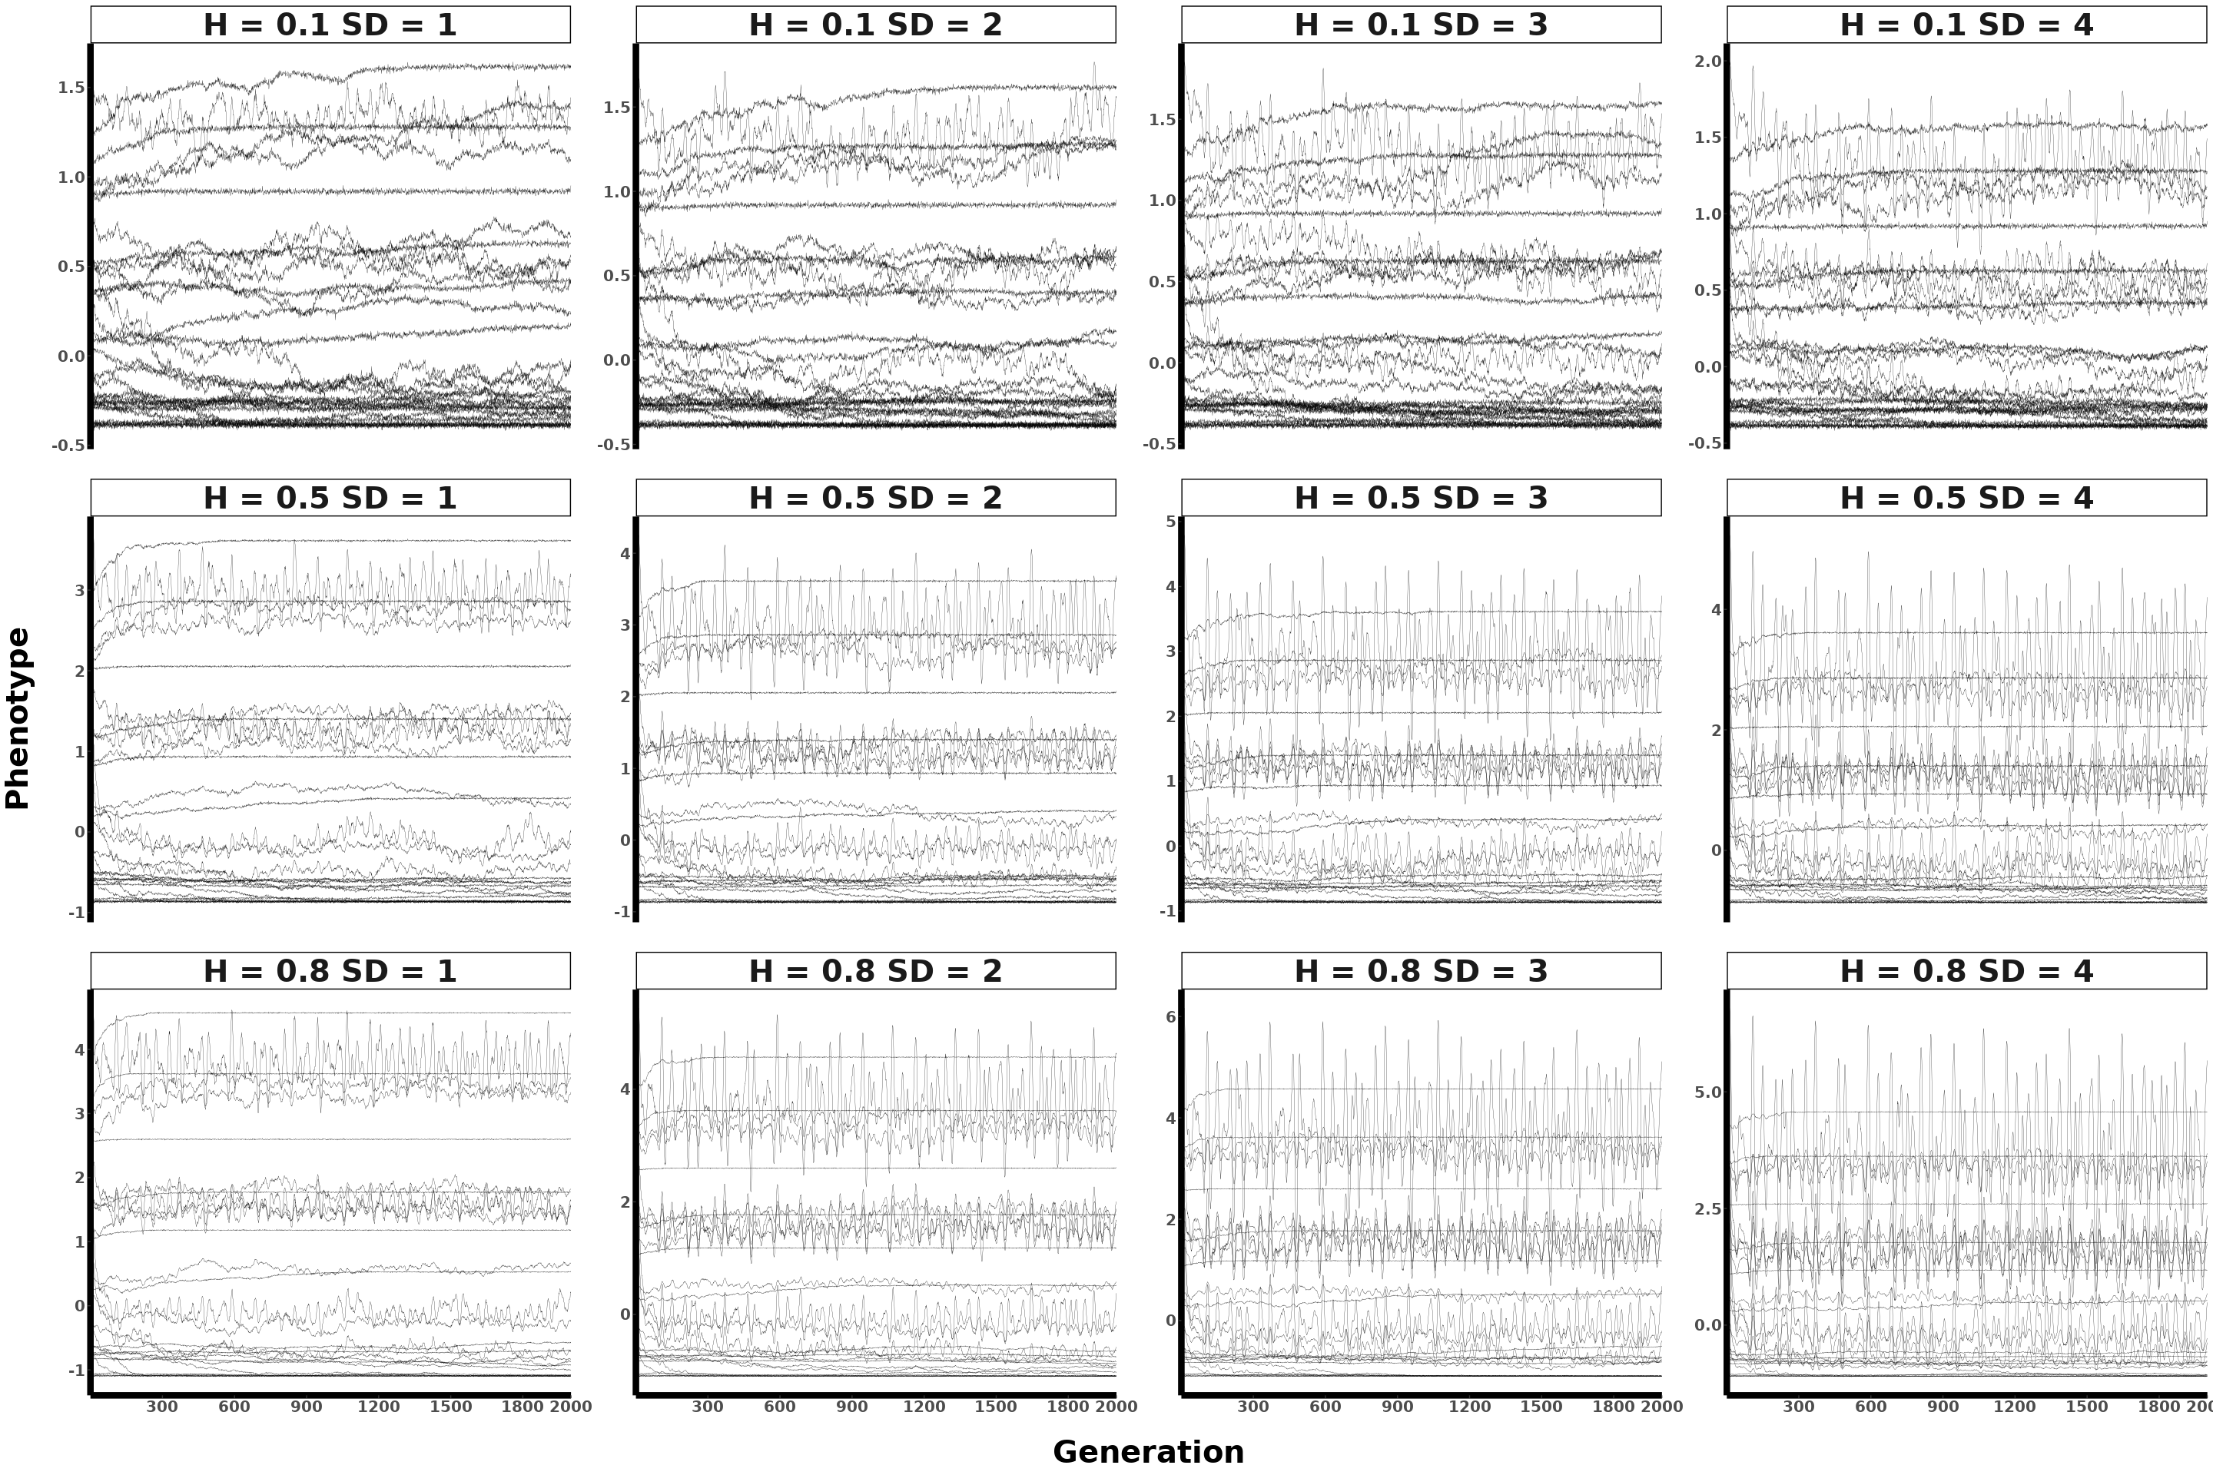

Figure: Monogenic mean population phenotypic plot across 30 replicates (each line represents a single replicate) for gradual four unequal seasons selection, showing parameter interactions.

#### 3.2.2. Oligogenic

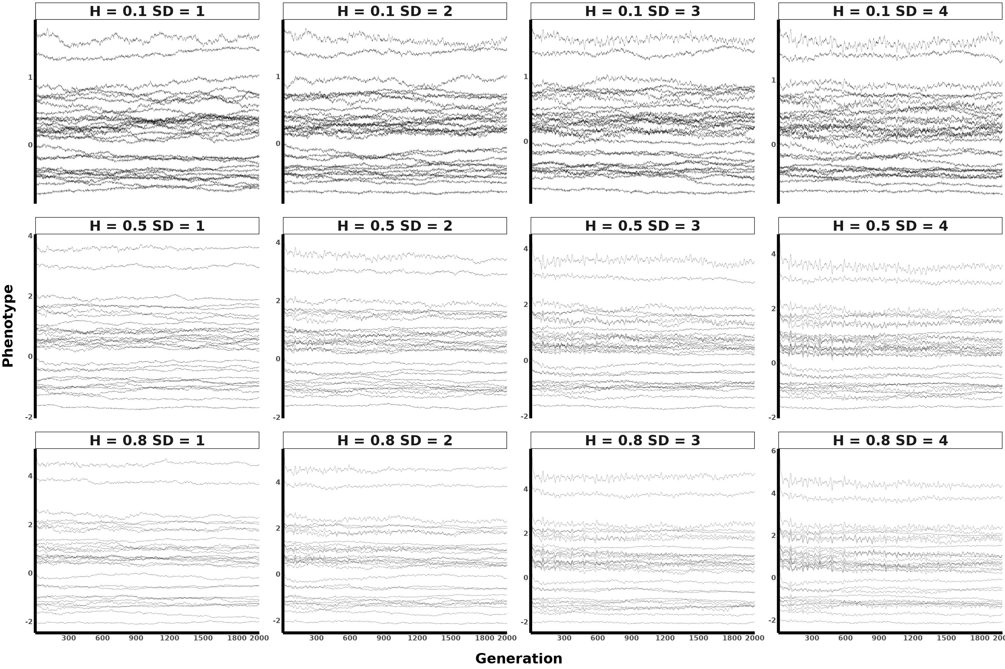

Figure: Oligogenic mean population phenotypic plot across 30 replicates (each line represents a single replicate) for gradual four unequal seasons selection, showing parameter interactions.

#### 3.2.3. Polygenic 70

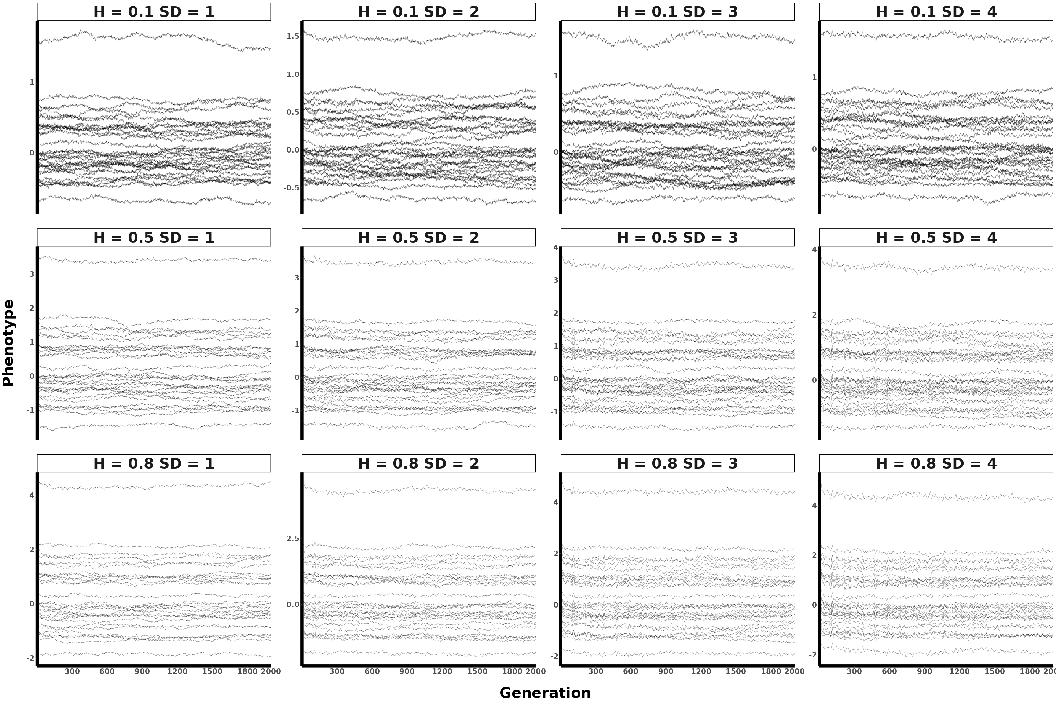

Figure: Polygenic (70 loci) mean population phenotypic plot across 30 replicates (each line represents a single replicate) for gradual four unequal seasons selection, showing parameter interactions.

#### 3.2.4. Polygenic 100

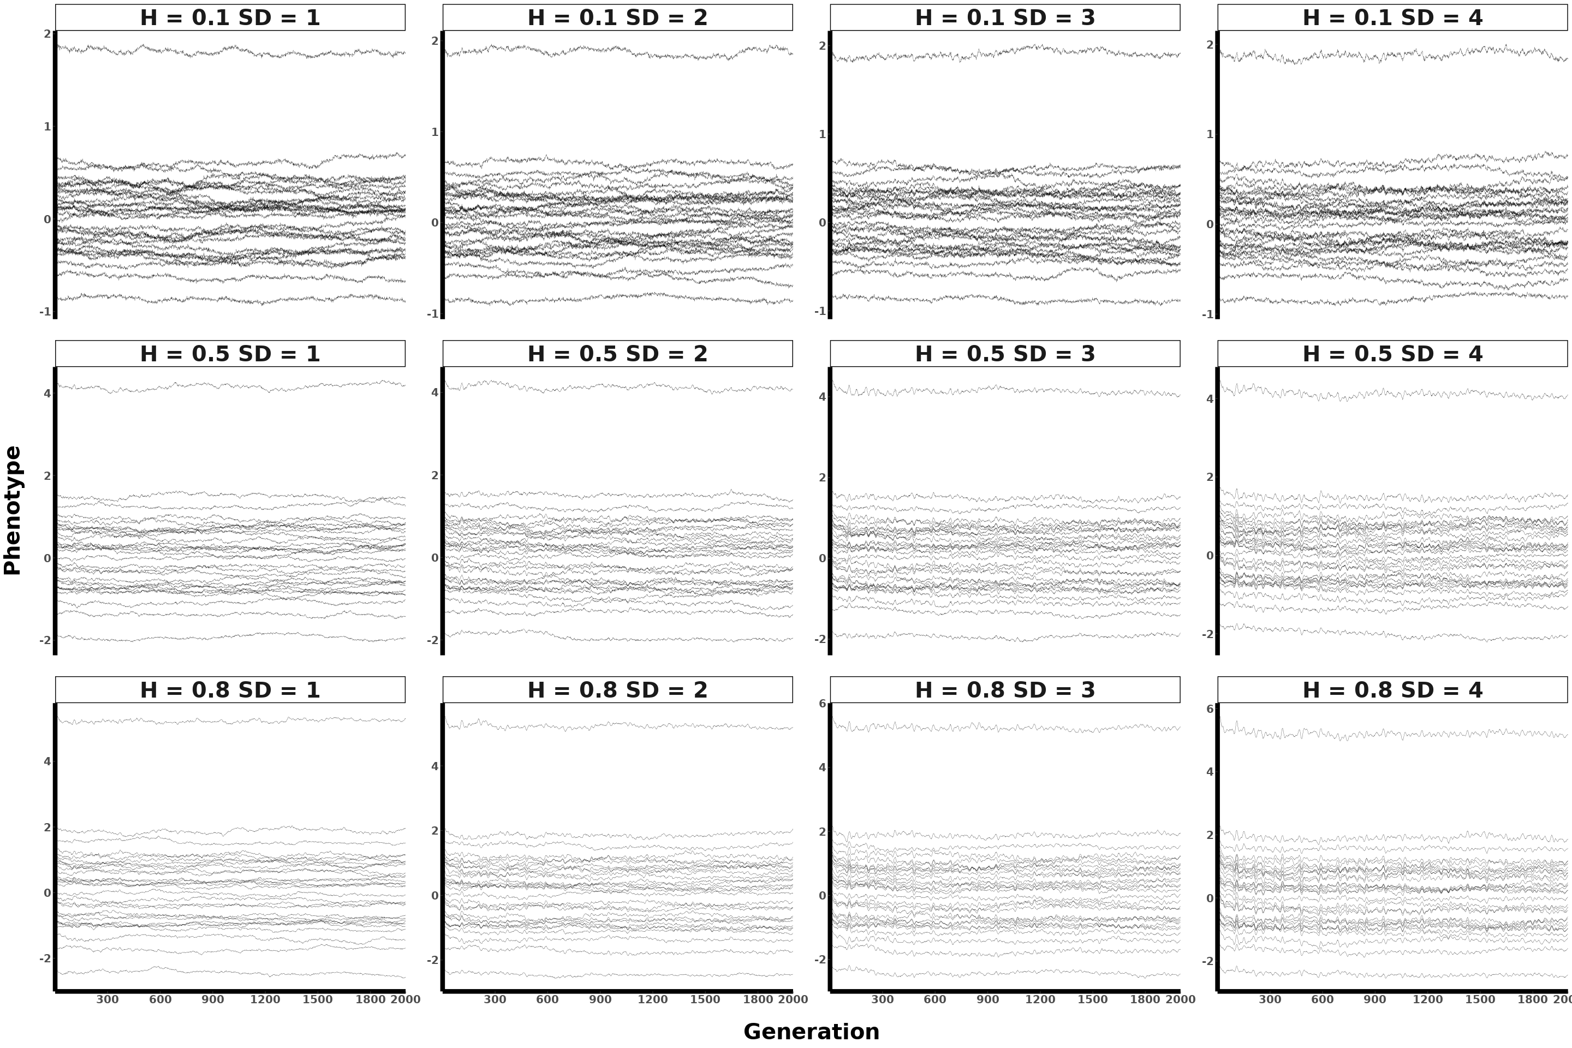

Figure: Polygenic (100 loci) mean population phenotypic plot across 30 replicates (each line represents a single replicate) for gradual four unequal seasons selection, showing parameter interactions.

#### 3.2.5. Polygenic 300

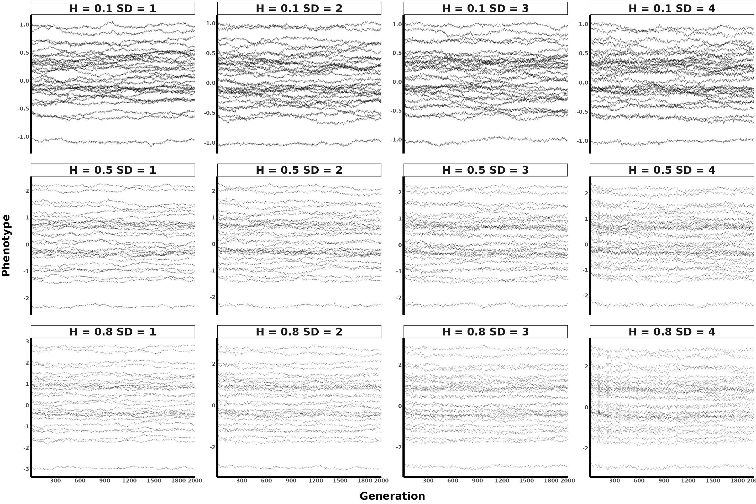

Figure: Polygenic (300 loci) mean population phenotypic plot across 30 replicates (each line represents a single replicate) for gradual four unequal seasons selection, showing parameter interactions.

### 3.3. Spec All params

#### 3.3.1. Monogenic

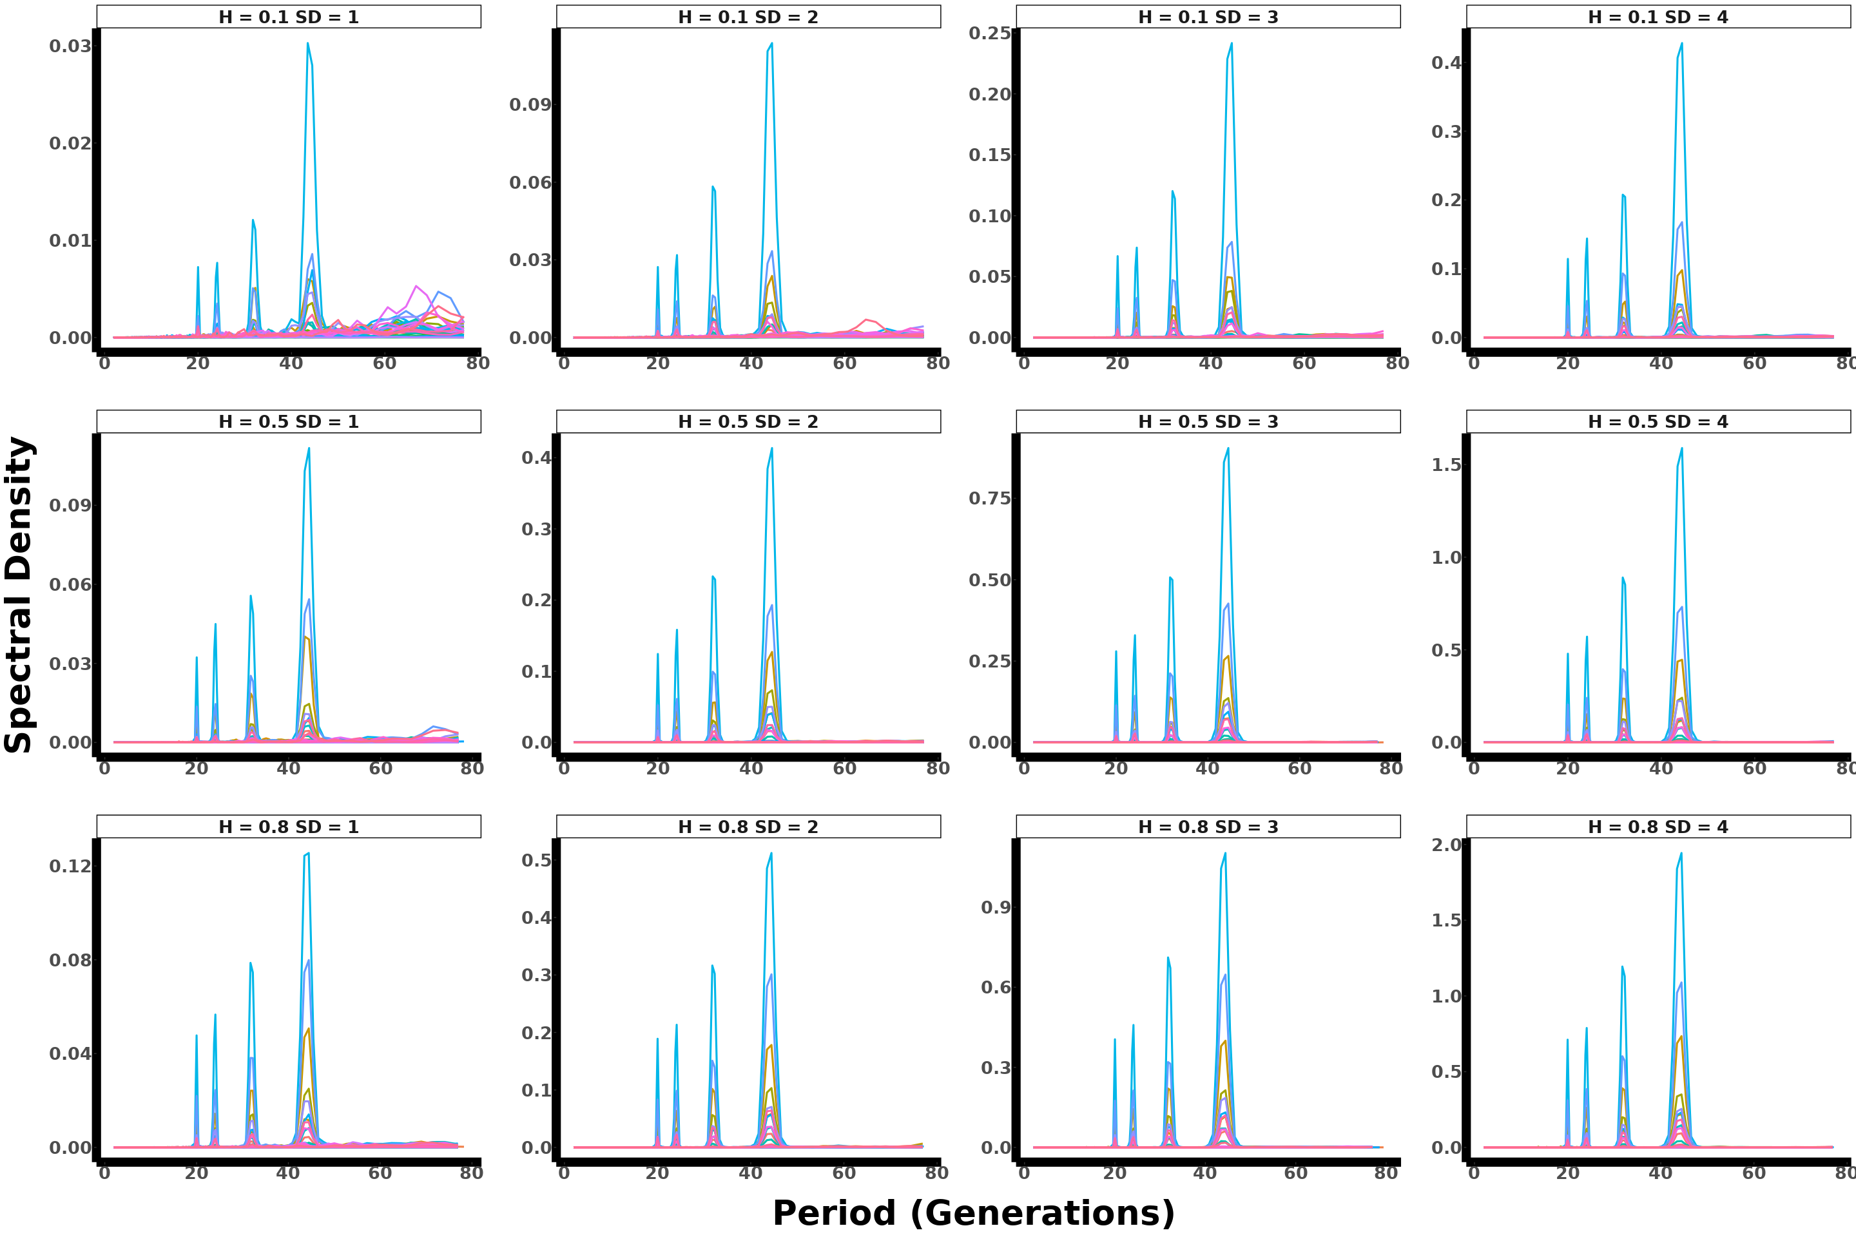

Figure: Monogenic spectral density plot across 30 replicates for gradual four unequal seasons selection, showing parameter interactions.

#### 3.3.2. Oligogenic

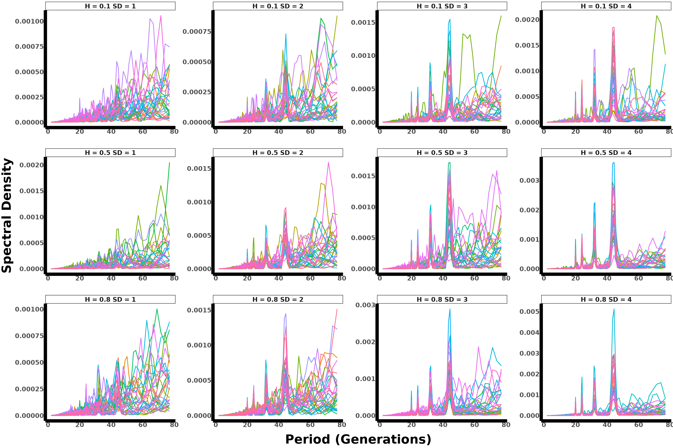

Figure: Oligogenic spectral density plot across 30 replicates for gradual four unequal seasons selection, showing parameter interactions.

#### 3.3.3. Polygenic 70

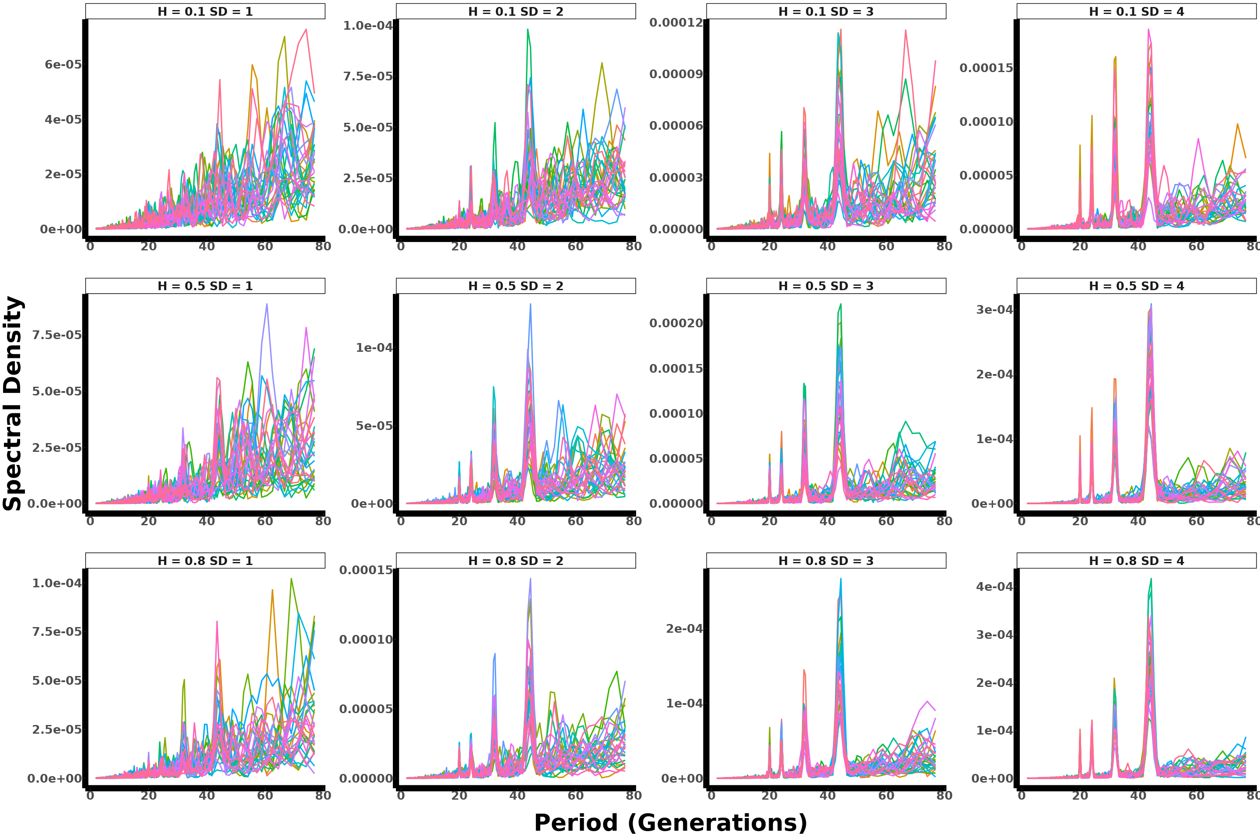

Figure: Polygenic (70 loci) spectral density plot across 30 replicates for gradual four unequal seasons selection, showing parameter interactions.

#### 3.3.4. Polygenic 100

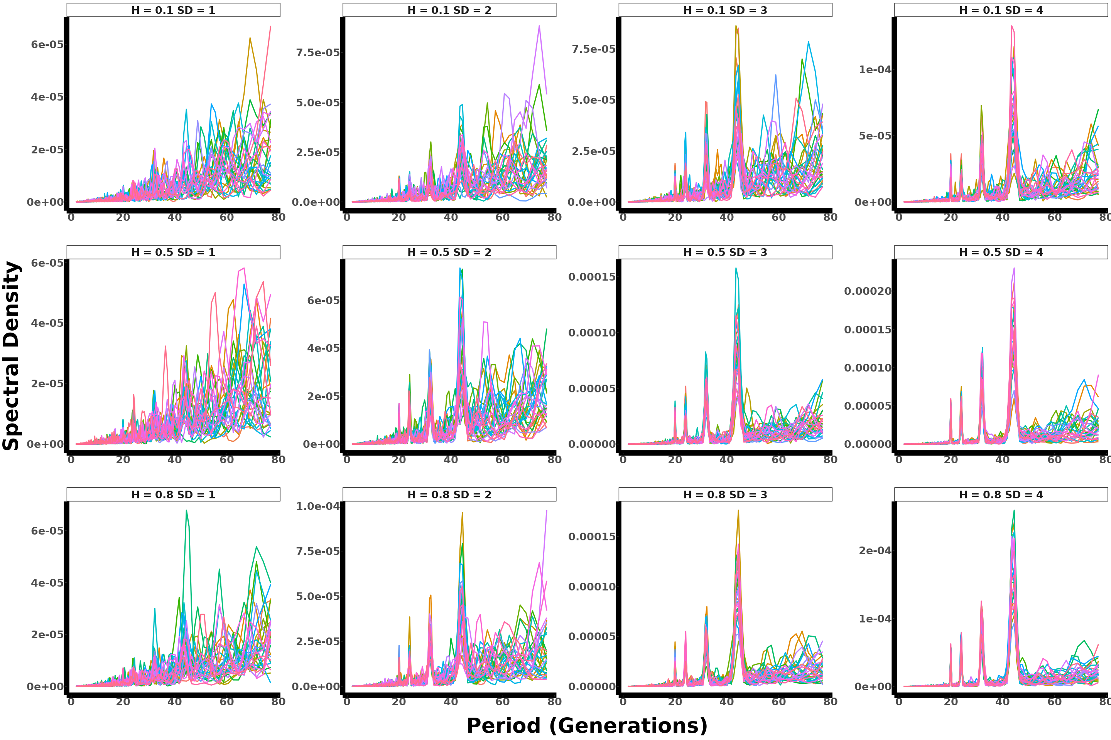

Figure: Polygenic (100 loci) spectral density plot across 30 replicates for gradual four unequal seasons selection, showing parameter interactions.

#### 3.3.5. Polygenic 300

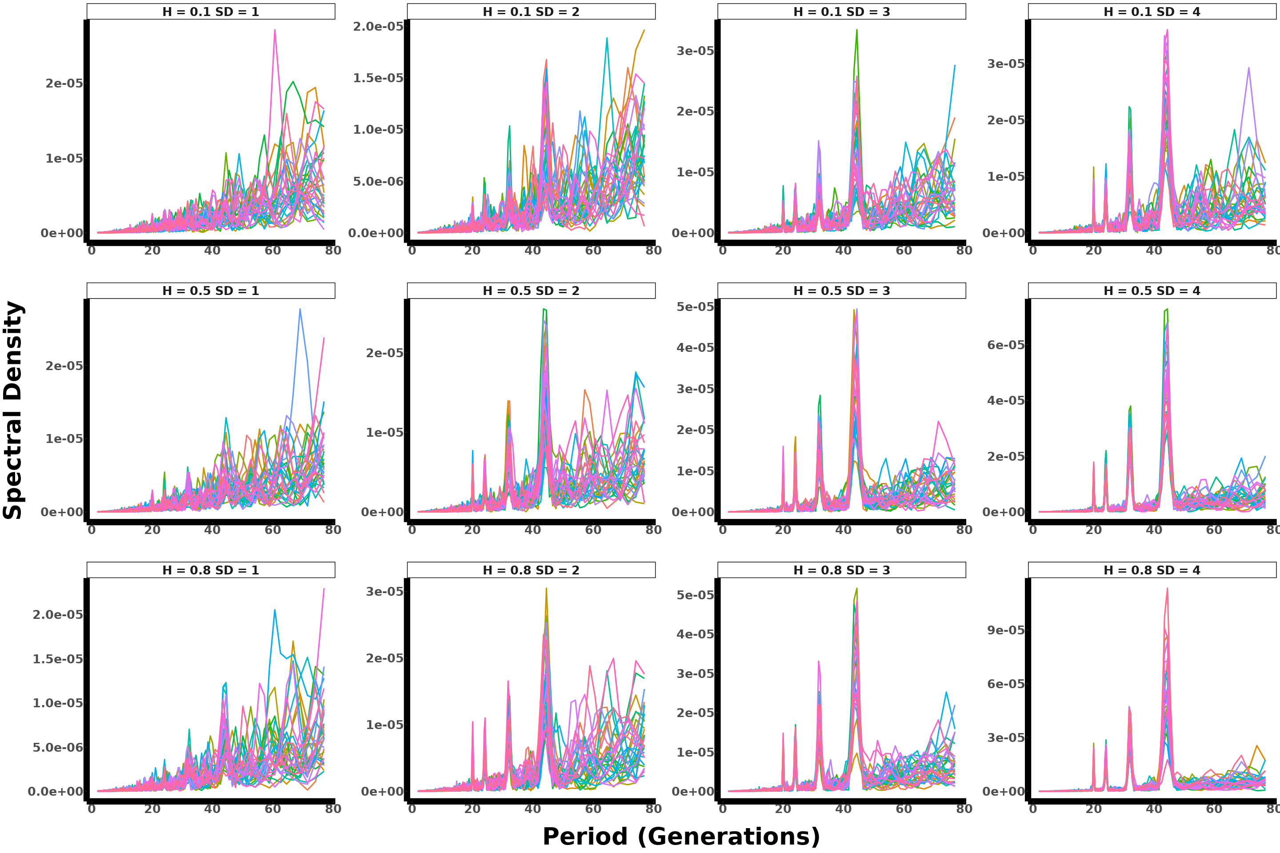

Figure: Polygenic (300 loci) spectral density plot across 30 replicates for gradual four unequal seasons selection, showing parameter interactions.

## 4. Constant model

### 4.1. AF All param & Single replicate

#### 4.1.1. Monogenic

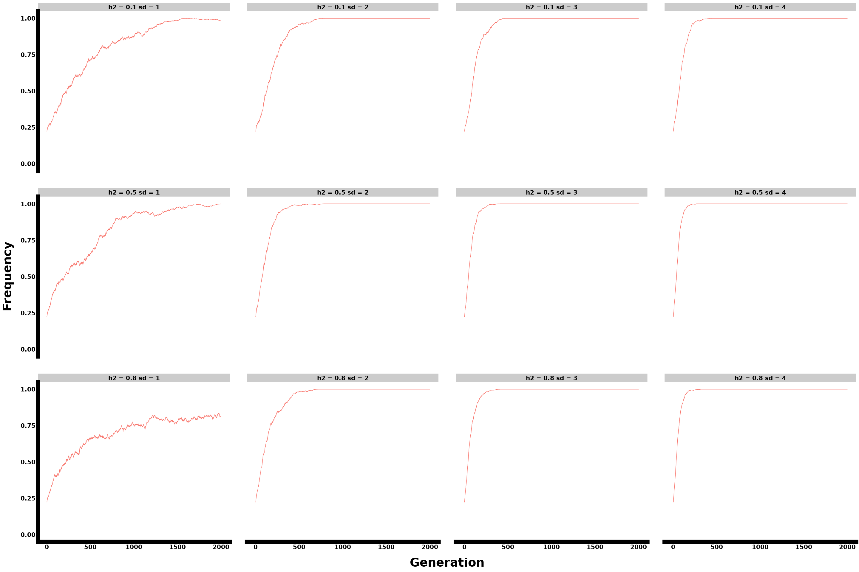

Figure: Monogenic single replicate allele frequency plot for constant selection, showing parameter interactions.

#### 4.1.2. Oligogenic

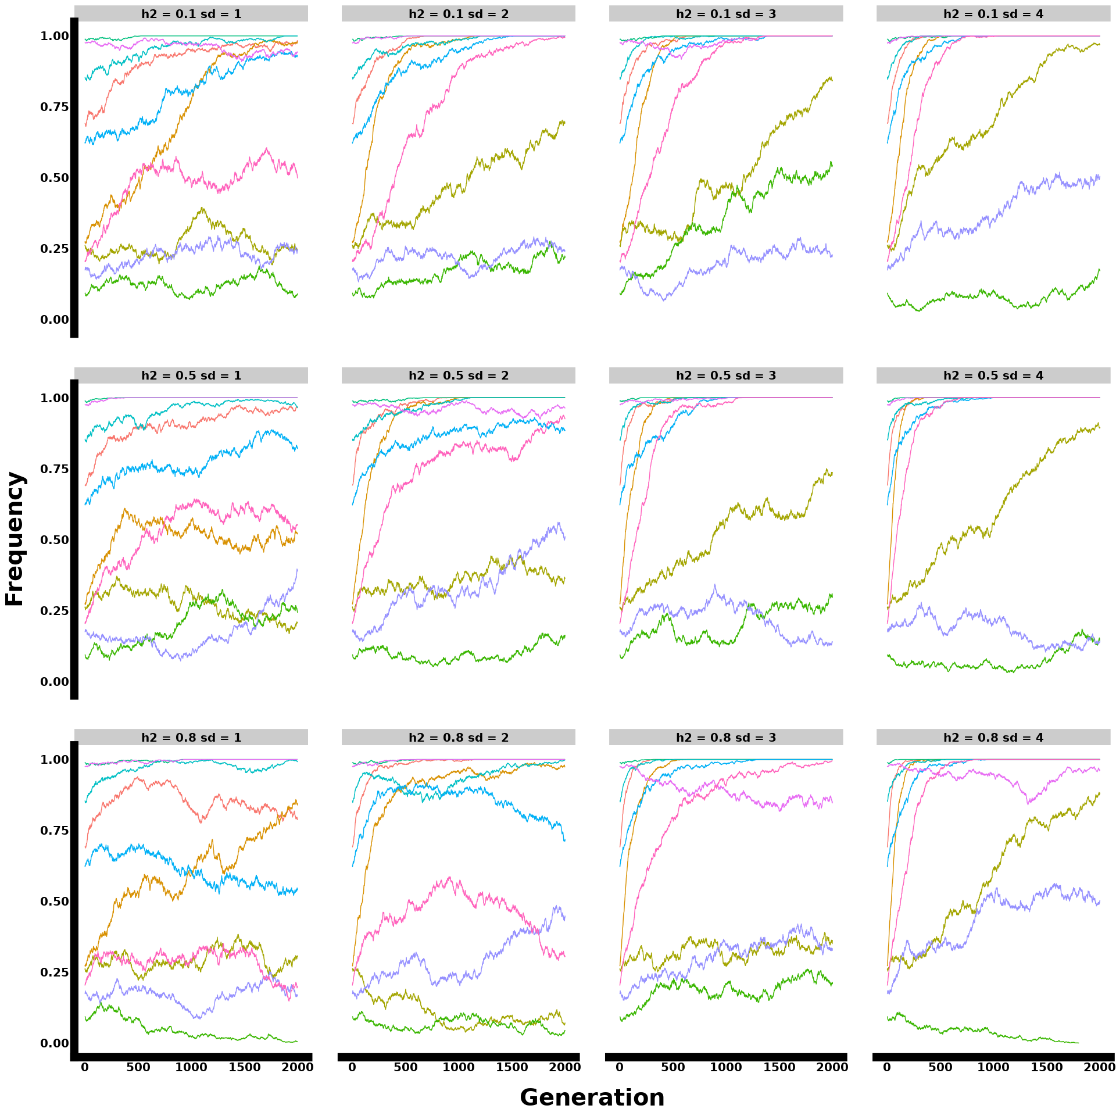

Figure: Oligogenic single replicate allele frequency plot for constant selection, showing parameter interactions.

#### 4.1.3. Polygenic 70 loci

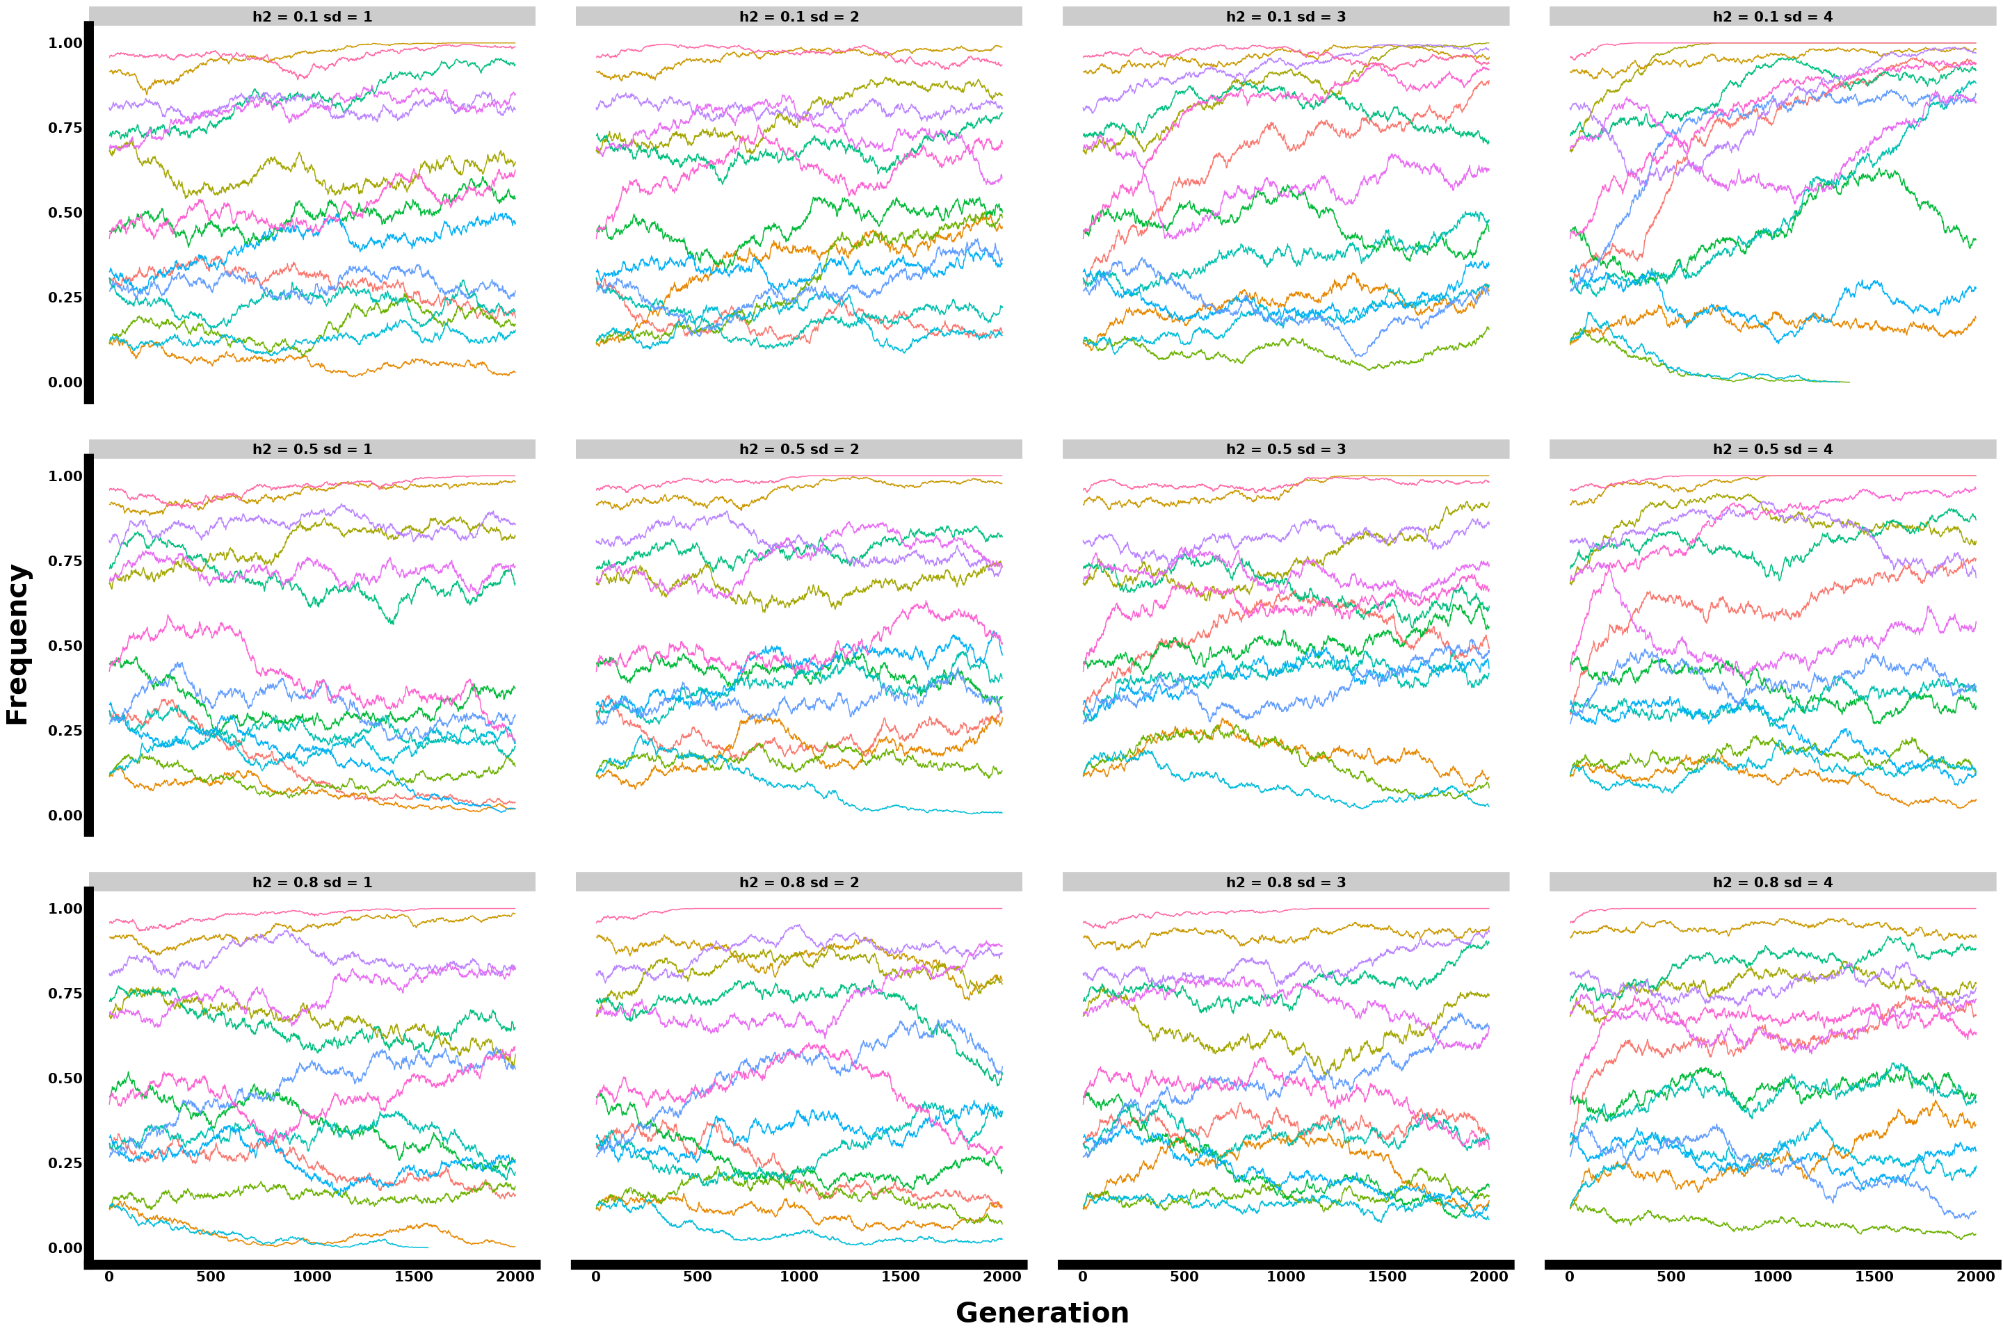

Figure: Polygenic single replicate allele frequency plot with 15 loci sampled from 70 genomic architecture for constant selection, showing parameter interactions.

#### 4.1.4. Polygenic 100 loci

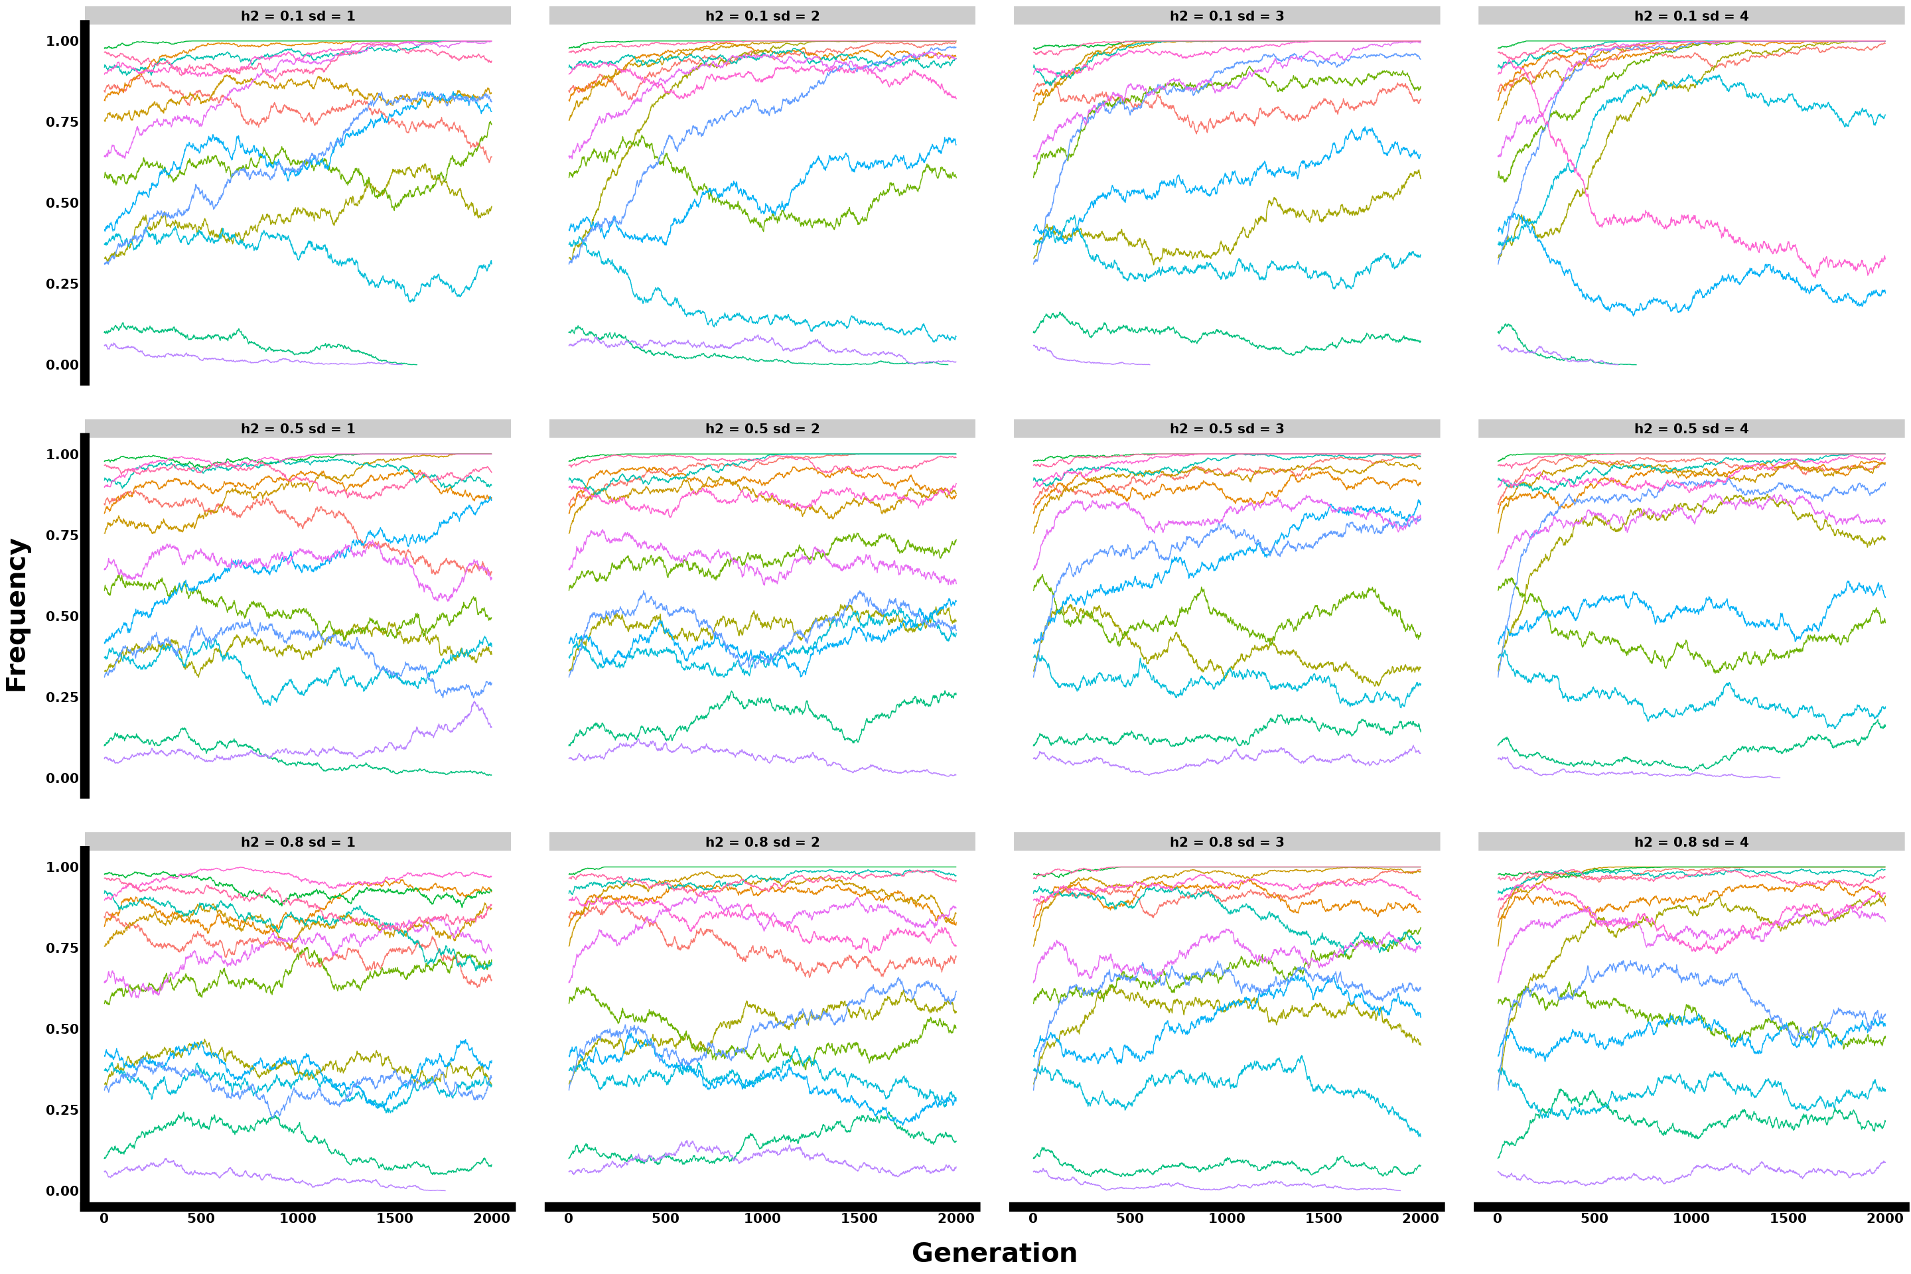

Figure:Figure: Polygenic single replicate allele frequency plot with 15 loci sampled from 100 genomic architecture for constant selection, showing parameter interactions.

#### 4.1.5. Polygenic 300 loci

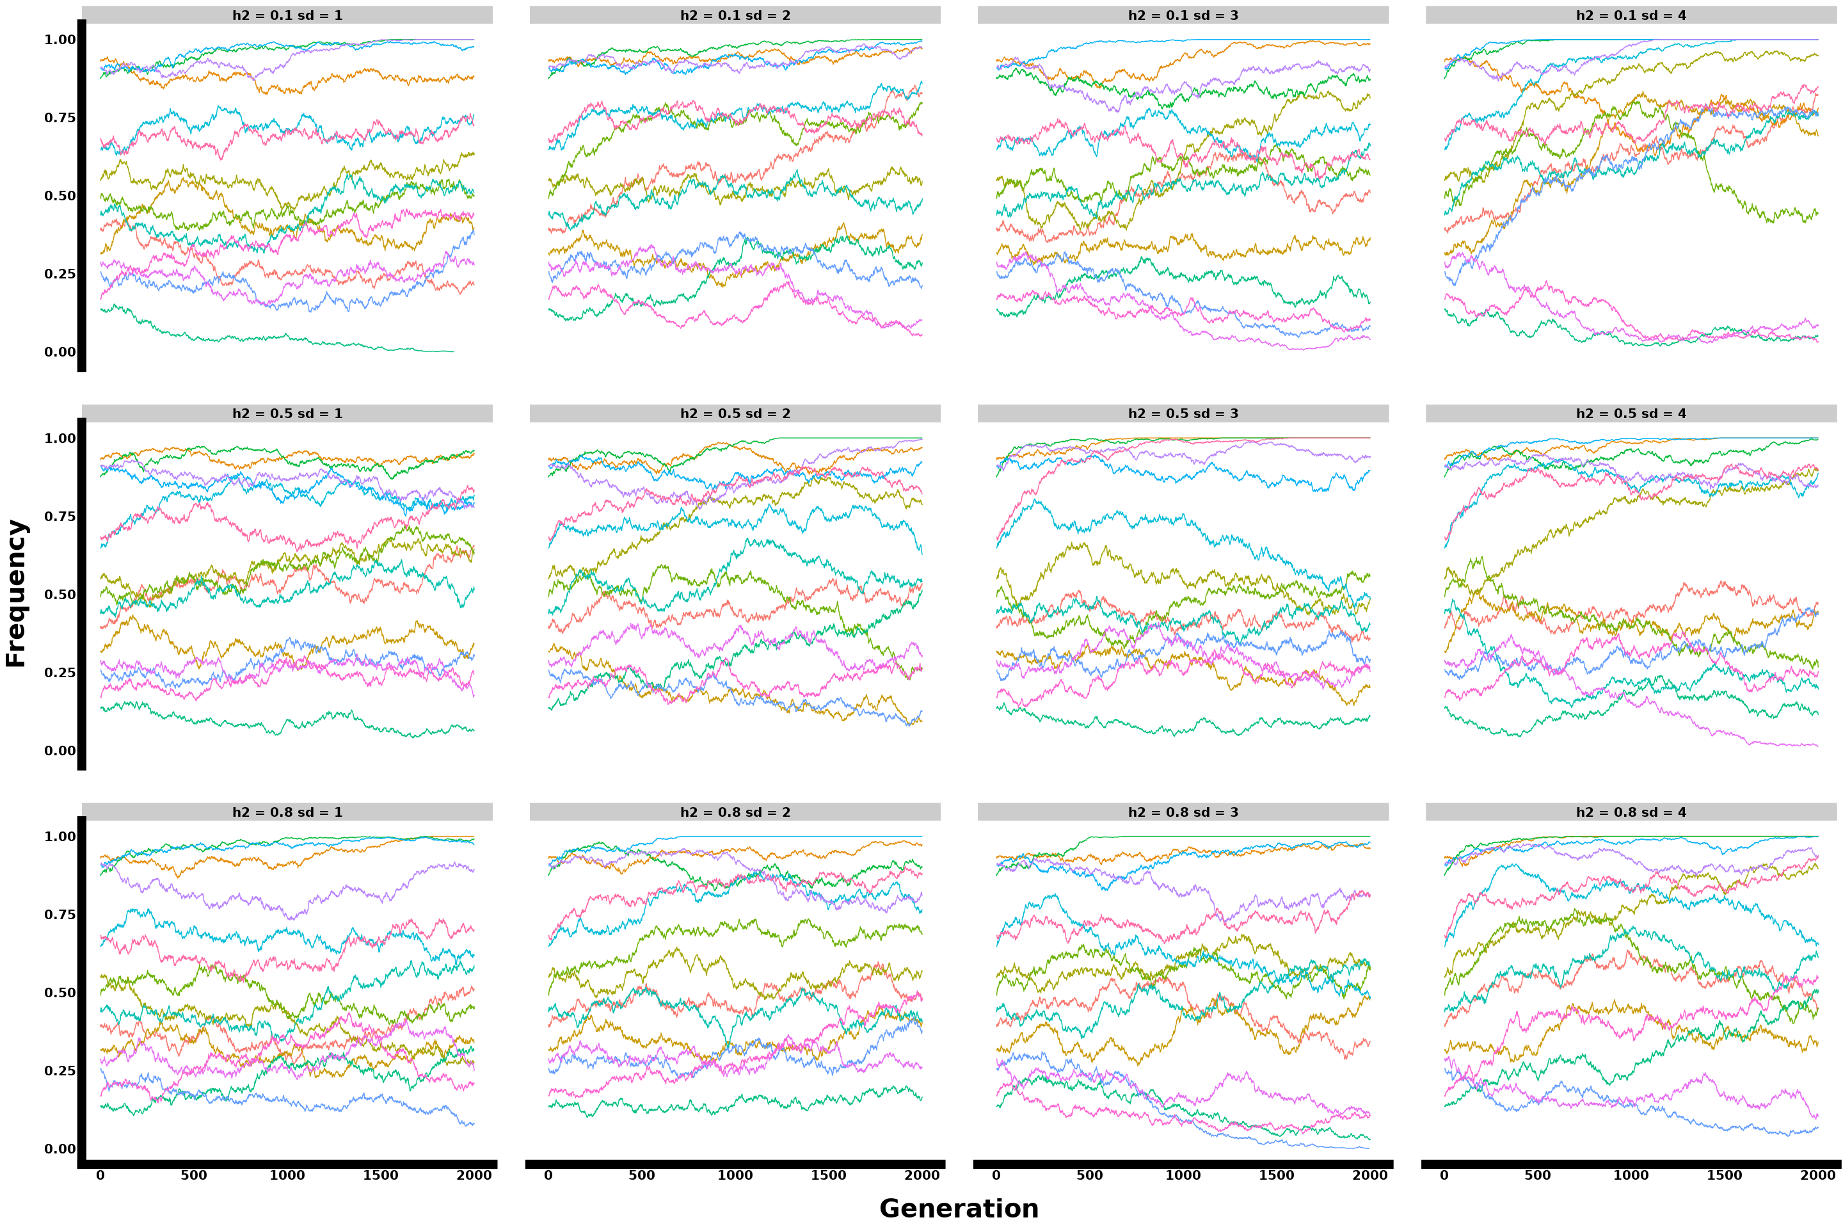

Figure: Polygenic single replicate allele frequency plot with 15 loci sampled from 300 genomic architecture for constant selection, showing parameter interactions.

### 4.2. Phenotypes all params

#### 4.2.1. Monogenic

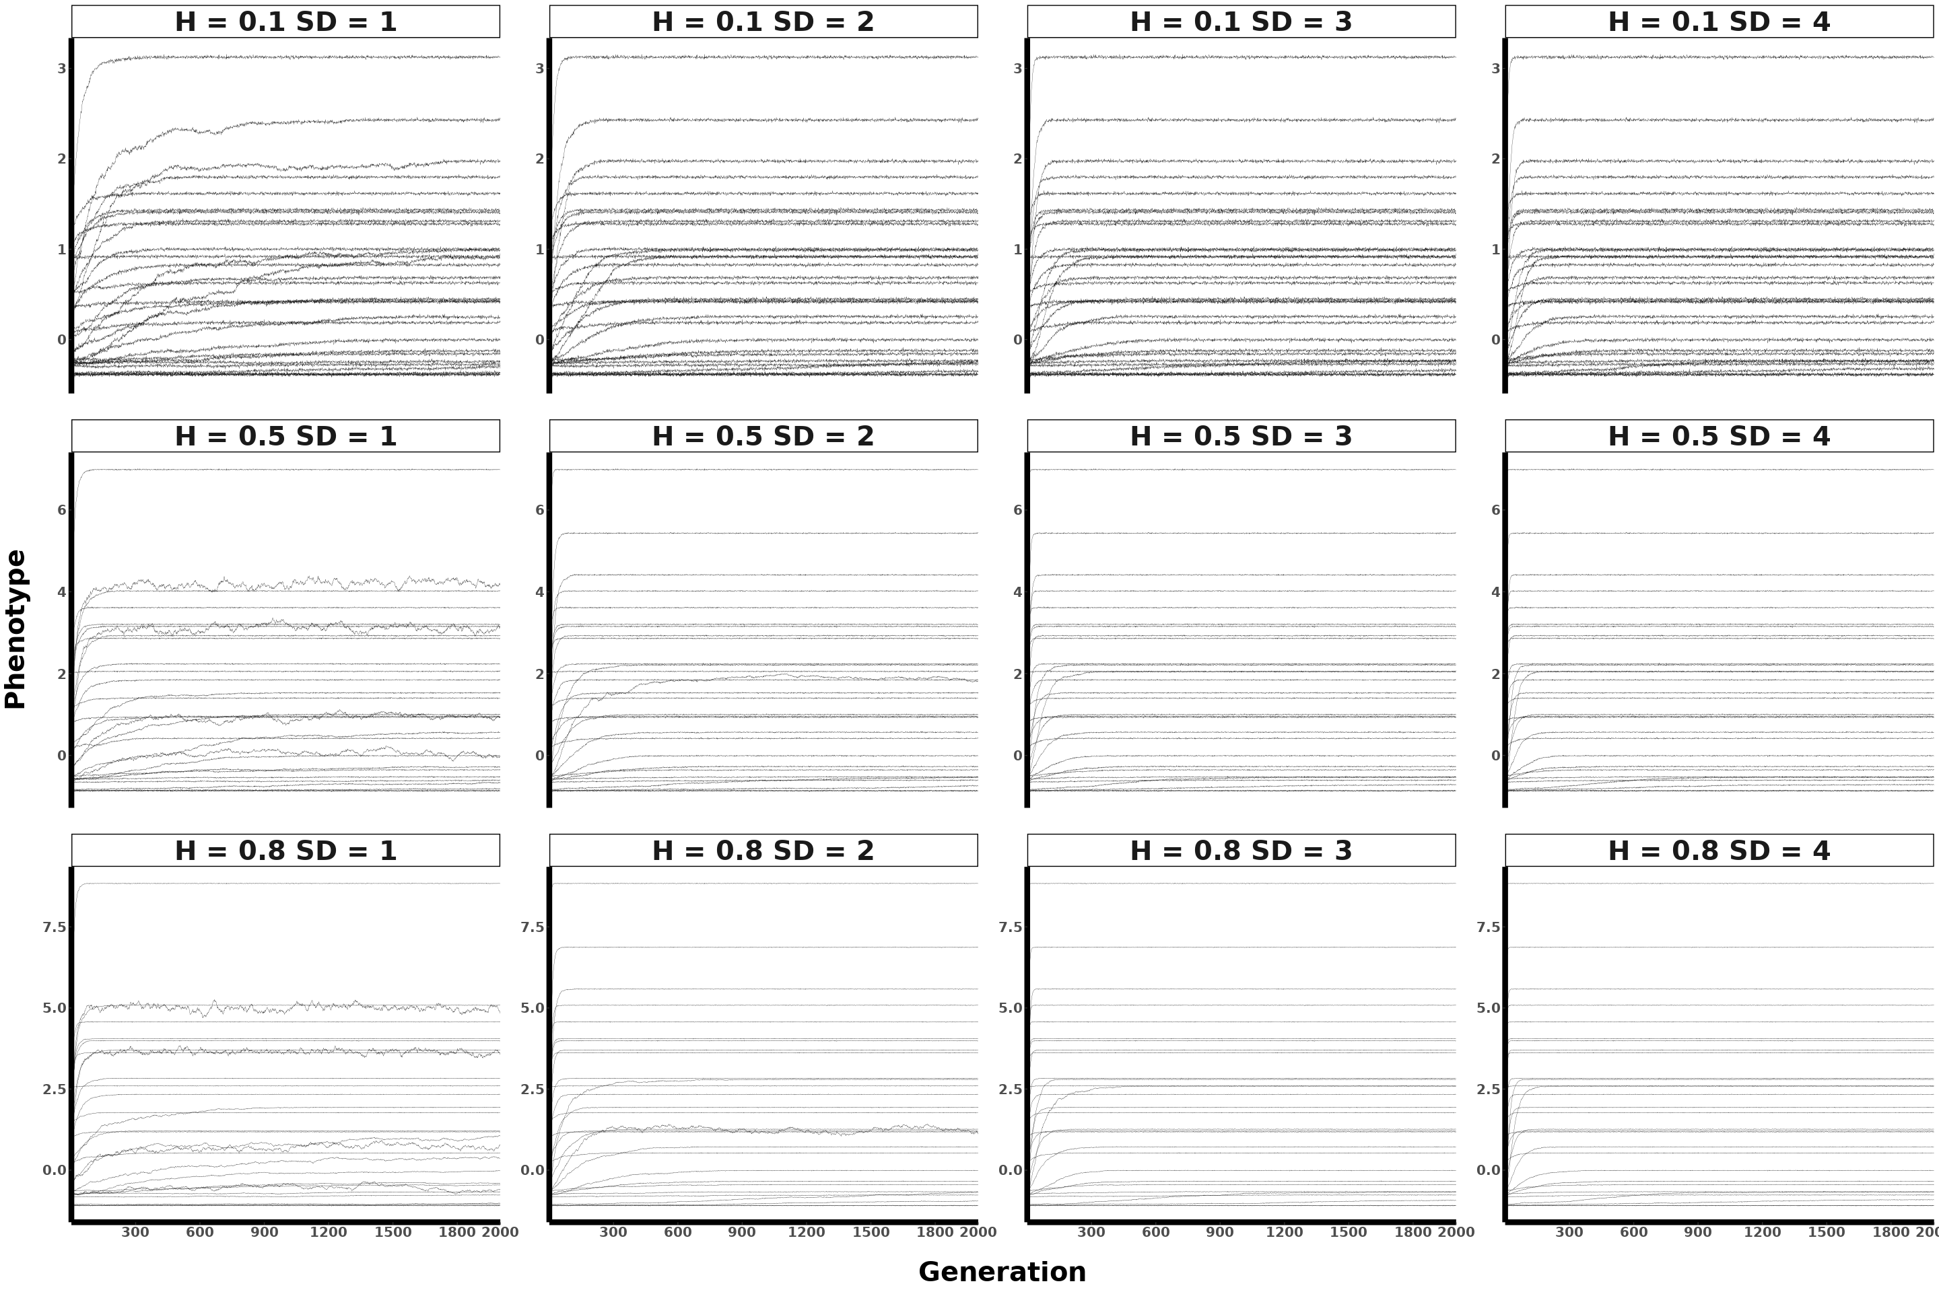

Figure: Monogenic mean population phenotypic plot across 30 replicates (each line represents a single replicate) for constant selection, showing parameter interactions.

#### 4.2.2. Oligogenic

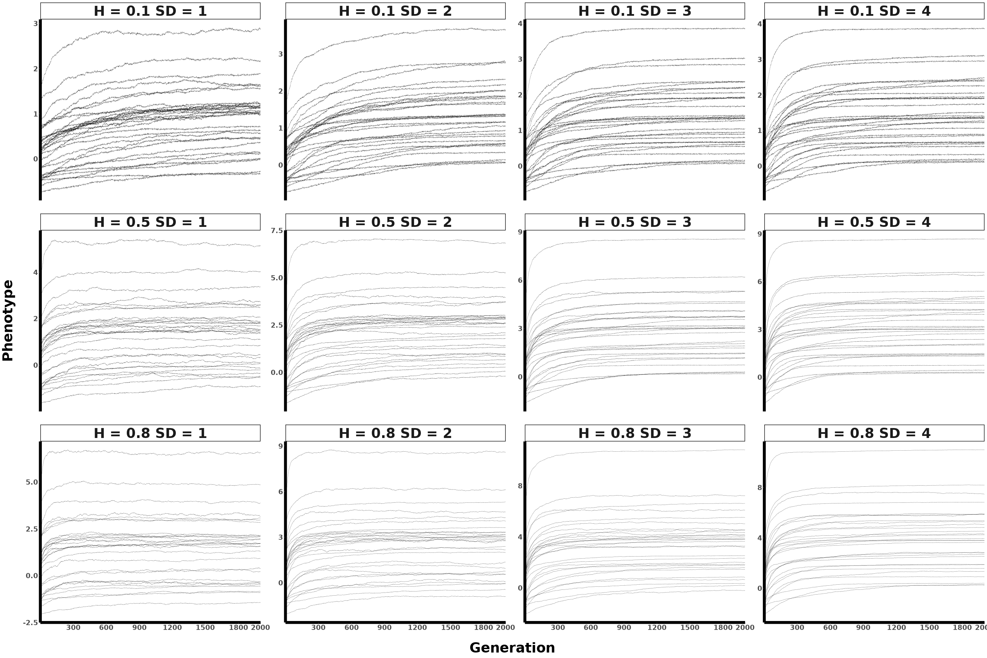

Figure: Oligogenic mean population phenotypic plot across 30 replicates (each line represents a single replicate) for constant selection, showing parameter interactions.

#### 4.2.3. Polygenic 70

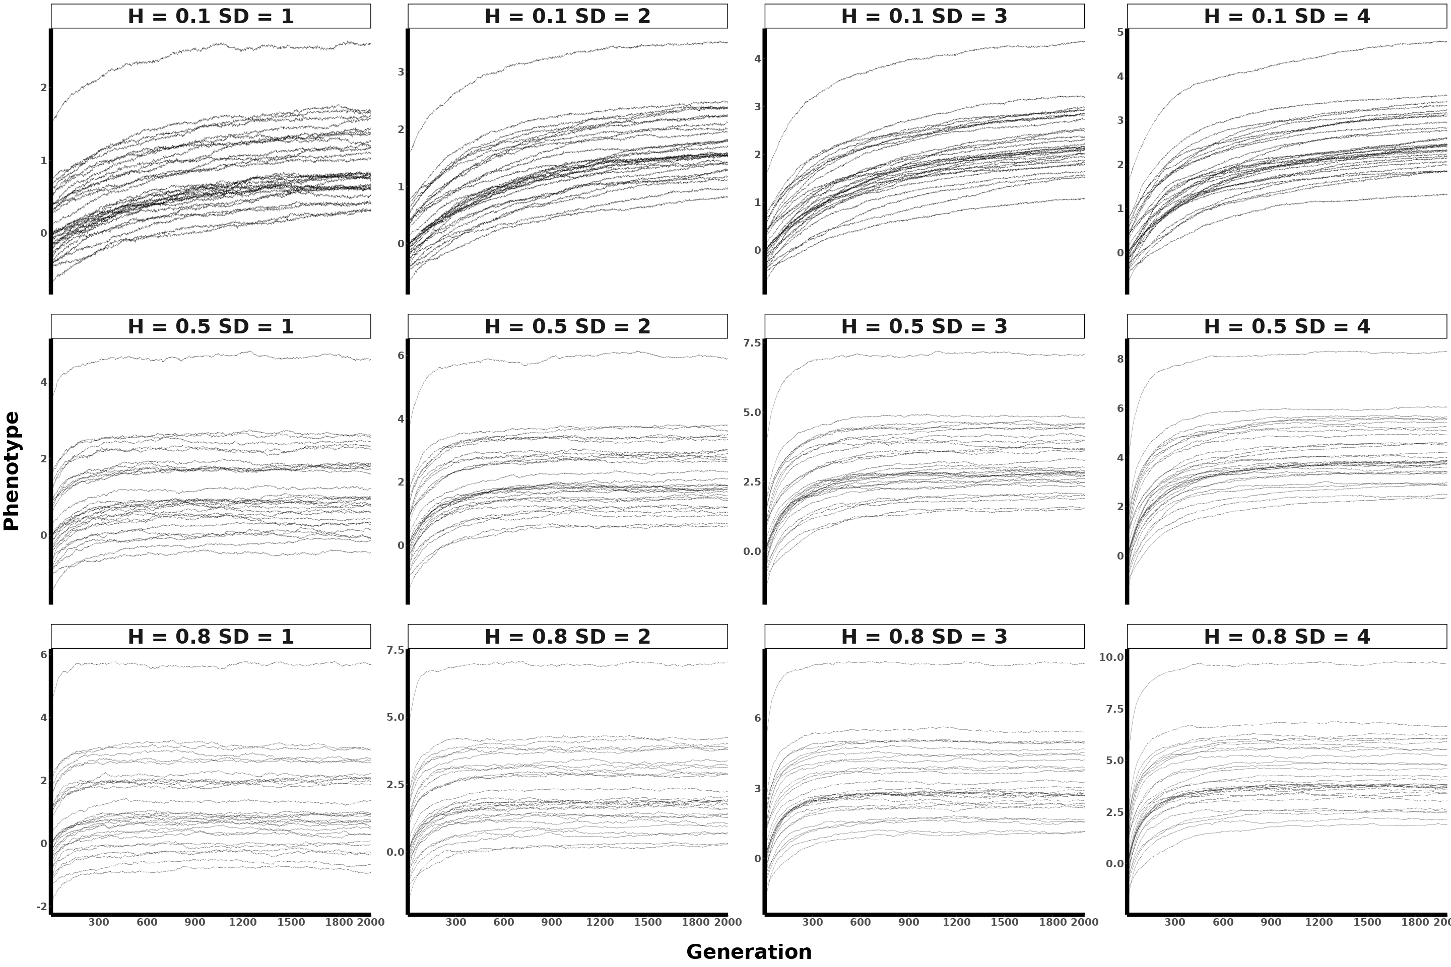

Figure: Polygenic (70 loci) mean population phenotypic plot across 30 replicates (each line represents a single replicate) for constant selection, showing parameter interactions.

#### 4.2.4. Polygenic 100

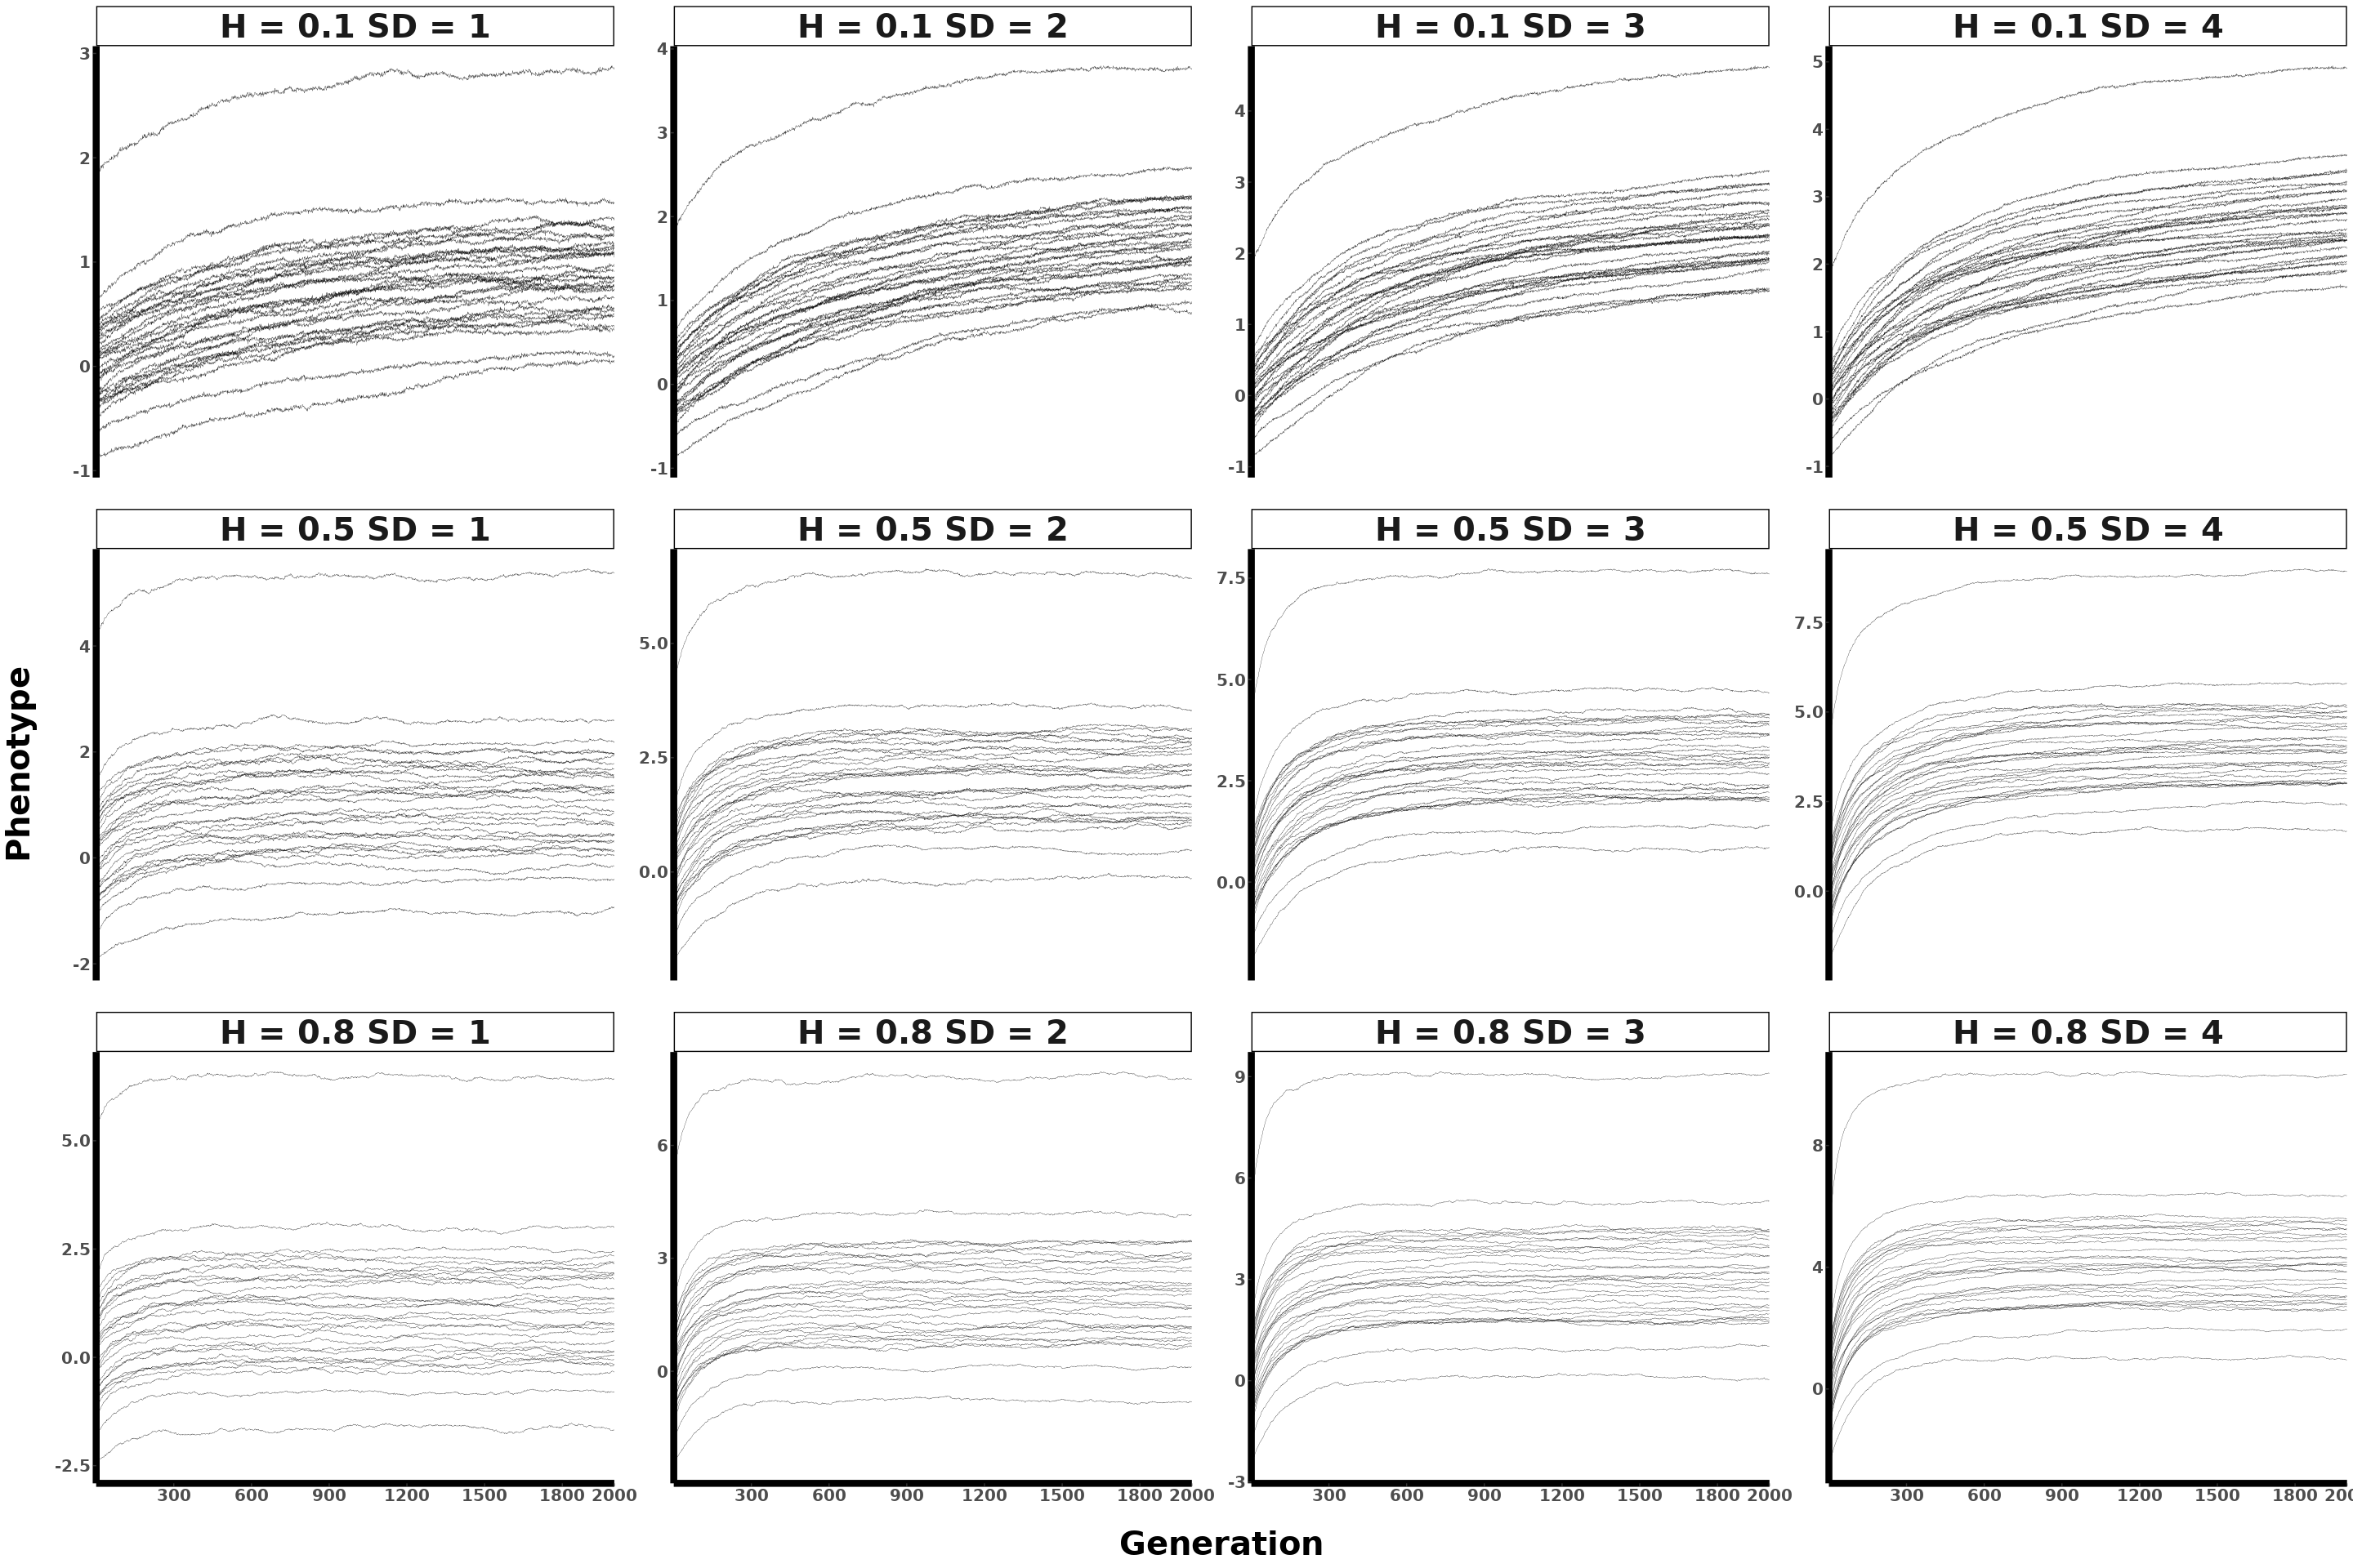

Figure: Polygenic (100 loci) mean population phenotypic plot across 30 replicates (each line represents a single replicate) for constant selection, showing parameter interactions.

#### 4.2.5. Polygenic 300

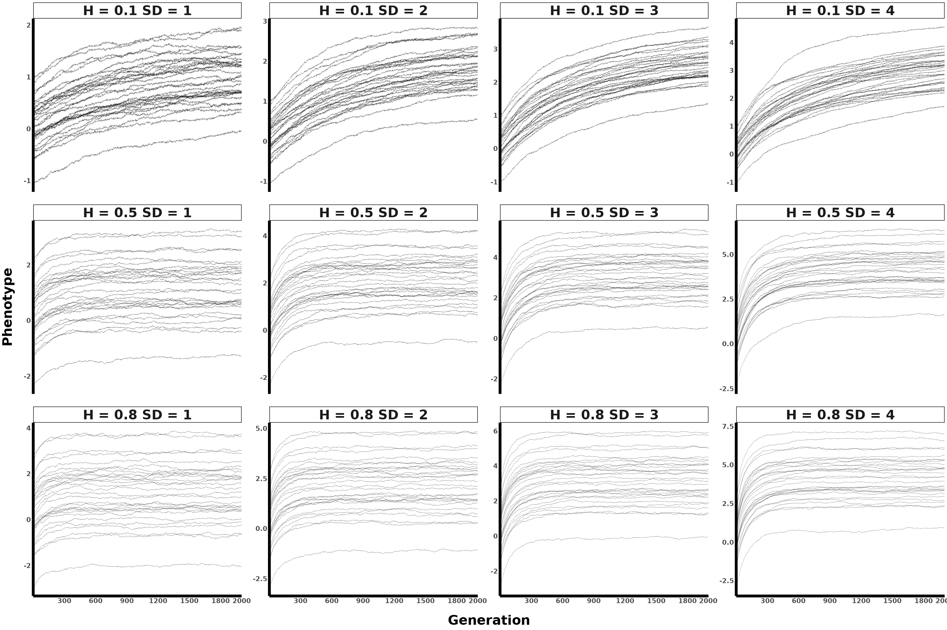

Figure: Polygenic (300 loci) mean population phenotypic plot across 30 replicates (each line represents a single replicate) for constant selection, showing parameter interactions.

### 4.3. Spec All params

#### 4.3.1. Monogenic

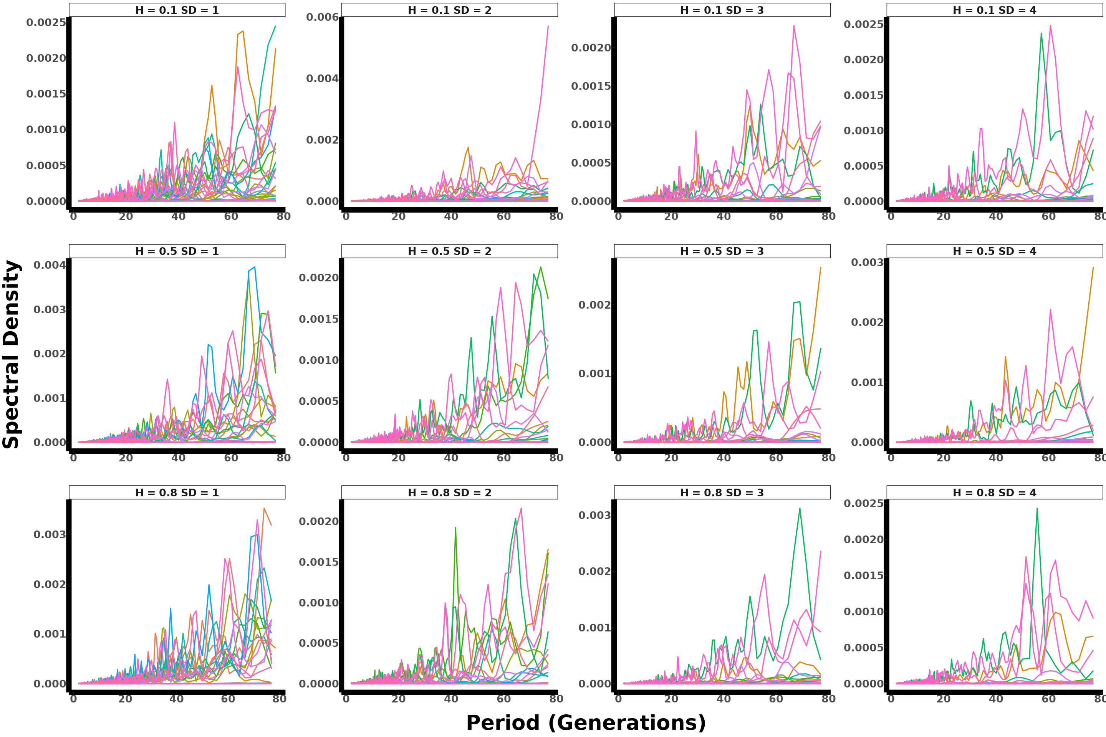

Figure: Monogenic spectral density plot across 30 replicates for constant selection, showing parameter interactions.

#### 4.3.2. Oligogenic

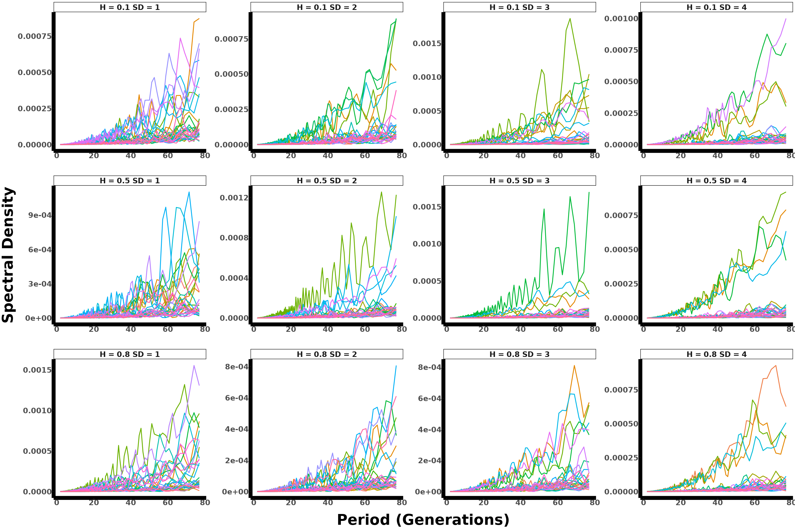

Figure: Oligogenic spectral density plot across 30 replicates for constant selection, showing parameter interactions.

#### 4.3.3. Polygenic 70

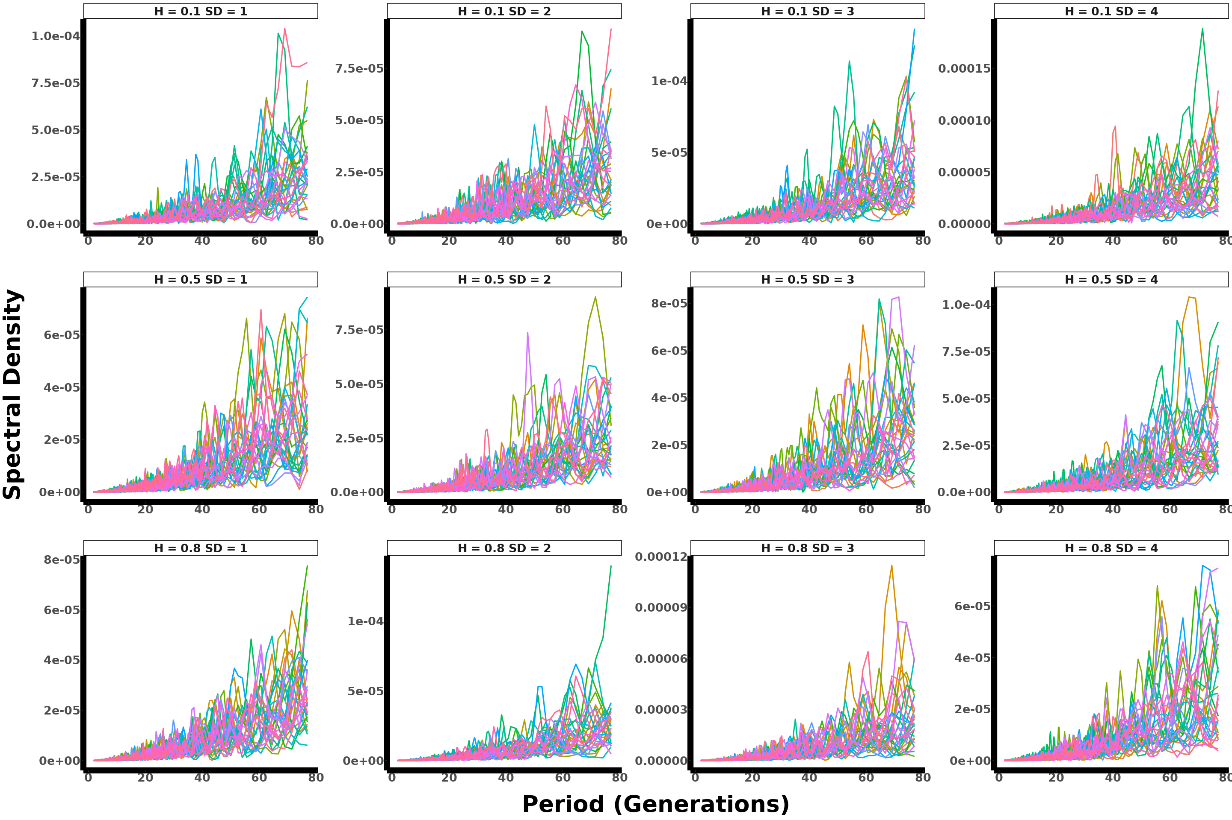

Figure: Polygenic (70 loci) spectral density plot across 30 replicates for constant selection, showing parameter interactions.

#### 4.3.4. Polygenic 100

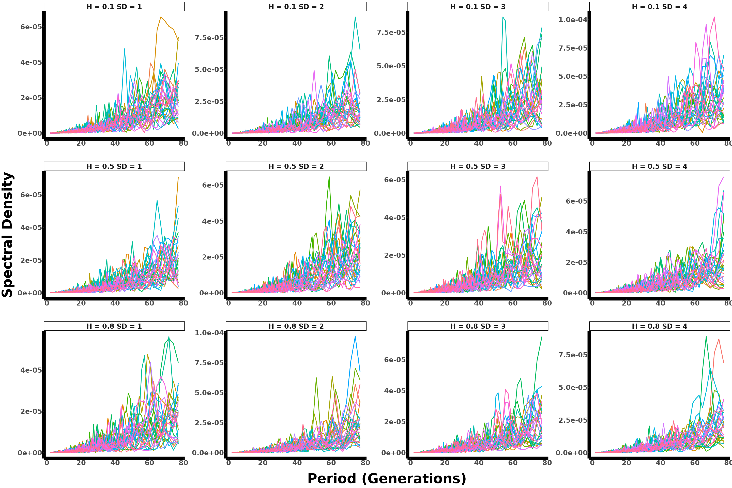

Figure: Polygenic (100 loci) spectral density plot across 30 replicates for constant selection, showing parameter interactions.

#### 4.3.5. Polygenic 300

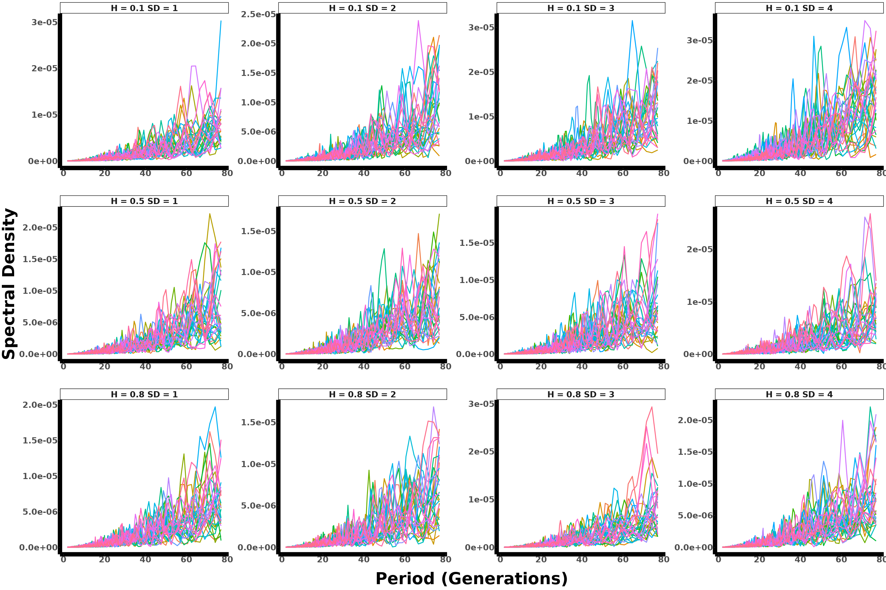

Figure: Polygenic (300 loci) spectral density plot across 30 replicates for constant selection, showing parameter interactions.